CANStream User Guide

**Table des matières**

Introduction 5

General overview 9

Getting started 13

Computer requirements 15

License agreement 19

Installation 24

Registration 31

PEAK USB CAN adapter driver 35

Main interface 42

CAN Controller panel 46

CAN controller modes 50

Spy & Manual mode 54

Cycle mode 58

CAN controller panel tool bar 62

Menu strip 66

CAN Configuration 70

Cycle 74

Recording 78

Tools 82

View 86

Help 90

Status bar 94

About form 98

CAN Frames configuration 103

CAN Configuration form 107

Single bus configuration 112

Bus properties 115

CAN message properties 119

CAN signal properties 123

CAN Configuration tree view 127

Multiplexed parameter 131

Message map 135

Virtual CAN signal 139

Vector CAN data base (dbc) import 144

Multiple buses configuration 149

CAN Bus information 155

Configuration import & export 159

Spy & Manual mode 163

Data Reception 167

Raw format data Reception 171

Engineering format data Reception 175

Virtual data Reception 179

Received data graphic 183

Data Transmission 188

Raw format data Transmission 192

Engineering format data Transmission 196

Virtual data Transmission 200

Cycle mode 204

Cycle playing 208

Cycle Reception data panel 213

Cycle starting and ending points setting 217

Cycle loop number setting 222

Virtual CAN signals in cycle 226

Cycle creation 230

Easy cycle creation 234

Cycle data association 239

Association type 244

Advanced cycle creation 248

Advanced cycle creation tool bar 253

Cycle parts setting 257

Cycle definition 261

Record replay 267

Record replay configuration 271

CAN controller appearance options 275

Control layout  279

Manual control layout 283

Cycle control layout 287

Grids contents control 291

Grid rows 295

Grid columns 299

Manual control grid columns 303

Cycle player grid columns 308

Data logging 312

Data logging start & stop 316

Automatic recording 320

Data file formats 324

Peak PCAN trace file 328

Record data file 332

Logging file conversion 336

Manual conversion 340

Automatic conversion 344

Conversion process control 348

Data file storage structure 352

Recording event & Recording session 356

Recording event creation & edition 360

Recording event selection 365

Recording session creation & edition 369

Recording session selection 374

User information 378

Data analysis 382

Analysis window 386

Data viewer page creation 390

Data viewer Toolbar 395

Data set information 399

Data browser 405

Root folder tree 409

Events & sessions list 413

Logging data list 418

Data browser tool bar 423

Graphic window 427

Graphic window tool bar 431

Shortcut keys 435

Data file 439

Analysis functions 443

Main cursor 447

Reference cursor 452

Zoom 457

Statistics 463

Legend 467

Snapshot 473

Print 477

Graphic window settings 482

Channel list 486

Graphic layout 491

Graphic configuration 496

Generic series properties 500

General properties 505

Graphic grids properties 511

Abscisse properties 515

Cursors properties 520

Graphic serie detailed configuration window 525

Serie general properties 529

Serie format 535

Serie Y Axis 540

Serie custom grid 545

Serie reference lines 551

Line styles 557

Virtual Channels 561

Virtual channel edition 565

Virtual channel library properties 570

Virtual channel properties 574

Virtual channel testing 579

Virtual channel built-in functions 584

Built-in signals 589

Built-in signals edition 593

Built-in signals library 598

Built-in signals properties 602

Built-in signals types 606

Sinus 609

Pulses 613

Triangle 617

Slopes 621

Ramp 625

Step 629

Random 633

**Introduction**

First of all, thanks for using CANStream !

This document is dedicated to the countless lost hours of both people having to search for simple answers, and people having to answer questions that shouldn't have to be asked in the first place. Documentation is always hard to get, good documentation nearly impossible.

This markup is based in the default appearance of Microsoft Windows. This can be different on your own system, but the names (text) should be always the same. This is especially important on the screen shots. They are only for reference, your appearance of CANStream can be quite different.

Also, when talking about the left and right mouse buttons, the logical left and right is meant. These are the same as the physical left and right mouse buttons in the case of a right-handed setup. However, if you have a left-handed setup you will probably have the buttons swapped so act accordingly. This means in general you do what you normally do for most actions, CANStream mostly follows the standard Windows application behavior.

Likewise, the layout is discussed as it is displayed in a left-to-right order.

*Created with the Personal Edition of HelpNDoc:* [*Generate EPub eBooks with ease*](http://www.helpndoc.com/create-epub-ebooks)

**General overview**

CANStream is a .NET application intended to be used for CAN (Controller Area Network) bus communication development, testing and validation. CANStream allows to extensively test any system using CAN communication by sending and receiving CAN frames. Thanks to its powerful built-in mathematical expression evaluator, CANStream can also behave as a real control system feeding back the test device or commanding a third party device with context sensible data. Extended data logging and data analysis features of CANStream provide a comprehensive solution for testing and results analysis.

CANStream extensively uses the PCAN-Basic API developed by PEAK System for the PCAN-USB adapter

For more information about PEAK System: <http://www.peak-system.com>

You will therefore need to have PCAN-USB adapter and at least one free USB port available to make a complete use of CANStream.

CANStream can manage up to eight PCAN-USB adapters at the same time, thus you will need eight USB ports available.

As any .NET application, CANStream needs a Microsoft .NET framework to operate. You might need to install or upgrade your .NET framework.

If so, please visit <http://www.microsoft.com/net> to download the latest version of the Microsoft .NET framework.

*Created with the Personal Edition of HelpNDoc:* [*Full-featured Documentation generator*](http://www.helpndoc.com)

**Getting started**

*Created with the Personal Edition of HelpNDoc:* [*Full-featured Help generator*](http://www.helpndoc.com/feature-tour)

**Computer requirements**

|  |  |
| --- | --- |
| **Hardware** | |
| **CPU** | Pentium 4 1.2 GHz |
| **RAM** | 1 GB |
| **Hard drive** | 25 MB free space |
| **USB port** | 1 minimum |
| **Operating system** | |
| **Any of those Windows versions** | 2000, XP (32/64 bits), Vista (32/64 bits), Seven (32/64 bits), 8 (32/64 bits) |
| **.NET Framework** | 4.0 |

*Created with the Personal Edition of HelpNDoc:* [*Free help authoring tool*](http://www.helpndoc.com/help-authoring-tool)

**License agreement**

**DEFINITIONS**

“Software” means CANStream and its components. "User" means the Software customer or end user.

**OWNERSHIP**

Cobalt Solutions is the owner of the Software and of its copyright.

**LICENSE**

The Software ownership is not transferred to the User. Cobalt Solutions grant the User a simple, notexclusive license to use the Software only on limited numbers of workstations as defined in the appendix to the present agreement, for a period of time depending of type of license. During this period the User is entitled to receive services as described in appendix to the present agreement. When the license will expire, licensed features will be automatically disabled. If the license is not renewed the User may continue to use the Software under terms and conditions set forth in this "LICENSE AGREEMENT", but is not entitled to receive any services of any kind. If the license is not renewed within four (4) months from the expiry date, then the renewal option will be lost and the User needs to order a brand new license.

**COPY RESTRICTIONS**

The User is allowed to make one (1) backup or archive copy only for reserve. All copyright notices and any other proprietary legends on the original Software shall be reproduced on such copy. Both the original and the reserve copy of the Software are subject to the restrictions set forth in this license agreement and they shall be destroyed in case of license termination.

**RESTRICTIONS**

The User shall not rent or loan, distribute or sublicense the original or the backup copy of the Software and the manuals. User may not modify, translate, edit, decompile, reverse engineer, disassemble the Software or create derivative utilities based upon it. User may not edit the structure of the Software, nor ask to any other person to do so in order to modify its structure, dimensions, etc. THE USER SHALL NOT COPY THE MANUALS OR THE RELATED DOCUMENTATION, unless Cobalt Solutions gives written authorization. The license will immediately terminate without notice if the User fails to comply with any provision set forth herein.

**DISCLAIMER OF RESPONSABILITY**

The Software is provided "AS IS" and without warranty of any kind.

**LIMITED WARRANTY**

Cobalt Solutions reserves the right to grant the User the license for the Software, and he will replace the media on which the Software is furnished (disks and/or CD and/or password keys) which prove to be defective in material or workmanship under normal use. This warranty is good during a period of thirty (30) days starting from the date of purchase, and it does not apply to damages or problems resulting from misuse, abuse, accident or improper installation.

DISCLAIMER OF WARRANTY AND LIMITATION OF LIABILITY. EXCEPT AS SET FORTH ABOVE, NO OTHER WARRANTIES, EITHER EXPRESS OR IMPLIED, INCLUDING THE WARRANTIES OR CONDITIONS OF MERCHANTABILITY AND FITNESS FOR A PARTICULAR PURPOSE ARE APPLICABLE TO THIS PRODUCT. COBALT SOLUTIONS SHALL NOT BE LIABLE FOR ANY LOSS OF PROFITS, LOSS OF BUSINESS, INDIRECT, SPECIAL, INCIDENTAL OR CONSEQUENTIAL DAMAGES, EXPRESSLY OR NOT SET FORTH HEREIN.

**THIRD PARTY RESPONSIBILITY**

The Software copyright is ownership of Cobalt Solutions. The User may be considered directly liable by Cobalt Solutions for any action concerning the use of the Software, made directly or indirectly, that does not comply with this "LICENSE AGREEMENT".

**USER DUTIES AND MISUSE**

The User agrees to make any effort in order to assure that his employees, consultants or other people that can access to the Software comply with the terms set forth in this "LICENSE AGREEMENT", including the prohibition to authorize anyone to use parts of the Software in order to identify its source code. The User shall immediately make any effort to stop any misuse that comes to his knowledge.

**LICENCE TERMINATION**

Cobalt Solutions reserves the right to terminate the license at any time if the User fails to comply with any provision of this "LICENSE AGREEMENT". In this case, the User must immediately destroy the Software and return the media and all the copies to Cobalt Solutions.

**CONTROLLING LAWS**

This agreement is governed by the laws of France, also for what concerns patent and copyright. In case of judicial acts or proceedings consequent to a demonstrated failure to comply with the conditions set forth in this "LICENSE AGREEMENT"., all the legal costs will be at losing party expense. This agreement regulates any Software update and/or upgrade, and constitutes the entire agreement between the parties with respect to the use of the Software and the related documentation. Any dispute falls under the competence of the Law Court of Paris (France).

***APPENDIX TO END USER LICENCE AGREEMENT* NUMBER OF INSTALLATIONS**

Number of workstations on which the Software may be installed on CANStream: a finite number of installations defined by User at order placement.

**IMPORTANT NOTE**

This covers only installations of Cobalt Solutions proprietary software. Any license fees for third party software are not included in the Cobalt Solutions license fee.

**SERVICES**

For one year from the order of a new license or renewal of an existing one the User is entitled to receive the following services

* 1. Supply of latest CANStream software release at the time of new license purchase or renewal;
  2. User is entitled to request, under payment, customization of CANStream software;
  3. Supply of upgraded features (at the sole discretion of Cobalt Solutions) and debugged CANStream software releases, if any, during a valid license period;

*Created with the Personal Edition of HelpNDoc:* [*Easy EPub and documentation editor*](http://www.helpndoc.com)

**Installation**

To install CANStream on your computer, just run the installation wizard and follow installation steps.

Depending of your system, Windows 32 bits or 64 bits, you have to run the appropriate installation wizard.

* + Windows 32 bits: Setup_Win32.exe
  + Windows 64 bits: Setup_x64.exe

Just double-click on the file corresponding to your system to launch the procedure.

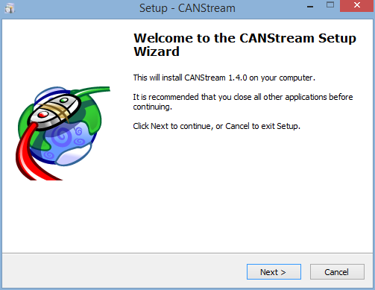

Click ‘Next' to start the installation.

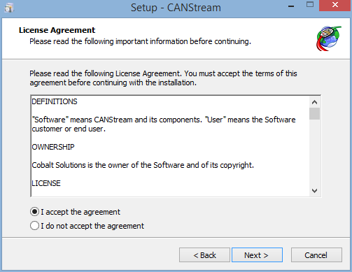

Click ‘I accept the agreement' and then click ‘Next'.

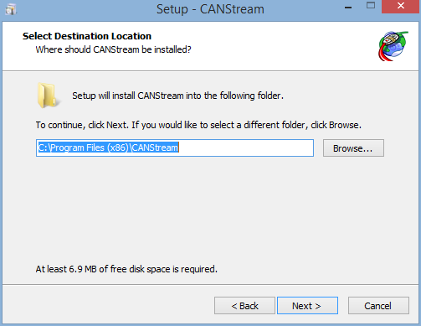

Check the installation folder, change it if you want by clicking the ‘Browse..' button and then click ‘Next'.

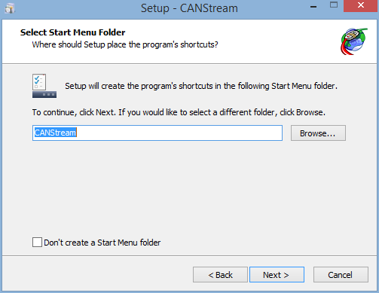

Check the name of the Start Menu folder that will be created and click ‘Next'. If you don't want create any 'Start Menu folder', just tick the box ‘Don't create a Start Menu folder' and then click ‘Next'.

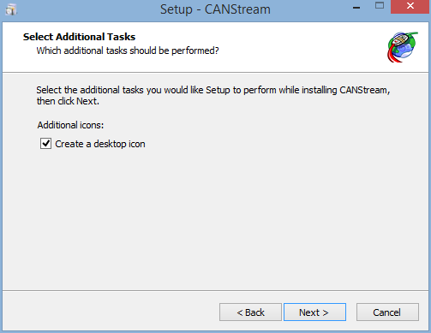

If you want create a desktop icon for CANStream, tick the box ‘Create a desktop icon' and then click ‘Next'.

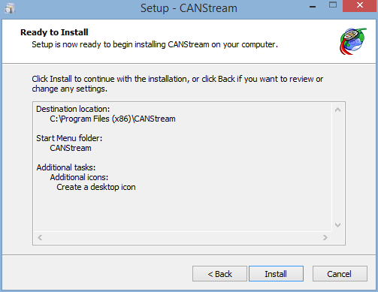

If you are happy with all settings summarized, click ‘Next' to start the actual installation of CANStream. Otherwise, click ‘Back' to change those settings.

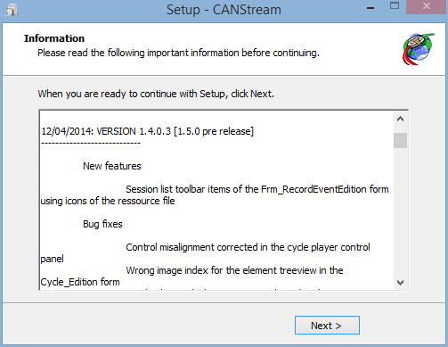

Check the release note for your information and click 'Next'.

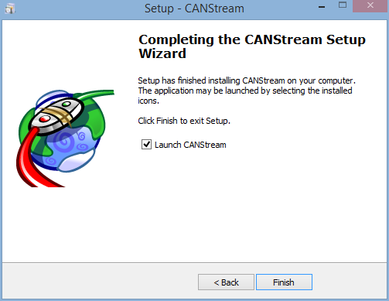

Here you are! CANStream has been installed. Just click ‘Finish' to launch CANStream. If you don't want launch CANStream now, simply uncheck the ‘Launch CANStream' box and click ‘Finish' to exit the installation wizard.

*Created with the Personal Edition of HelpNDoc:* [*Easily create Web Help sites*](http://www.helpndoc.com/feature-tour)

**Registration**

Unless you are using a demo version, at the first start up you will ask for license registration to enable the software.

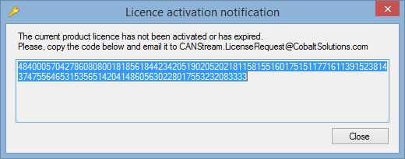

To get a license, send copy the code contained into the activation window (48400057...) and email it to [CANStream.LicenseRequest@CobaltSolutions.com](mailto:CANStream.LicenceRequest@CobaltSolutions.com?subject=%20CANStream%20License%20Request) or to your software dealer.

Within 24 hours you will receive the license file allowing product activation.

Once you get the license file, place it in the folder hosting CANStream executable file (CANStream.exe, generally in C:\Program Files (x86)\CANStream).

Check the 'About form' section of the present documentation for further details about licensing.

*Created with the Personal Edition of HelpNDoc:* [*Produce electronic books easily*](http://www.helpndoc.com/create-epub-ebooks)

**PEAK USB CAN adapter driver**

In order to use the PEAK PCAN-USB adapter you need to install its driver.

Download the driver package on the Peak web site: <http://www.peak-system.com/fileadmin/media/files/usb.zip>

You should get a zip file (usb.zip) containing the driver installation wizard. Unzip this file and run lunch the file 'PeakOemDrv.exe'.

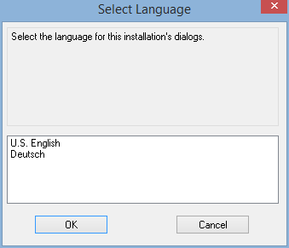

Select installation language and click 'OK'.

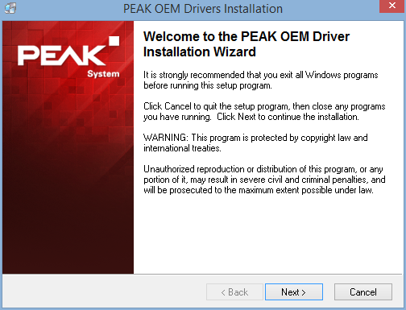

Click 'Next' to start the installation process.

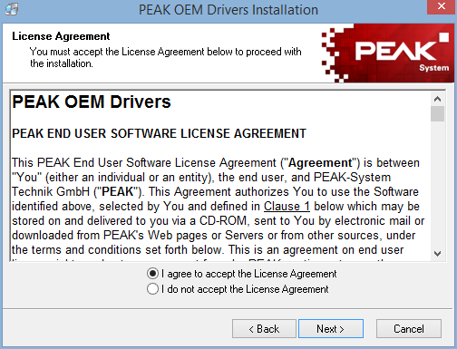

Read the license agreement and click 'I agree to accept the License Agreement' and then click 'Next'.

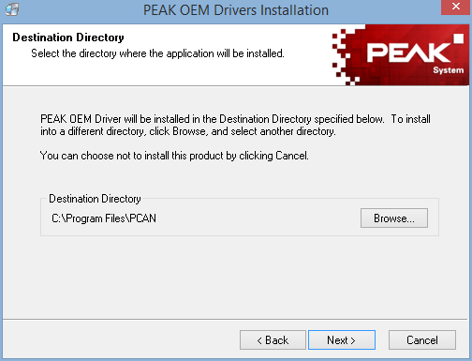

Check the installation folder and click 'Next'. Installation folder may be modified using the 'Browse' button.

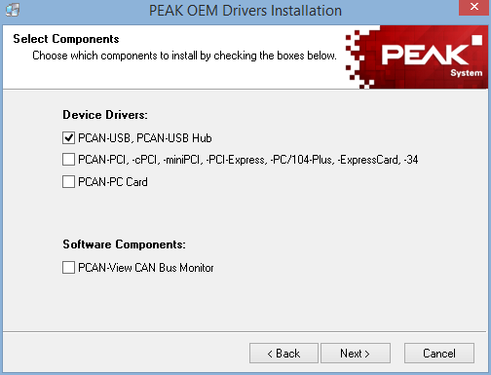

Since CANStream is only using PCAN-USB adapter the only driver requested is therefore 'PCAN-USB, PCAN-USB Hub'. Check this box and click 'Next'.

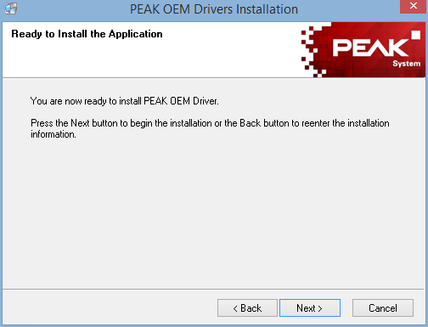

Click 'Next' to launch the actual driver installation.

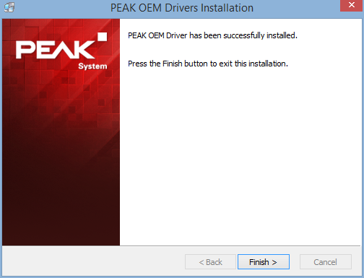

Once all files copied, click 'Finish' to quit the installation wizard.

*Created with the Personal Edition of HelpNDoc:* [*Generate EPub eBooks with ease*](http://www.helpndoc.com/create-epub-ebooks)

**Main interface**

At startup CANStream comes as the picture bellow.

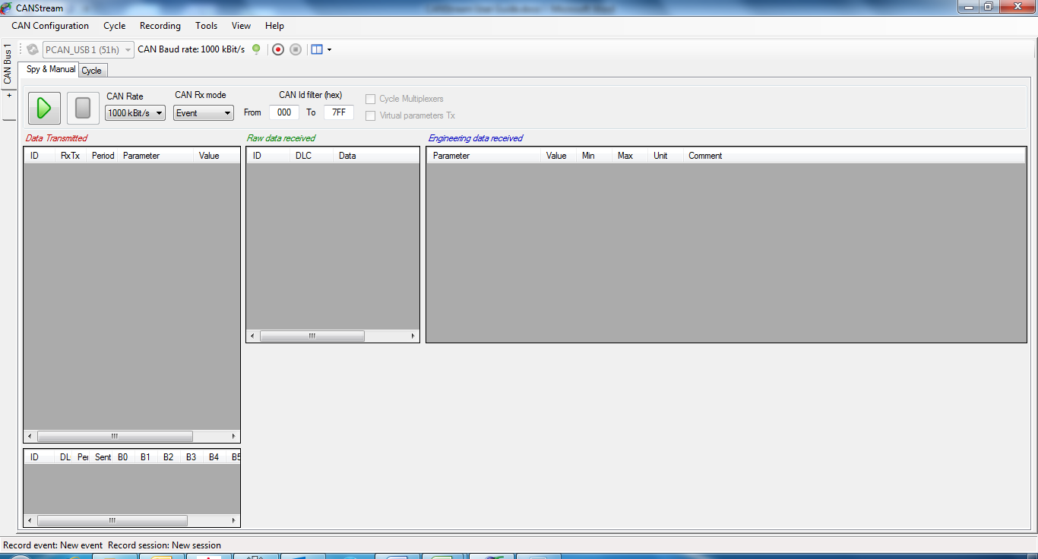

The main CANStream interface is composed of different elements

* + CAN Controller panels using the most of the space
  + The menu strip, on the top, regrouping all commands and tools accesses
  + A status bar on the bottom showing different information such like the current record event and session, the current CAN configuration name and error flags

*Created with the Personal Edition of HelpNDoc:* [*Easily create Web Help sites*](http://www.helpndoc.com/feature-tour)

**CAN Controller panel**

The CAN controller panel is where the CANStream magic happens!

There is one panel for each Peak PCAN-USB adapter you want to use. By default only one panel is opened, simply click the ‘+' tab to open a new panel and use an additional PCAN-USB adapter.

The CAN controller panel is composed of a tool bar and a multi-tab panel.

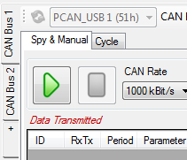

CANStream can handle up to eight PCAN-USB adapters, so it is possible to open a maximum of eight panels.

To close a panel and release its PCAN-USB adapter, stop the current panel operation (Manual control or Cycle player). Then right-click on the panel you want to close, and click the ‘Close CAN Bus' command.

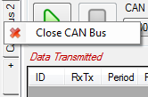

*Created with the Personal Edition of HelpNDoc:* [*Create iPhone web-based documentation*](http://www.helpndoc.com/feature-tour/iphone-website-generation)

**CAN controller modes**

A CAN controller has two operation modes, ‘Manual & Spy’ and ‘Cycle’. Each mode has its own tab in the panel.



*Created with the Personal Edition of HelpNDoc:* [*Full-featured Help generator*](http://www.helpndoc.com/feature-tour)

Spy & Manual mode

The ‘Spy & Manual’ mode is intended to be used to spy the content of frames (or messages) circulating on the bus.

Using this mode, it also possible to send messages containing values set by the user.

Both reception and transmission handle ‘Engineering’ and ‘Raw’ formats of data. ‘Engineering’ means that user can read and write actual physical values of CAN signals while the ‘Raw’ format means raw byte values of the CAN messages.

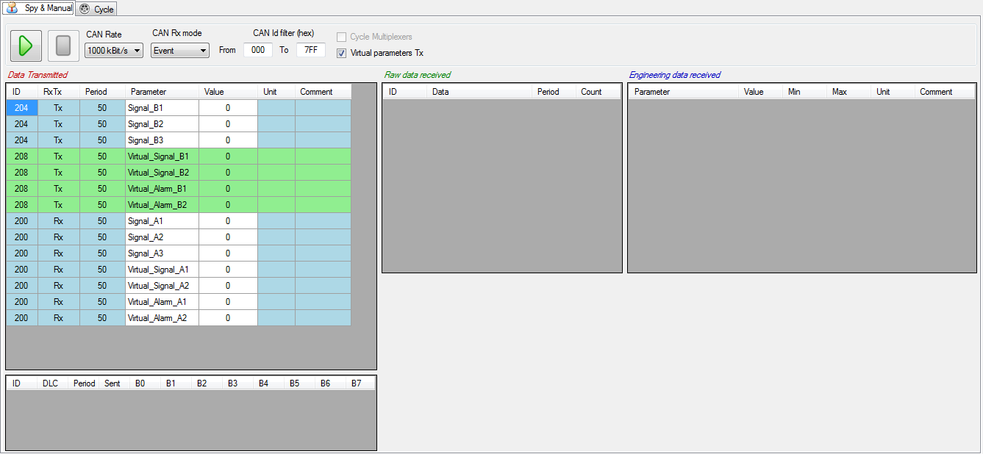

*Created with the Personal Edition of HelpNDoc:* [*Create HTML Help, DOC, PDF and print manuals from 1 single source*](http://www.helpndoc.com/help-authoring-tool)

Cycle mode

In ‘Cycle’ mode CANStream is sending a pre-defined sequence of message. This mode allows simulation of real usage conditions in which values have a very high dynamic that couldn’t be replicated by a human.

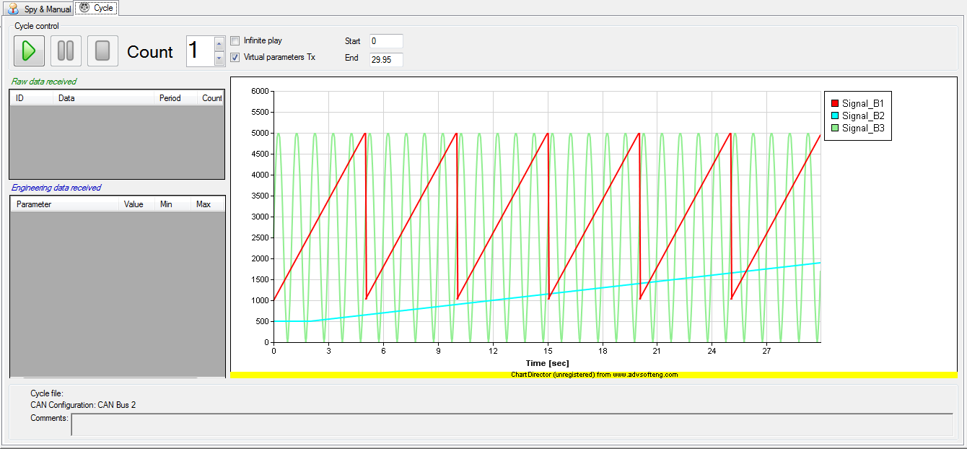

*Created with the Personal Edition of HelpNDoc:* [*Full-featured EPub generator*](http://www.helpndoc.com/create-epub-ebooks)

**CAN controller panel tool bar**

The CAN controller panel tool bar contains common commands for both ‘Spy & Manual’ and ‘Cycle’ modes



At the CANStream start up or on new controller opening, if a PCAN-USB adapter is connected and free (not used by another application) CANStream takes the control of this adapter and tool bar is as shown above.

By default the CAN Baud rate is set to 1000 kBit/s, however Baud rate can be changed in the CAN Configuration editor.

The ‘Stop connection’ button  permits to stop the connection and to release the PCAN-USB adapter in order to make it available for another controller panel or another application. Click the ‘Start connection’ button  to restart the connection using the same PCAN-USB adapter.

When the connection stops, ‘Refresh PCAN USB Devices list’ command  and the PCAN USB device list are enabled.



Click the ‘Refresh PCAN USB Devices list’ button  to refresh the ‘PCAN USB Devices list’. Click in the list to select the PCAN-USB device that you want use.



The ‘Start stream recording’ button  starts the data recorder. When it is clicked, the ‘Stop stream recording’ button  becomes enabled allowing the stop of data recording.

Command ‘View’  contains several sub-commands to customize the appearance of the ‘Spy & Manual’ panel. See the ‘Manual control layout’ section for more details.

*Created with the Personal Edition of HelpNDoc:* [*Produce electronic books easily*](http://www.helpndoc.com/create-epub-ebooks)

**Menu strip**

The menu strip gives access to all CANStream functions and tools.



*Created with the Personal Edition of HelpNDoc:* [*Full-featured EBook editor*](http://www.helpndoc.com/create-epub-ebooks)

**CAN Configuration**

This menu contains all function related to the CAN configuration of the current controller.

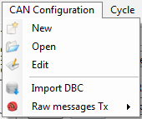

 New: Create a new CAN configuration.

 Open: Open a CAN configuration file.

 Edit: Edit the current CAN Configuration.

 Import DBC: Import a DBC file and use it as current CAN configuration.

 Raw messages Tx: Management of transmitted raw messages list.

*Created with the Personal Edition of HelpNDoc:* [*Free EPub and documentation generator*](http://www.helpndoc.com)

**Cycle**

This menu contains all functions related to the cycle player.

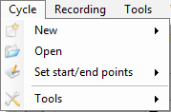

 New: Create a new cycle. Check the ‘Cycle creation’ section for more details.

 Open: Load a cycle into the cycle player of the current CAN controller.

 Set start/end points: Access to cycle starting and ending points control functions. Check the ‘Cycle playing’ section for more details.

 Tools: Access to cycle creation tools. Check the ‘Cycle creation’ section for more details.

*Created with the Personal Edition of HelpNDoc:* [*Easy EBook and documentation generator*](http://www.helpndoc.com)

**Recording**

This menu contains all functions related to the data recorder.

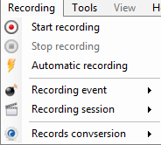

 Start recording: Start the data recorder.

 Stop recording: Stop the data recorder.

 Automatic recording: Enable or disable the automatic recording. Check the ‘Data recording’ section for more details.

 Recording event: Access to recording event control functions. Check the ‘Recording event’ for more details.

 Recording session: Access to recording session control functions. Check the ‘Recording session’ for more details.

 Recording conversion: Access to recording conversion control function. Check 'Recording conversion' for more details.

*Created with the Personal Edition of HelpNDoc:* [*Single source CHM, PDF, DOC and HTML Help creation*](http://www.helpndoc.com/help-authoring-tool)

**Tools**

This menu contains all CANStream tools access

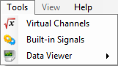

 Virtual Channels: Open the virtual channels editor.

 Built-in Signals: Open the built-in signals editor.

 Data Viewer: Open the data viewer.

*Created with the Personal Edition of HelpNDoc:* [*Free EPub and documentation generator*](http://www.helpndoc.com)

**View**

This menu contains layout configuration functions for the manual mode of the current CAN controller.

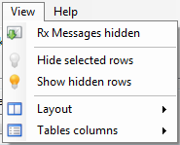

 Rx Messages hidden: Hide Rx messages in the transmission panel

 Hide selected rows: Hide the selected rows of the active grid

 Show selected rows: Show hidden rows of the active grid

 Layout: Access to the control layout configuration functions.

 Tables columns: Access to the grid columns configuration functions.

*Created with the Personal Edition of HelpNDoc:* [*Write eBooks for the Kindle*](http://www.helpndoc.com/feature-tour/create-ebooks-for-amazon-kindle)

**Help**

This menu contains access to the help file and the ‘About’ form

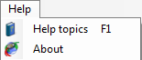

 Help topics: Open the CANStream user guide. This function is also accessible by pressing the ‘F1’ key.

 About: Open the CANStream ‘About’ form containing different information including the release name and version and license request command.

*Created with the Personal Edition of HelpNDoc:* [*Easily create EPub books*](http://www.helpndoc.com/feature-tour)

**Status bar**

The status bar of CANStream is located at the bottom of the main window. This bar contains different information.



The name of the CAN configuration file currently in use



Names of current data recording event and session.



In case of CAN error, name and description of the error detected will also appear in the status bar.



*Created with the Personal Edition of HelpNDoc:* [*Create HTML Help, DOC, PDF and print manuals from 1 single source*](http://www.helpndoc.com/help-authoring-tool)

**About form**

The CANStream ‘About’ form is accessible through the command 'Help\About'  of the main menu strip.



It contains different information including the release name and version.

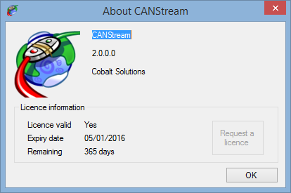

License information panel at the bottom shows details of the current license state.

* + License valid: Indicates whether or not the current product license is still valid.
  + Expiry date: Expiry date of the current license.
  + Remaining. Number of days remaining before the current license expire.

30 days before the expiry date, a warning message will pop up at the software start up informing that your license is about to expire.

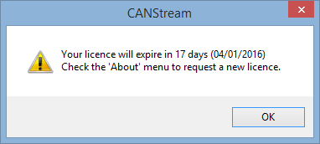

In that case, the 'Request license' button  of the form will be enabled.

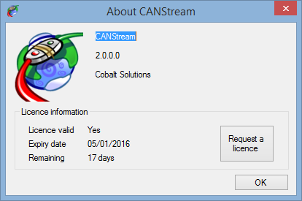

Click this button to get the license generation code and follow the licensing procedure.

*Created with the Personal Edition of HelpNDoc:* [*Free EPub and documentation generator*](http://www.helpndoc.com)

**CAN Frames configuration**

You can use CANStream to send and receive CAN messages in raw format (hexadecimal byte values) but if you want use all features of CANStream and get the maximum out of it (and I'm sure you do), the first thing you have to do is to create a CAN configuration file.

A CAN configuration file contains the description of all messages (frames) circulating on the CAN bus and all properties of all parameters (nodes) for each message. Such configuration doesn't need to be exhaustive, you can setup only messages and parameters which are of your interest and simply ignore those you don't want work with.

CANStream actually handles two kinds of CAN configuration file: single bus configuration and multiple buses configuration.

A single bus configuration simply contains descriptions and properties of CAN messages and parameters for a single CAN bus. This the configuration you have to use if you are using only one Peak PCAN-USB adapter.

A multiple buses configuration does the same but it can handle up to height CAN buses at the same time. This is the kind of configuration which is intended to be used when you are using simultaneously two, three or more (up to eight) Peak PCAN-USB adapters.

*Created with the Personal Edition of HelpNDoc:* [*Easily create iPhone documentation*](http://www.helpndoc.com/feature-tour/iphone-website-generation)

**CAN Configuration form**

To create a CAN configuration, click on the ‘CAN Configuration' menu of the menu strip and then click on ‘New'.

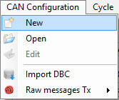

The CAN configuration editor should appear as bellow.

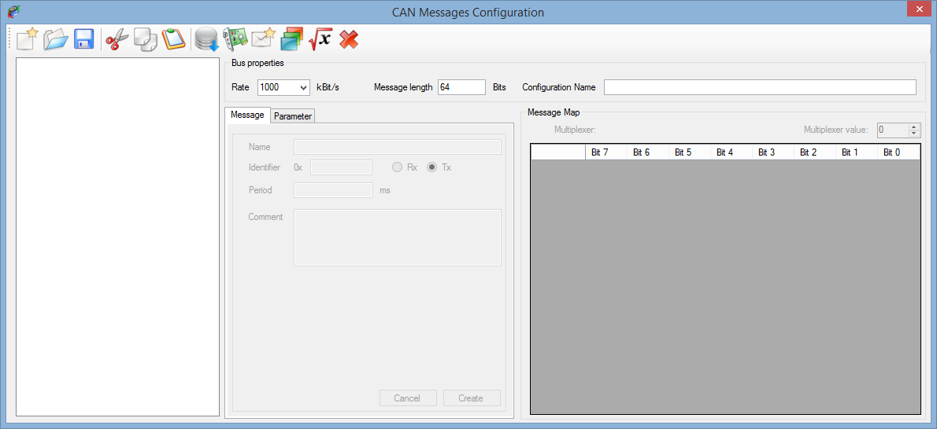

The CAN configuration editor contains several things:

* + A tool bar containing all CAN configuration edition functions access
  + A tree view in which the CAN configuration is shown as a tree
  + A multitab panel where messages and parameters properties are set
  + The bus properties panel showing general properties of a CAN bus
  + A grid showing the mapping of the active CAN message

All edition functions of a CAN configuration are available in the tool bar.

 New: Create a new CAN configuration.

 Open: Open an existing CAN configuration for edition.

 Save: Save the current CAN configuration into a file.

 Cut: Cut an element of the CAN configuration and place it on the clipboard.

 Copy: Copy an element of the CAN configuration to the clipboard.

 Past: Past an element of the CAN configuration from the clipboard.

 DBC Import: Import a DBC file in the current CAN configuration.

 New CAN controller: Add a CAN controller to the current CAN configuration.

 New CAN message: Add a CAN message to the CAN configuration.

 New CAN parameter: Add a CAN parameter to the current CAN message.

 New virtual CAN parameter: Add a virtual CAN parameter to the current CAN message.

 Delete: Delete an element of the CAN configuration.

*Created with the Personal Edition of HelpNDoc:* [*Easily create iPhone documentation*](http://www.helpndoc.com/feature-tour/iphone-website-generation)

**Single bus configuration**

A single bus configuration is a CAN configuration made for only one CAN controller used through a single Peak PCAN-USB device.

*Created with the Personal Edition of HelpNDoc:* [*Free help authoring environment*](http://www.helpndoc.com/help-authoring-tool)

**Bus properties**

First, set the CAN bus properties in the ‘BUS properties' panel. Most important properties here are bus rate and message length. By default those properties are set to 1000 kBit/s for the rate and 64 bits (8 bytes) for the message length. Optionally, you can give a name to your configuration.



*Created with the Personal Edition of HelpNDoc:* [*Full-featured Kindle eBooks generator*](http://www.helpndoc.com/feature-tour/create-ebooks-for-amazon-kindle)

**CAN message properties**

Click the ‘New message'  button of the tool bar to create a new CAN message.

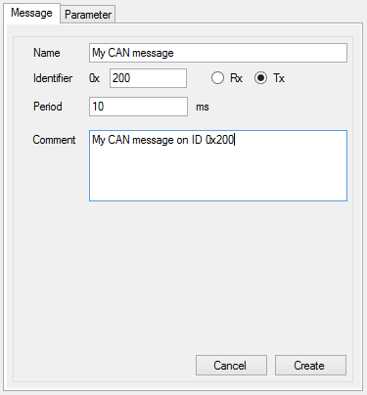

Most important CAN message properties are its identifier (ID) which must be an hexadecimal value. The message direction, ‘Rx' whether the message is received by CANStream or ‘Tx' whether it is sent by CANStream. Period in millisecond to indicate the frequency of the message reception or transmission.

You may also give a name and add a comment to your message but those are not mandatory.

Then click the ‘Create' button to add your new message into the current configuration.

*Created with the Personal Edition of HelpNDoc:* [*Full-featured Help generator*](http://www.helpndoc.com/feature-tour)

**CAN signal properties**

Once your message created, add some parameters (signals) to it by clicking the ‘New parameter' button .

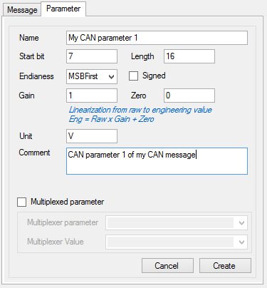

A CAN parameter has several important properties that need to be set with attention.

* + Start bit: The index of the bit in the frame where the parameter starts. Whether parameter endianess is MSB or LSB (see below for details) start bit will be different.
  + Length: The number of bits use by the parameter in the frame.
  + Endianess: How the parameter engineering (or physical) value is encoded inside its bits. There two different endianesses, MSB first (Most significant byte first) also known as Motorola format and LSB first (Least significant byte first) also known as Intel format.

There are tons of documentation available on the web describing in great details the difference between those two formats. Basically, for a given value, let's say 50 000, its encoded value will be 0xC350 in MSB format, while it will be 0x50C3 in LSB format.

* + Signedness: Indicating whether parameter sign (positive or negative) is considered for the parameter value encoding.
  + Gain and Zero: Those are values used to scale the parameter value from the raw to the engineering format
  + Name, unit and comment: Those properties are not essential but it may ease parameters identification and value exploitation.
  + Multiplexed parameter: Use those settings if you want multiplex your message. See the ‘Multiplexed parameter' section for more details.

Once all properties set, click the ‘Create' button to add the parameter to the current message.

*Created with the Personal Edition of HelpNDoc:* [*Produce Kindle eBooks easily*](http://www.helpndoc.com/feature-tour/create-ebooks-for-amazon-kindle)

**CAN Configuration tree view**

The CAN configuration tree view, on the left of the CAN configuration editor, shows all messages and all parameters of each message in a tree form.

Each message is represented by a tree node and all its parameters are a child node (or a branch) of this message node.

Click on a message or a parameter node to display its properties. Those properties can also be modified. Select the element that you want to modify, make all changes you need and then click on the ‘Modify' button.

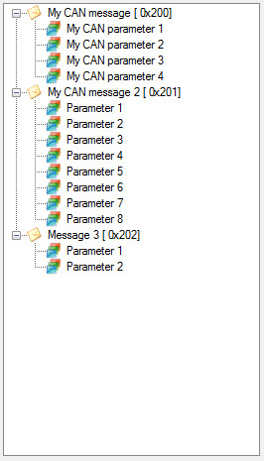

Using ‘Cut' , ‘Copy'  and ‘Past'  commands of the tool bar, you can duplicate or move messages and parameters inside the configuration.

The ‘Delete selection'  button allows to delete a message or a parameter.

*Created with the Personal Edition of HelpNDoc:* [*iPhone web sites made easy*](http://www.helpndoc.com/feature-tour/iphone-website-generation)

**Multiplexed parameter**

Once you have at least two parameters in a message, one of those parameters, the multiplexer, can be used to multiplex other parameters of the message.

As we saw in the ‘CAN signal properties' section, each parameter uses a range of bits inside the message frame. In a multiplexed message, the same bit range of the frame, or a part of it, can be shared between multiple parameters. In other words, a single message can have different parameters arrangements, current arrangement being defined by the current value of the multiplexer.

The multiplexer must be unique within a message while there could be bunches of multiplexed and fixed parameters.

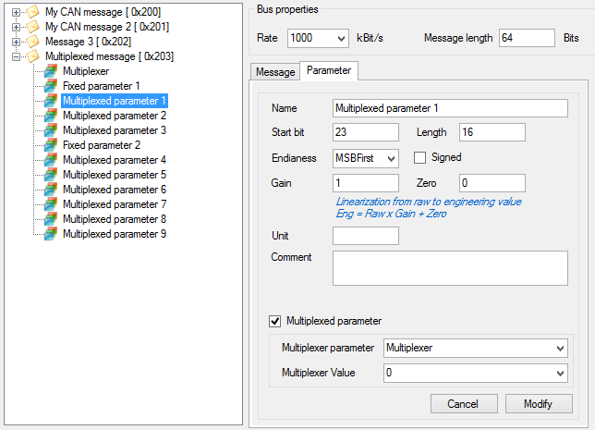

On the example above, parameters ‘*Multiplexed parameter X*' are sharing the same range of bits within the message ‘*Multiplexed message*', multiplexer of this message being the ‘Multiplexer' parameter.

To create multiplexed parameters inside a message, in first create a fixed parameter (a parameter which is not multiplexed and which will be present in all arrangements of the message). Then create a second parameter. In the properties of your second parameter, tick the ‘Multiplexed parameter' box. Lists ‘Multiplexer parameter' and ‘Multiplexer value' are now active.

Select the multiplexer parameter in the ‘Multiplexer parameter' list and then select which of its value is making your parameter active in the ‘Multiplexer value' list.

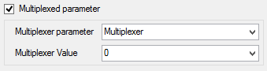

*Created with the Personal Edition of HelpNDoc:* [*Produce electronic books easily*](http://www.helpndoc.com/create-epub-ebooks)

**Message map**

The message map is a grid that shows in graphical way the bit mapping of parameters of a given CAN message.

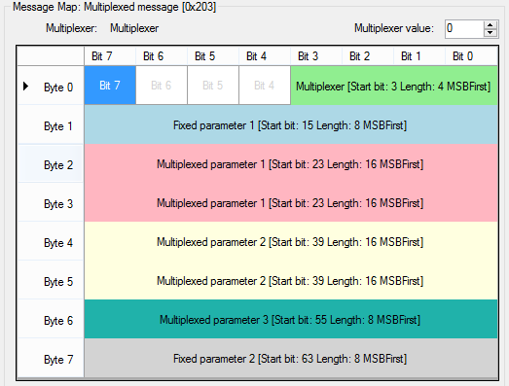

Each row of the grid represent a single byte of the message while each column is the bit number for each byte.

Inside this grid, parameters are represented by colored area. Most important properties of a parameter are written inside its area.

Click on a parameter to display or edit all its properties.

For multiplexed messages, change the multiplexer value to see the message map for any multiplexer value.

*Created with the Personal Edition of HelpNDoc:* [*Full-featured EBook editor*](http://www.helpndoc.com/create-epub-ebooks)

**Virtual CAN signal**

Basically, a virtual CAN signal is a virtual channel embedded into a CAN message.

A standard CAN signal can be used either in manual TX or RX mode in a cycle. For transmission (TX) it uses a static value defined by the user. In reception (RX) it simply gets the value received.

Value of a virtual CAN signal is neither defined by the user or received! The value is computed real time using other parameter values. See the 'Virtual channel' section for more details.

Click the 'New virtual parameter' button  to create a virtual CAN signal.

The virtual channels selection window should appear.

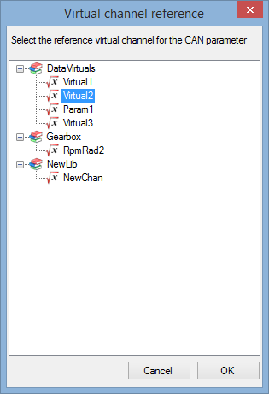

Pick up the virtual channel that you want to add in your message and click 'OK'.

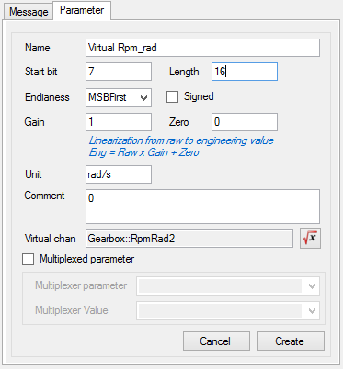

Configure your virtual signal the same way you would do for a standard parameter and then click the 'Create' button.

Note that compared to standard parameter, for virtual CAN signal the section 'Virtual chan' appeared. This section shows the virtual channel used as source of the virtual signal.

The source is indicated using the following format: 'XXX::YYY' where 'XXX' is the name of the library hosting

your virtual channel and 'YYY' is the name of the virtual channel.



Click on the  button to change the virtual source.

In order to be easily identified in the CAN configuration tree view, virtual CAN signal are marked with the virtual channel icon .

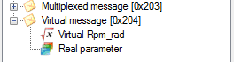

*Created with the Personal Edition of HelpNDoc:* [*Free EPub producer*](http://www.helpndoc.com/create-epub-ebooks)

**Vector CAN data base (dbc) import**

A Vector CAN data base file (extension *.dbc) is, at the end of day, a Vector CAN configuration. By the way, Vector is the editor of the famous tool CANalyser, one the most used (if not the most) tool in the CAN engineering world.

For more detail about CANalyser and DBC file, please visit <http://vector.com/vi_canalyzer_en.html>.

As per CANStream a DBC file contains CAN message and parameters description.

To save the pain of creating a CANStream CAN configuration file from scratch if you have already a DBC, CANStream can import it and convert it to its own format.

Do to so, click the 'Import DBC' button .

Select the DBC file to import and click 'Open'.

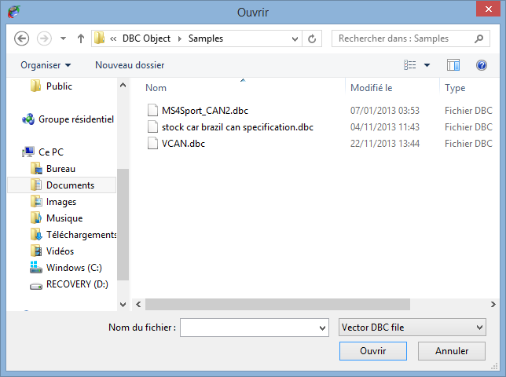

All messages contained in the DBC as well as all their parameters are going to be added to the current CAN configuration.

Note that the 'DBC import' function doesn't reset the current CAN configuration, it simply add messages coming from the DBC.

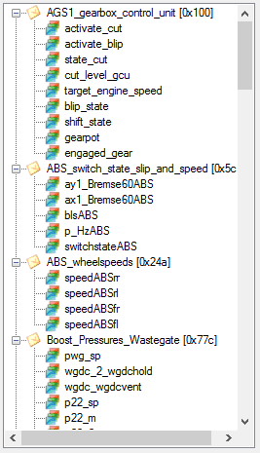

*Created with the Personal Edition of HelpNDoc:* [*Easy EBook and documentation generator*](http://www.helpndoc.com)

**Multiple buses configuration**

As we saw in the previous section, a CAN configuration contains description of CAN messages and parameter for a single CAN bus.

In the CANStream world, a CAN bus is considered as a Peak PCAN-USB adapter. One CAN bus = one PCAN-USB.

Since CANStream can handle up to eight PCAN-USB adapters, it can run simultaneously up to eight CAN configurations. Those multiple configurations (or buses) can be grouped in a single file in order to have the user configuring its buses once and using and reusing them with a simple command.

To create a multiples buses CAN configuration, click on the ‘CAN Configuration' menu of the menu strip and then click on ‘New'.



The CAN configuration editor should appear as bellow.



Click the 'New CAN bus controller' button  to create a new CAN Bus.

Then, add messages and parameters using the same method you would use for a single bus configuration.

You don't need to create such configuration from scratch. You can open  an existing single bus configuration or import a DBC file  first and then create all buses on the top of it. On the 'New CAN bus controller' button  click, CANStream will automatically create a fist CAN bus for existing messages and then create a second CAN bus in which you can add messages and parameters.

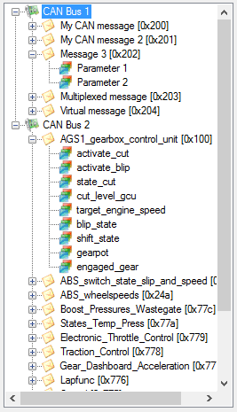

In multiple CAN buses mode, each bus is represented in the configuration tree view by the bus controller icon . Then CAN messages of a bus become child nodes (or branches) of the CAN bus.

Multiple Buses CAN configuration file has a specific extension (*.mcb). Use standard 'Save CAN configuration' button  to save your multiple buses configuration, CANStream will automatically switch to the '*.mcb' extension.

When you are using the 'Open CAN configuration' command  , the file opening dialog has two file extension filters: '*.xcc' for single bus configuration and '*.mcb' for multiple buses configuration. Just switch to the '*.mcb' extension to open a multiple buses configuration and load it into the CAN configuration edition form.

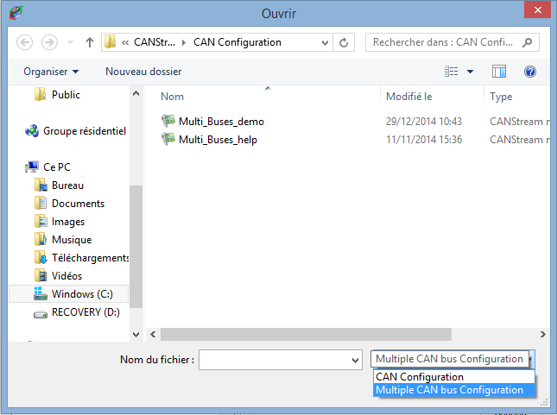

*Created with the Personal Edition of HelpNDoc:* [*Free EPub and documentation generator*](http://www.helpndoc.com)

**CAN Bus information**

While working with multiple buses CAN configuration, a third tab 'Bus controller' appears in the edition form in addition of 'Message' and 'Parameter' tabs.

Click on a CAN bus node  of the CAN configuration tree view to edit its properties.

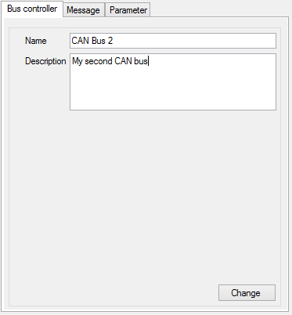

In addition of standard CAN bus properties, in that tab, you can add few information about the current bus.

* + Name: To give a sensible name to your bus.
  + Description: You can write a short description of the bus in order to ease usage of multiple buses configuration.

Then, click the 'Change' button to apply your changes.

*Created with the Personal Edition of HelpNDoc:* [*Free Kindle producer*](http://www.helpndoc.com/feature-tour/create-ebooks-for-amazon-kindle)

**Configuration import & export**

While creating a multiple buses CAN configuration, using the 'CAN Configuration\Import' command , CANStream offers the possibility to use an existing single bus CAN configuration (*.xcc) for the current CAN bus.

Simply right click on the CAN bus node  of the tree view that you want to set, select the 'CAN Configuration' item  and then the 'Import' command . A file opening dialog will pop up in which you can choose the CAN configuration file to import.

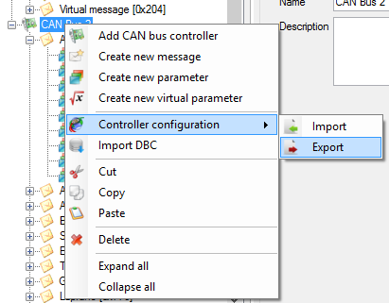

On the other way around, the 'Export' command  permits to export the CAN configuration of a particular bus in order to reuse it as a single CAN bus configuration.

*Created with the Personal Edition of HelpNDoc:* [*Easily create Help documents*](http://www.helpndoc.com/feature-tour)

**Spy & Manual mode**

The ‘Spy & Manual' mode is intended to be used to spy the content of frames (or messages) circulating on the bus.

Using this mode, it also possible to send messages containing values set by the user.

Both reception and transmission handle ‘Engineering' and ‘Raw' formats of data. ‘Engineering' means that user can read and write actual physical values of CAN signals while the ‘Raw' format means raw byte values of the CAN messages.

The ‘Spy & Manual' mode is controlled through the tool bar of the ‘Spy & Manual' panel.

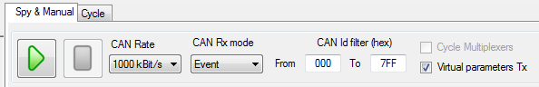

This tool bar contains the following elements.

 Start button: Start data transmission and reception.

 Stop button: Stop data transmission and reception.

 CAN rate selection: Allows definition of the CAN communication speed.

 Rx mode selection: Allows selection of the message reception mode (event, manual, periodic).

 Rx IDs filter: Allows the definition of the range of CAN message IDs that have to be considered in the reception panel.

 Virtual parameters transmission enabled flag: Enable and disable the transmission of virtual CAN signals.

 Multiplexer auto-cycling flag: If the CAN configuration in use contains some multiplexed message, CANStream will automatically cycle the multiplexer value for data transmission.

*Created with the Personal Edition of HelpNDoc:* [*Full-featured Help generator*](http://www.helpndoc.com/feature-tour)

**Data Reception**

The ‘Start' button  of the tool bar will be enabled only if an operational PCAN-USB device has been selected.

Click that button to start the data reception. While the manual mode is operating, ‘Start' button  is disabled. Click the ‘Stop' button  to stop the manual mode operation and consequently the data reception.

Those commands control both transmission and reception parts of the ‘Spy & Manual' mode.

*Created with the Personal Edition of HelpNDoc:* [*Easily create HTML Help documents*](http://www.helpndoc.com/feature-tour)

**Raw format data Reception**

Received frames raw values (before decoding) are shown into the ‘Raw data received’ grid.

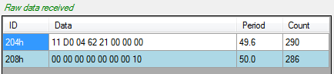

*Created with the Personal Edition of HelpNDoc:* [*Produce electronic books easily*](http://www.helpndoc.com/create-epub-ebooks)

**Engineering format data Reception**

In order to decode data received over the CAN bus, a CAN configuration file has to be loaded. Then when CAN frames are received they are decoded and signals are shown in the ‘Engineering data received' grid.

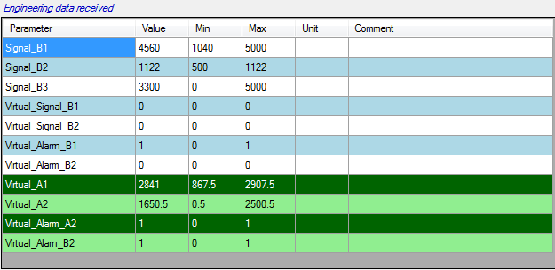

*Created with the Personal Edition of HelpNDoc:* [*Easily create CHM Help documents*](http://www.helpndoc.com/feature-tour)

**Virtual data Reception**

If one or more virtual channels libraries are loaded and data received are containing signal used in those virtual channels, virtual channels are automatically computed and their values are shown into the grid with green background color.



*Created with the Personal Edition of HelpNDoc:* [*iPhone web sites made easy*](http://www.helpndoc.com/feature-tour/iphone-website-generation)

**Received data graphic**

When CAN frames received contains data that can be decoded using the loaded CAN configuration, values of CAN signals received can be traced in real time into a graphic.

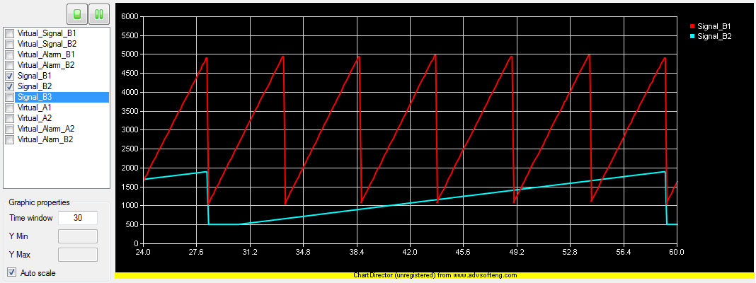

The graphic shows CAN parameters values as a function of the time. By default, the graphic is empty, simply select data to trace by checking channels in the channels list.

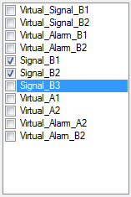

Using the small tool bar on the top of the channel list, it is possible to stop or freeze the graphic.



Button  stops the real time graphic plotting. Once clicked this button becomes ‘Start plot’ button  Those two commands actually reset the graphic window so all data plotted will be lost after a ‘Stop/Start’ commands.

Button  freezes the real time graphic plotting. Once clicked this button becomes ‘Resume’ button  Unlike the ‘Stop’ button, ‘Freeze’ command doesn’t reset the graphic. On graphic resuming, graph will appear as if it never stopped before.

Graphic time window and Y axis scale can be changed through the ‘Graphic properties’ panel.

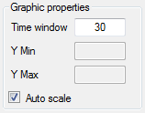

Field ‘Time window’ define the time span between the beginning and the end of graphic.

If check box ‘Auto scale’ is ticked, all values of all plotted signal are shown in the graphic. Uncheck that box to define the scale of the Y axis. After having typed a value into the ‘Y min’ or ‘Y max’ fields; press ‘Enter’ to update the graphic.

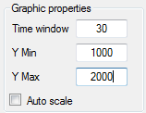

*Created with the Personal Edition of HelpNDoc:* [*Easily create Web Help sites*](http://www.helpndoc.com/feature-tour)

**Data Transmission**

The ‘Start' button  of the tool bar will be enabled only if an operational PCAN-USB device has been selected.

Click that button to start the data transmission. While the manual mode is operating, ‘Start' button  is disabled. Click the ‘Stop' button  to stop the manual mode operation and consequently the data transmission.

Those commands control both transmission and reception parts of the ‘Spy & Manual' mode.

Transmission panel of ‘Spy & Manual' control is divided in two parts: ‘Engineering' on the top and ‘Raw' data transmission at the bottom.

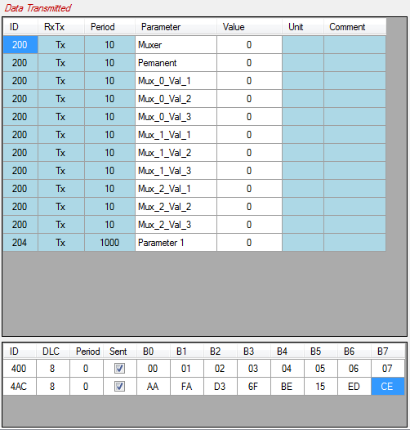

*Created with the Personal Edition of HelpNDoc:* [*Easily create Web Help sites*](http://www.helpndoc.com/feature-tour)

**Raw format data Transmission**

To send ‘Raw' CAN messages over the bus, you first need to define those messages. Click the ‘CAN Configuration\ Raw messages Tx' menu to get the raw messages management functions.

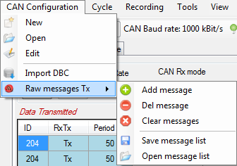

Alternatively, right click in the raw message grid to open the creation menu.

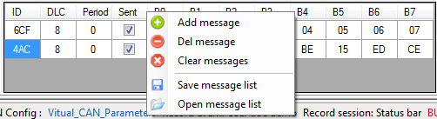

This contextual menu contains a bunch of commands to manage the raw message list.

 Add message: Add a message in the list.

 Del message: Remove a message from the list.

 Clear messages: Remove all messages of the list.

 Save: Save the message list in a file.

 Open: Open a message list file.

Once messages have been loaded or created it is possible to set their properties in the different cells of the grid.

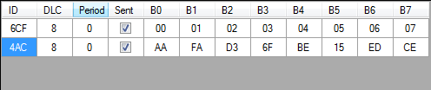

* + ID: Message identifier.
  + DLC: Message byte length.
  + Period: Message transmission period in millisecond.
  + Sent: Define whether or not the message is sent.
  + B0… B7: Message bytes value.

If the property ‘Period' is set to zero, message is not sent over.

*Created with the Personal Edition of HelpNDoc:* [*Single source CHM, PDF, DOC and HTML Help creation*](http://www.helpndoc.com/help-authoring-tool)

**Engineering format data Transmission**

In order to send engineering data over the CAN bus a CAN configuration file has to be loaded. Once loaded, this CAN configuration is displayed in the ‘Engineering data transmission' grid.

Simply change the content of the ‘Value' cell to send a new value.

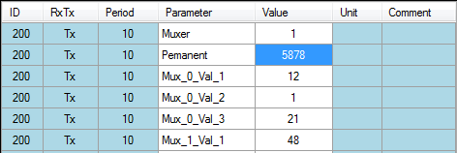

*Created with the Personal Edition of HelpNDoc:* [*Single source CHM, PDF, DOC and HTML Help creation*](http://www.helpndoc.com/help-authoring-tool)

**Virtual data Transmission**

Virtual CAN signal appear with a green color into the grid.

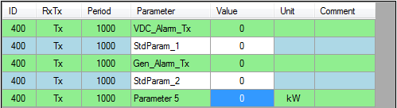

Since the value of a virtual CAN signal is calculated, its value cannot be set by the user.

Virtual CAN signal transmission can be turned on and off at any time, checking or unchecking the box .

*Created with the Personal Edition of HelpNDoc:* [*Easily create iPhone documentation*](http://www.helpndoc.com/feature-tour/iphone-website-generation)

**Cycle mode**

The ‘Cycle’ mode of CANStream sends a pre-defined sequence of message. This mode allows simulation of real usage conditions in which values have a very high dynamic that couldn’t be replicated by a human.

The ‘Cycle’ mode is controlled through the tool bar of the ‘Cycle’ panel.

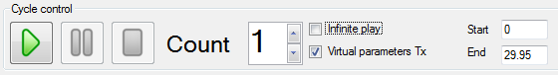

This tool bar contains the following elements.

 Start button: Starts cycle play.

 Pause button: Makes a pause in the cycle.

 Stop button: Stop cycle play.

 Cycle loops: Number of cycle repetition.

 Infinite repetition: If that box is checked, cycle is in definitively repeated until the ‘Stop’ button is clicked.

 Virtual CAN signal sent: If that box is checked, virtual CAN signal values are sent along cycle data.

 Cycle starting point: Defines the cycle play starting time for partial cycle playing.

 Cycle ending point: Defines the cycle play ending time for partial cycle playing.

*Created with the Personal Edition of HelpNDoc:* [*Easy CHM and documentation editor*](http://www.helpndoc.com)

**Cycle playing**

Open a cycle using the ‘Cycle\Open’ command of the menu strip.

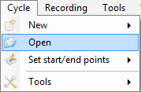

Once loaded, cycle data are showed into the cycle graphic.

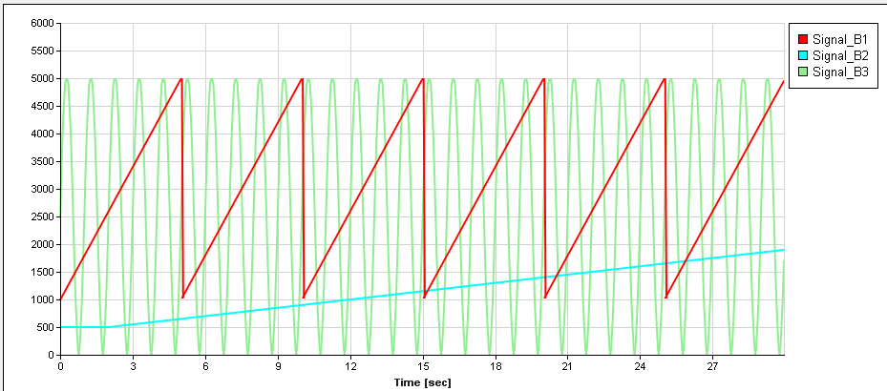

Prior to start the cycle; set the number of cycle repetitions in the ‘Count’ field. Then, click the ‘Play’ button  to start the cycle.

The cycle can be stopped at any time using the ‘stop’ button  or just held at the current position clicking the ‘Pause’  button.

During the cycle playing, a cursor appears in the graphic showing the current position within the cycle.

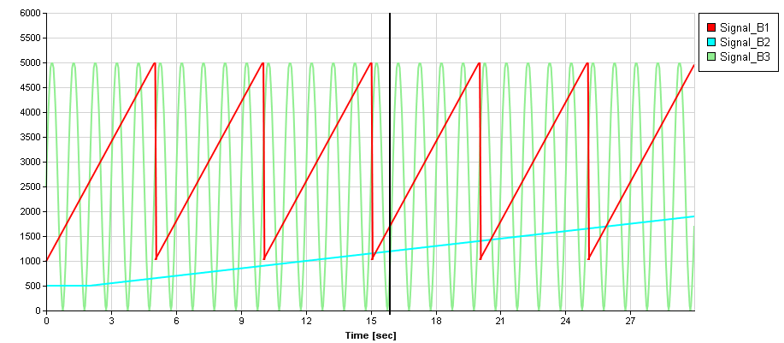

In addition of this cursor, some more information shows up in the cycle control panel while the cycle is played.

Current repetition number (starting at one)



Cycle progression bars.



Those progress bars show the progression of the cycle.

* + Current cycle: Progression of the current cycle
  + Total: Progression of the whole sequence considering the number of repetitions. For instance, if repetition is set to two, the ‘Total’ bar will be filled up two times slower than the ‘Current cycle’ bar.

By default, all cycle data are plotted into the graphic. To hide one or more signal, right click in the graphic and uncheck signals that you don’t want to see.

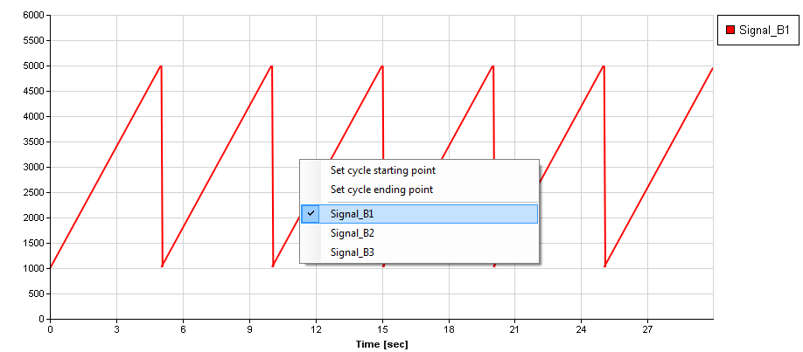

*Created with the Personal Edition of HelpNDoc:* [*Easily create PDF Help documents*](http://www.helpndoc.com/feature-tour)

**Cycle Reception data panel**

During cycle playing, data received are shown and decoded in the ‘Received data’ panel. As per the manual mode, this panel is split in two parts: raw data and engineering data.

In the panel ‘Raw data received’ received CAN frames and values of their bytes are shown. While the ‘Engineering data received’ shows decoded signal values of received frames.

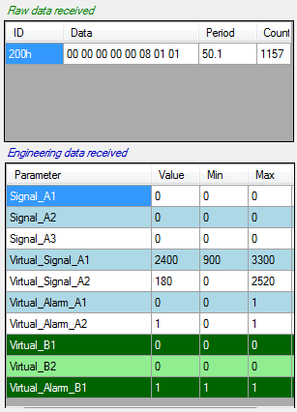

As per the manual mode, columns and rows of those two grids can be customized using their contextual menus or the ‘View’ menu of the main menu strip.

*Created with the Personal Edition of HelpNDoc:* [*Free CHM Help documentation generator*](http://www.helpndoc.com)

**Cycle starting and ending points setting**

By default, a cycle is played from the beginning to the last sample value. This is not mandatory since user can define the part of the cycle that will be played. Then cycle will no longer be played from the beginning to the end but from the starting and/or ending points defined by the user.

Even better, user doesn’t necessarily need to define both starting and ending points. If only the starting point is defined, then cycle will be played from this point to the end. Alternatively, if only the ending point is set, cycle will be played from the beginning to this ending point.

There are two methods to define cycle starting and ending points.

The numeric method: simply change the value of ‘Start’ and ‘End’ fields. Value of those fields must be time in second.



If values set are different than actual cycle beginning and ending points cursors appear in the graphic showing current cycle starting and ending points.

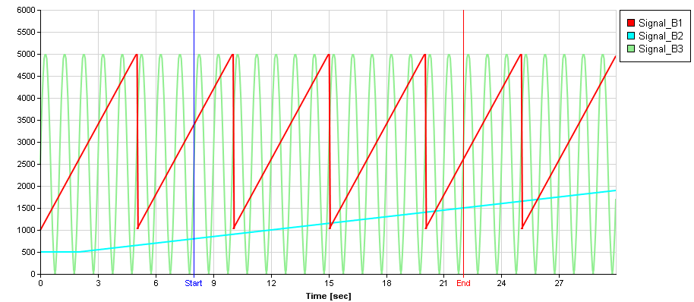

The second method consists in positioning those cursors directly into the graphic.

To do so, right click in the graphic and click ‘Set cycle starting point’ to set the starting point or ‘Set cycle ending point’ for the ending point.

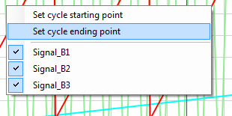

Then place the cursor at the position you want the cycle to start or end by clicking this position into the graphic.

Once that position defined, right click again into the graphic to get the contextual menu and click ‘Confirm cycle start/end points settings’ to confirm starting or ending position.

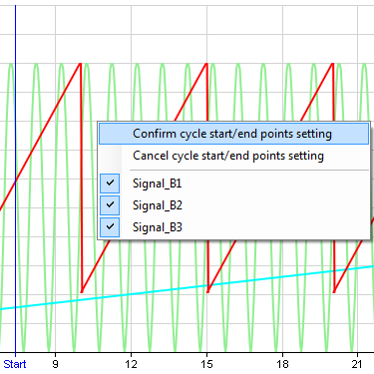

If you click ‘Cancel cycle start/end points settings’, the cursor goes back to the previous position defined if any. Otherwise it simply disappears and starting or ending are either the beginning or the end of the cycle.

*Created with the Personal Edition of HelpNDoc:* [*Easily create Help documents*](http://www.helpndoc.com/feature-tour)

**Cycle loop number setting**

A cycle can be played multiple times. To define the number of cycle repetitions, simply change the value ‘Count’ prior to launch the cycle.



Alternatively, a cycle can be played in definitively by checking the box ‘Infinite play’ . In that case, cycle will be played and repeated until the ‘Stop’ button  is clicked.

*Created with the Personal Edition of HelpNDoc:* [*Free help authoring tool*](http://www.helpndoc.com/help-authoring-tool)

**Virtual CAN signals in cycle**

As per manual mode, virtual channels can be computed based on values received on the CAN bus while a cycle is played. This can be particularly useful if virtual channels are alarms sent to a device to stop unit operation or ignore commands.

When a virtual channel is computed, it appears in the ‘Engineering data received’ with green background.

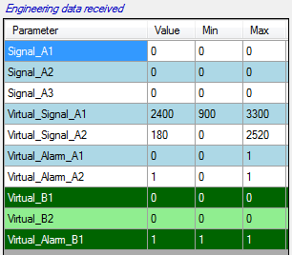

*Created with the Personal Edition of HelpNDoc:* [*Free EBook and documentation generator*](http://www.helpndoc.com)

**Cycle creation**

Prior to be loaded and played, a cycle has to be somehow created…

CANStream proposes three methods to create cycle files:

* + Easy cycle creation: With this method the cycle is created based on a data file. This mode has very few options, that’s why it is called ‘easy’.
  + Advanced cycle creation: Unlike the ‘easy’ mode, the ‘advanced’ mode has extended options in order to tweak the cycle.
  + Record replay: This is actually the easiest cycle creation mode! Cycle is built using a record which is converted into a cycle file.

*Created with the Personal Edition of HelpNDoc:* [*Free iPhone documentation generator*](http://www.helpndoc.com/feature-tour/iphone-website-generation)

**Easy cycle creation**

The ‘Easy cycle creation’ method creates a cycle based on a data file. This mode has very few options, that’s why it is called ‘easy’.

Click the ‘Cycle\New\Easy cycle creation’ menu of the main menu strip to access the ‘Easy cycle creation’ mode.

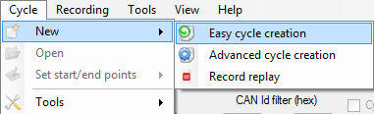

The ‘Easy cycle creation’ form shows up.

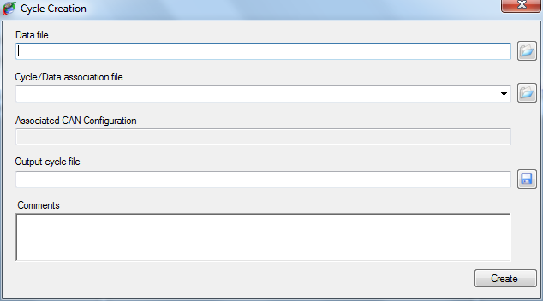

To create a cycle using this method, simply follow steps described below:

* + Select a cycle source data file by clicking the ‘Open’  button on the right of the ‘Data file’ field.

Several formats of data are supported for cycle creation. Change the extension by changing the extension filter of the open file dialog.

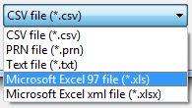

* + Select a ‘Cycle/Data association’ file by clicking the ‘Open’  button on the right of ‘Cycle/Data association file’ filed. If your association file is located in the ‘Cycle Data Association’ folder of the ‘CANStream’ folder of ‘My documents’, it will present in the list. So you can drop down the list and pick up the association file that you want to use.

Once the association file selected, the CAN configuration for which the association has been made for is displayed (for information) in the ‘Associated CAN configuration’ text box. This text box cannot be modified, so select another association file (or make a new one) if you don’t want use the CAN configuration showed.

* + Set the name and path of the output cycle file clicking the ‘Save’  button.
  + Optionally write a description of your cycle in the ‘Comments’ area.
  + Then click the ‘Create’ button  to launch the cycle creation.

Depending of the type of the source file (Excel or ASCII) and its size, it may take several minutes to create the cycle. This is particularly long with large Excel files since the Excel automation interface for .NET application is a kind of slow…

However, during the creation a progress bar appears indicating progression of the cycle creation process. At the end of the cycle creation, a message box pops up to let the user know that creation process has ended.

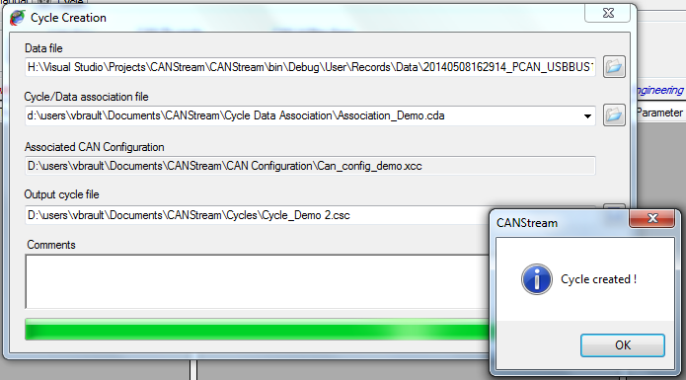

*Created with the Personal Edition of HelpNDoc:* [*Easy EBook and documentation generator*](http://www.helpndoc.com)

Cycle data association

A ‘Cycle data association’ file is a file containing association between CAN parameters and data source channels.

For example, let’s say that you have a CAN configuration containing a CAN parameter called ‘Speed’ and that you want create a cycle using this configuration. You have a source data file to create your cycle but in this data file, the ‘Speed’ channel is called ‘Velocity’.

A ‘Cycle data association’ file will fix that issue since it allow to associate CAN parameters with a data channel. So in our case we will simply states that the CAN parameter ‘Speed’ is using values of the data channel ‘Velocity’ as source of data.

To open the ‘Cycle data association’ edition form, click the ‘Cycle\Tools\New Cycle\Data association’ menu.

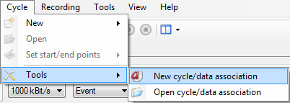

The ‘Cycle data association’ edition form appears.

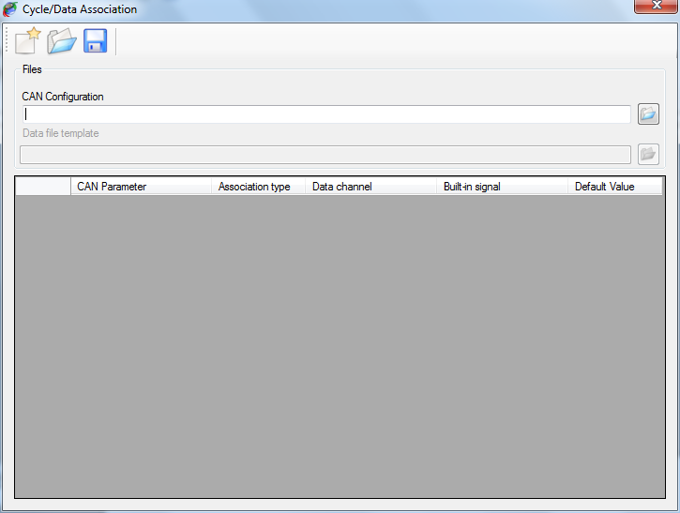

This form contains a tool bar on the top to access the ‘Cycle data association’ file management commands (new, open, save).

A control panel in which CAN configuration and data file are intended to be specified.

A grid, containing actual CAN parameter/data channel associations.

Click the ‘Open’  button on the right of the ‘CAN configuration’ field.

Then select the data file that you want to use as template to set associations by clicking the ‘Open’  button on the right of the ‘Data file template’ field.

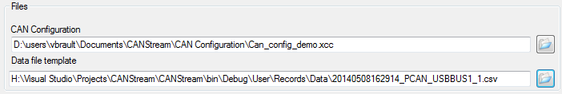

As mentioned by its label, that file is a template. So it doesn’t mean that association works only with this particular data file. It means association will work with any data file having the same structure as the template.

This is important here to underline that by ‘structure’ we consider both data channel name and data channel location. If channel ‘Velocity’ is placed on the third column of the data file, association will work with all data file having a channel ‘Velocity’ on the third column. If ‘Velocity’ moves to the fifth column for some reasons, association won’t any longer work and association file will have to be modified accordingly.

Another important point is that CANStream consider data of the first column as time vector. If time isn’t on the first column it may results to unpredictable cycle.

Once the CAN configuration loaded the association grid is filled, each row of the grid being a CAN parameter of the CAN configuration.

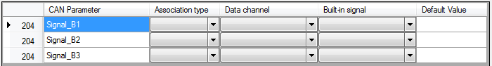

The association grid has six columns:

* + Message ID: Identifier of the message containing the CAN parameter (for information only).
  + CAN Parameter: Name of the CAN parameter in the CAN configuration.
  + Association type: Type of the association.
  + Data channel: Name of the data channel associated to the CAN parameter.
  + Built-in signal: Name of the built-in signal associated to the CAN parameter.
  + Default value: Fix value associated to the CAN parameter.

*Created with the Personal Edition of HelpNDoc:* [*Produce electronic books easily*](http://www.helpndoc.com/create-epub-ebooks)

Association type

Main purpose of an association file is to associate CAN parameters with data channel. Actually, a CAN parameter can be associated with something else than a data channel.

There are four types of association:

* + None: CAN parameter isn’t associated, its value will zero in the cycle
  + AcqData: CAN parameter is associated to a data channel. CAN parameter values in the cycle will be values of the data channel.
  + Built-in signal: CAN parameter is associated to a built-in signal. CAN parameter values in the cycle will be values of the built-in signal
  + Fixed value: CAN parameter is associated to a fix value. CAN parameter values in the cycle will be the value defined all the time.

Click on ‘Association type’ cell of a CAN parameter and pick up the association that you want to use.

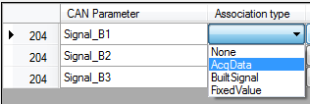

Once the association type defined, select the data channel or built-in signal in the corresponding cell.

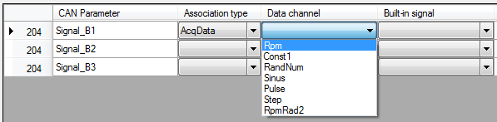

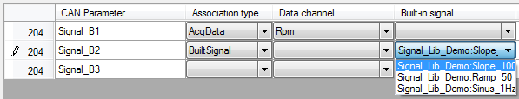

For a ‘Fixed value’ association simply type a value into the ‘Default value’ cell.

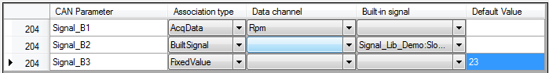

Several CAN parameters can be associated with the same data channel or built-in signal.

Once all associations are set click the ‘Save’  button of the tool bar to save the association file.

*Created with the Personal Edition of HelpNDoc:* [*Full-featured EBook editor*](http://www.helpndoc.com/create-epub-ebooks)

**Advanced cycle creation**

The ‘Advanced cycle creation’ method has extended options for cycle creation allowing tweaking the cycle in order to fit with particular needs.

With the ‘Advanced cycle creation’ method, cycle creation configuration can be saved into a cycle creation configuration file (*.x3c) in order to have configuration re-useable. Such file contains all information needed to create the cycle (CAN configuration, built-in signals, virtual channels) so it can be easily distributed to others without having to give a whole bunch of files.

The biggest advantage of using the ‘Advanced cycle creation’ is that it can use virtual channels as source of data for the cycle. Thus, since virtual channels can be computed using multiple built-in signals, variables and functions, it allows the generation of complex profiles for the cycle.

Click the ‘Cycle\New\Advanced cycle creation’ menu of the main menu strip to access the ‘Advanced cycle creation’ mode.

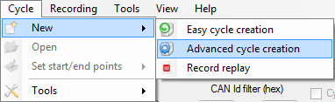

If there is no CAN configuration currently loaded, a message box pops up proposing to load one.

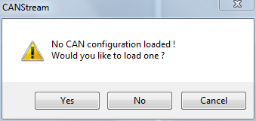

If you answer ‘Yes’ a ‘File open’ dialog will show up in which you can select the CAN configuration that has to be used to create the cycle.

If you answer ‘No’, the ‘Advanced cycle creation’ form will open but you still will have to open a CAN configuration file in order to create a cycle.

If you answer ‘Cancel’, it cancels the cycle creation and returns to the main form of CANStream.

Well, let’s say that we have answered ‘No’ to this question… Form appears as below.

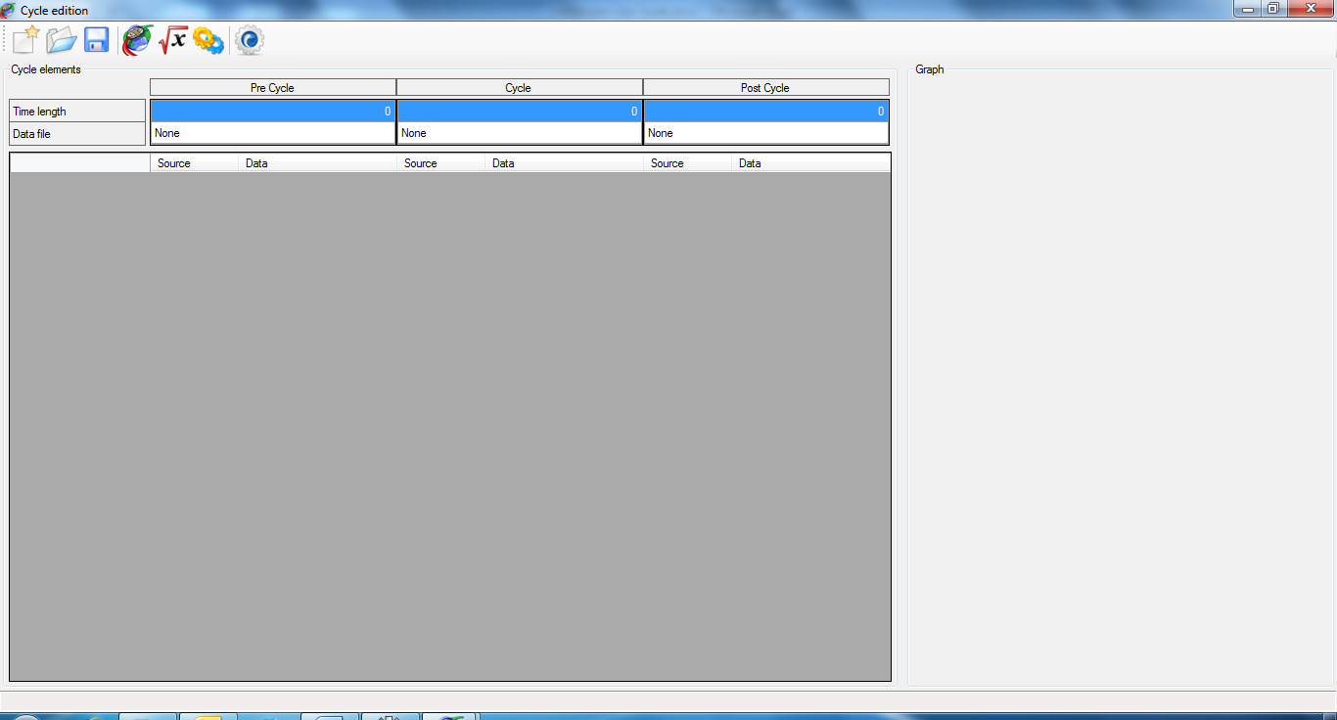

In the ‘Advanced cycle creation’ environment, a cycle is split in three parts: ‘Pre-cycle’, ‘In cycle’ and ‘Post-cycle’.

Those parts can be considered as sub-cycles, final whole cycle being the concatenation of the three parts. If we consider the ‘In cycle’ part as the actual cycle, the ‘Pre-cycle’ part is the sequence played before the cycle like an introduction. The ‘Post-cycle’ part is therefore the sequence played after the cycle like a conclusion.

‘Pre’ and ‘Post’ cycle concept is very useful when the system to test has to be gently started and stopped.

For instance, something looking like the profile bellow.

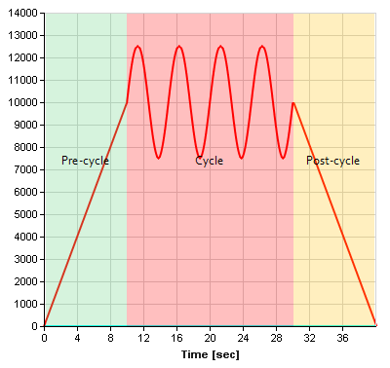

*Created with the Personal Edition of HelpNDoc:* [*Easily create EBooks*](http://www.helpndoc.com/feature-tour)

Advanced cycle creation tool bar

The tool bar at the top of the form contains some commands:

 New: Create a new cycle creation configuration file

 Open: Open a cycle creation configuration file

 Save: Save the current cycle creation configuration file

 Load CAN Configuration: Load a CAN configuration file

 Virtual channel: Reload the current virtual channels library collection (in case of virtual channel modification during the cycle edition).

 Built-in Signals: Reload the current built-in signals library collection (in case of built-in signals modification during the cycle edition).

 Build cycle: Starts the cycle creation process.

*Created with the Personal Edition of HelpNDoc:* [*Easily create Web Help sites*](http://www.helpndoc.com/feature-tour)

Cycle parts setting

The grid on the top regroups cycle parts properties.

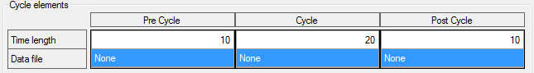

There is one column for each cycle part.

Row ‘Time length’ specifies the time length (in second) of each part, final cycle time length being the sum of cycle parts length. So in the example above, final cycle will be 40 seconds (10 + 20 + 10 = 40).

Row ‘Data file’ contains the file used as data source for each cycle part. All cycle parts can use the same or different files.

To set a data file for a cycle part, click in the ‘Data file’ cell of the part to make the ‘Open file’ button visible.

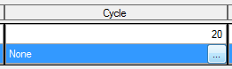

Click this button to open the open file dialog and select a file. Once the data file selected, its name is shown in the cell.

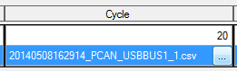

If the time length of the data file exceeds the time length of the cycle part, CANStream will propose you to change the cycle part length in order to match the length of the data file but this is not mandatory.

If the time length of a part exceeds the data file time length, the last sample value of the data file is used until the end of the cycle part.

*Created with the Personal Edition of HelpNDoc:* [*Produce Kindle eBooks easily*](http://www.helpndoc.com/feature-tour/create-ebooks-for-amazon-kindle)

Cycle definition

If there was not CAN configuration loaded at the form start up, click the ‘Load CAN Configuration’ button  of the tool bar to load one.

Once loaded, all CAN parameters contained in CAN messages set with ‘Transmission’ (Tx) flag will be display in the grid.

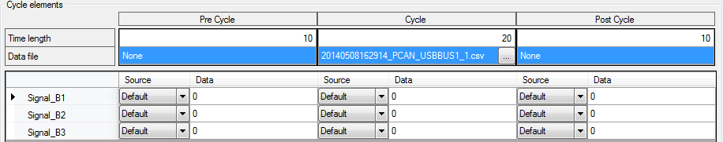

Each row of the grid represents a CAN parameter and has three groups of two columns.

Those three groups are respectively, ‘Pre-cycle’, ‘Cycle’ and ‘Post-cycle’ parts of the cycle.

The two columns of each group are configuration of the CAN parameter for a given cycle part.

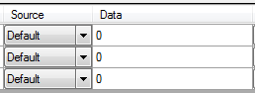

Column ‘Source’ defines the data source for the CAN parameter. Click the ‘Source’ cell to drop the source list down and pick up the desired source.

There are six possible sources:

* + None: CAN parameter value is set to zero.
  + Default: CAN parameter value is set with the default value which is zero.
  + Constant: CAN parameter value is set with the constant value set in the ‘Data’ cell.
  + BuiltSignal: CAN parameter value is set with value of the built-in signal defined in the ‘Data’ cell.
  + VirtualChannel: CAN parameter value is set with value of the virtual channel defined in the ‘Data’ cell.
  + AcqData: CAN parameter value is set with value of the acquisition data channel defined in the ‘Data’ cell.

If the ‘Source’ property is set to ‘BuiltSignal’ or ‘VirtualChannel’, click the ‘Data’ cell to get the list of items available.

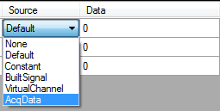

Available item list takes a form of a tree where libraries are roots of the tree and items (virtual channels or built-in signals are branches. Just double-click an item to select it as data source of the CAN parameter.

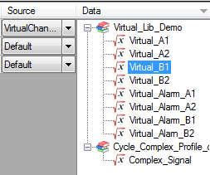

If the ‘Source’ property is set to ‘AcqData’, click the ‘Data’ cell to get the list of data channels available. Simply double-click a channel to select it as data source of the CAN parameter.

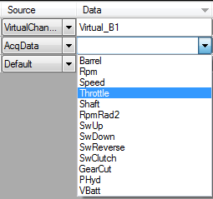

You don’t need here to select a source for each CAN parameter and for all cycle parts. If a cycle part length is null, it won’t generated so it can be ignored while selecting data sources of CAN parameters.

Once all CAN parameter of your interest are set, click the ‘Build cycle’ button  to launch the cycle creation.

At the first cycle building, a ‘file save’ dialog pops up. Set the name and path of the output cycle file. The cycle can be built several times but the ‘file save’ dialog will show up only once.

During cycle building, the ‘Abort’ button  will appear. Click this button at any time while CANStream is building the cycle to cancel the process.

At the end of the cycle creation process, a message box will pop up indicating that cycle has been successfully created.

In addition, a graphic preview of the cycle will be drawn on right side of the form.

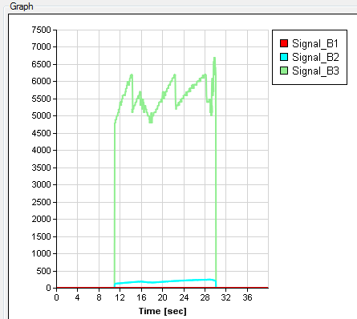

As per the cycle player graph, right click in the graph to select traces that you want to see in the graphic.

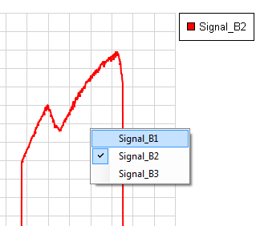

*Created with the Personal Edition of HelpNDoc:* [*Free Web Help generator*](http://www.helpndoc.com)

**Record replay**

The ‘Record replay’ cycle creation method simply transform one or more PCAN Trace files (*.trc) into a cycle file. This method is particularly useful to quickly replicate a behavior that has been previously recorded.

With this method you don’t need to associate anything, frames contained in the PCAN Trace file are simply reformatted to fit with the CANStream cycle file format.

Click the ‘Cycle\New\Record replay’ menu of the main menu strip to access the ‘Record replay creation’ mode.

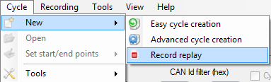

The ‘Record replay’ form shows up.

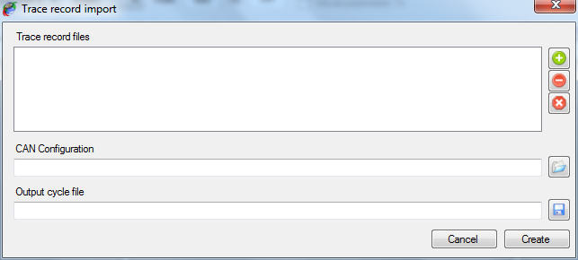

*Created with the Personal Edition of HelpNDoc:* [*Free help authoring environment*](http://www.helpndoc.com/help-authoring-tool)

Record replay configuration

To create a cycle using this method, simply follow steps described below:

* + Add one or more PCAN Trace file into the ‘Trace record file’. Basically all trace files are concatenated to each other in the order they appear in the list in order to make the final cycle.

Trace files list control commands are located on the left of the list. There are three commands:

 Add: Add a PCAN Trace file into the list.

 Del: Remove a PCAN Trace file from the list.

 Clear: Clear all PCAN Trace file from the list.

* + Select a CAN configuration file by clicking the ‘Open’ button  on the right of the ‘CAN Configuration’ field. This CAN configuration is only use to get the CAN bus speed (1000 kBit/s, 500 kBit/s) nothing else.
  + Define name and file path of the output cycle by clicking the ‘Save’ button  on the right of the ‘Output cycle file’ field.
  + Click the ‘Create’ button  to launch the cycle creation.

During the cycle creation process two progress bars appears.

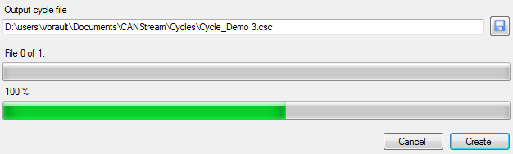

The first bar, on the top, indicates the process progression among PCAN Trace file to convert. The second bar, at the bottom, indicates the progression of the conversion for the current file.

At the end of the cycle creation, when all PCAN Trace file have been converted, a message box pops up indicating that process has ended.

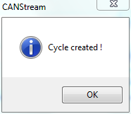

At any time in the process it is possible to cancel the cycle creation by clicking the ‘Cancel’ button .

*Created with the Personal Edition of HelpNDoc:* [*Produce Kindle eBooks easily*](http://www.helpndoc.com/feature-tour/create-ebooks-for-amazon-kindle)

**CAN controller appearance options**

The appearance of a CAN controller can be customized in order to best fit with user needs.

*Created with the Personal Edition of HelpNDoc:* [*Generate EPub eBooks with ease*](http://www.helpndoc.com/create-epub-ebooks)

**Control layout**

The ‘View’  command of the tool bar contains functions to customize the appearance of the current CAN controller.

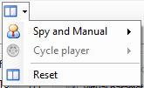

Whether the active panel is ‘Spy and Manual’  or ‘Cycle’  the corresponding commands group is enabled. ‘Reset’  button restores all default layout options for both ‘Spy and Manual’ and ‘Cycle’ panels.

*Created with the Personal Edition of HelpNDoc:* [*Produce electronic books easily*](http://www.helpndoc.com/create-epub-ebooks)

**Manual control layout**

Click ‘Spy and Manual’  to get layout commands of this mode.

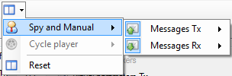

The menu is divided in two parts:

 Messages Tx: for the transmission part of the manual control.

 Messages Rx: for the reception part of the manual control.

The ‘Message Tx’  menu is divided in two parts:

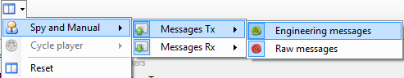

 Engineering messages: Showing or hiding the ‘Engineering’ section of the data transmission panel.

 Raw messages: Showing or hiding the ‘Raw’ data section of the data transmission panel.

The ‘Message Rx’  menu is also divided in two parts:

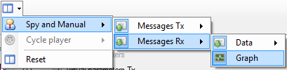

 Data: Showing or hiding the ‘Data’ section of the data reception panel.

 Graph: Showing or hiding the ‘Graphic trace’ section of the data reception panel.

Finally, ‘Data’  menu is split in two parts as well:

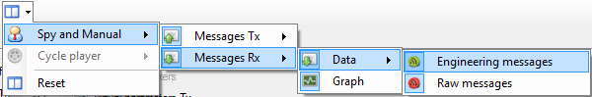

 Engineering messages: Showing or hiding the ‘Engineering’ section of the data reception panel.

 Raw messages: Showing or hiding the ‘Raw' data section of the data reception panel.

*Created with the Personal Edition of HelpNDoc:* [*Easily create Web Help sites*](http://www.helpndoc.com/feature-tour)

**Cycle control layout**

Click ‘Cycle player’  menu to get layout commands of this mode.

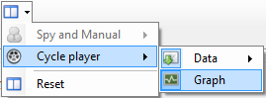

The ‘Cycle player menu is divided in two parts:

 Data: Showing or hiding the ‘Data’ section of the cycle panel.

 Graph: Showing or hiding the ‘Graphic trace’ section cycle.

Then, ‘Data’ sub-menu is split in two parts

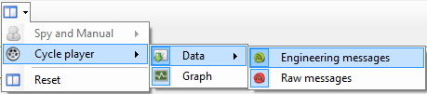

 Engineering messages: Showing or hiding the ‘Engineering’ section of the data reception panel.

 Raw messages: Showing or hiding the ‘Raw data section of the data reception panel.

*Created with the Personal Edition of HelpNDoc:* [*Free PDF documentation generator*](http://www.helpndoc.com)

**Grids contents control**

The contents of all grids (columns and rows) of a CAN controller can be individually customized.

To customize the content of a grid, right click on it to get its contextual menu.

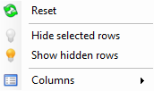

Grid customization commands are also available through the ‘View’ menu of the main menu strip.



*Created with the Personal Edition of HelpNDoc:* [*Produce electronic books easily*](http://www.helpndoc.com/create-epub-ebooks)

**Grid rows**

Each row of a grid can be hidden. Select rows that you want hide and click ‘Hide selected rows’ . Then click on ‘Show hidden rows’  to make hidden rows visible.

*Created with the Personal Edition of HelpNDoc:* [*Easily create HTML Help documents*](http://www.helpndoc.com/feature-tour)

**Grid columns**

The width of the different columns of a grid cannot be changed but it is possible to selected columns that have to be shown and columns that have to be hidden.

Menu ‘Columns’  of the contextual menu of a grid contains columns title for the grid owning the contextual menu. Simply check or uncheck column titles to make columns visible or invisible.

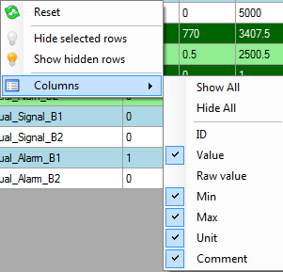

Commands ‘Show all’ and ‘Hide all’ show and hide all columns at once. Then every single column can be individually set checking or unchecking its title.

The ‘Table columns’  menu of the ‘View’ menu contains columns control commands of all grid of a CAN controller.

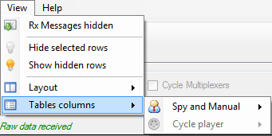

Whether the active panel is ‘Spy and Manual’  or ‘Cycle’  the corresponding commands group is enabled.

*Created with the Personal Edition of HelpNDoc:* [*Free iPhone documentation generator*](http://www.helpndoc.com/feature-tour/iphone-website-generation)

Manual control grid columns

Click ‘Spy and Manual’ to get the grid columns commands of this mode.

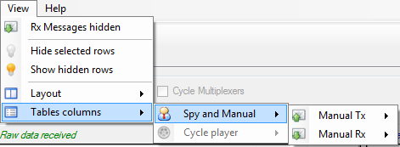

The menu is divided in two parts:

 Messages Tx: for the transmission part of the manual control.

 Messages Rx: for the reception part of the manual control.

The ‘Manual Tx’  contains columns control commands of the engineering data transmission grid.

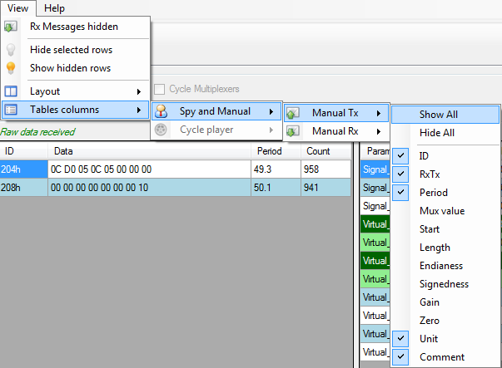

Columns of the raw data transmission grid cannot be customized since all columns are needed.

The ‘Manual Rx’  menu is divided in two parts:

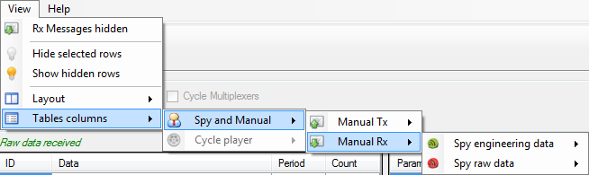

 Engineering messages: containing columns control commands of the engineering data reception grid.

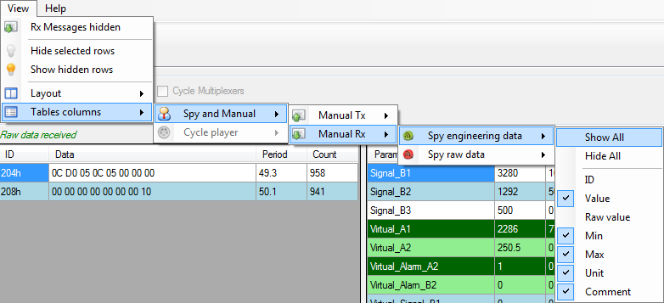

 Raw messages: containing columns control commands of the raw data reception grid.

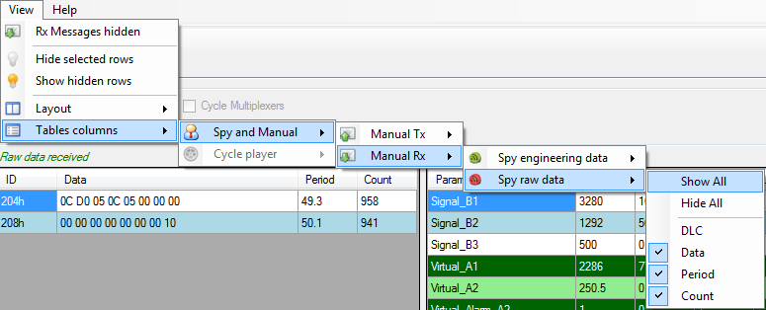

*Created with the Personal Edition of HelpNDoc:* [*Free CHM Help documentation generator*](http://www.helpndoc.com)

Cycle player grid columns

Click ‘Cycle player’  to get the grid columns commands of this mode.

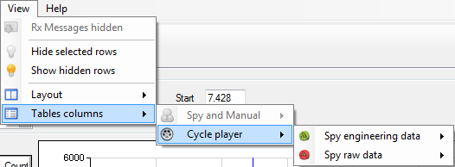

The ‘Cycle player’ menu is divided in two parts:

 Engineering messages: containing columns control commands of the engineering data reception grid for the cycle panel.

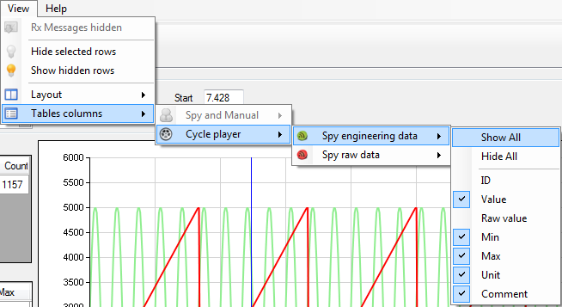

 Raw messages: containing columns control commands of the raw data reception grid for the cycle panel.

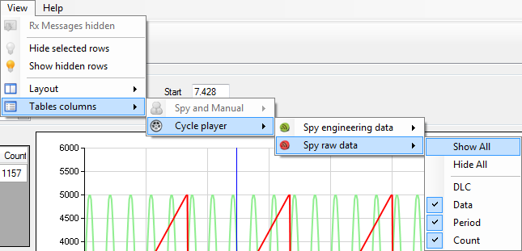

*Created with the Personal Edition of HelpNDoc:* [*Easily create Help documents*](http://www.helpndoc.com/feature-tour)

**Data logging**

While manual or cycle player modes are running it is possible to record all CAN frames circulating on the CAN bus. For the time that data logger is turned on, the content of all frames as well as their time stamps will be recorded and stored into a file.

Such logging files are actually very difficult to read for a human. Indeed, it is a very large file containing hexadecimal values. Fortunately CANStream offers the ability to decode those files and convert it to a readable format. On the top of that, CANStream can also show logging data in a graphic window to make easy and accurate the record analysis.

Data recording doesn’t require any special configuration; just turn it on and off when you need. However, logging file naming convention being a kind of meaningless, it may be very difficult to identify which particular logging file among twenty or thirty files (or even more) is corresponding to a particular test. To assist the user in this task, CANStream has also some functions to enhance logging files storage.

*Created with the Personal Edition of HelpNDoc:* [*Full-featured EPub generator*](http://www.helpndoc.com/create-epub-ebooks)

**Data logging start & stop**

Data logger can be turned on when a PCAN-USB device is connected and used by CANStream. When this is the case, the ‘Start stream logging’ button  of the tool bar becomes active.



Just click this button to start logging the data. When data logging starts, the ‘Start stream logging’ button is disabled and the ‘Stop steam logging’ button  is active. Simply click this button to stop the data logging.



You don’t necessarily need to start the ‘Spy & Manual’ or the ‘Cycle’ mode to record data. If CAN frames are circulating in the bus they will be recorded whether or not CANStream is operating.

Start and stop logging commands are also available in the ‘Recording’ menu of the main menu strip.



*Created with the Personal Edition of HelpNDoc:* [*Easily create EBooks*](http://www.helpndoc.com/feature-tour)

**Automatic recording**

If you don’t want manually start and stop the logger each time you are testing, you can turn on the ‘Automatic recording’ feature.

To enable this function, click the ‘Automatic recording’ item in the ‘Recording’ menu of the main menu strip.

When active, the ‘Automatic recording’ is automatically turning the logger on and off when you start and stop CANStream ‘Spy & Manual’ or ‘Cycle’ mode. Thus your entire work session can be recorded without the need to care about the logger itself.

While automatic recording is active the thunderbolt icon of its menu item is highlighted.



*Created with the Personal Edition of HelpNDoc:* [*Easily create PDF Help documents*](http://www.helpndoc.com/feature-tour)

**Data file formats**

Data logging function of CANStream is dealing with two different file extensions: ‘*.trc’  and ‘*.csv’ .

 ‘*.trc’ files are raw data file generated by the Peak PCAN-USB driver. Those files contain CAN frames in hexadecimal format and their timestamps.

 ‘*.csv’ files are decoded and converted logging file generated by CANStream. Those files are intended to be used by the user either in the data analysis window of CANStream or in an external application such as Microsoft Excel or equivalent.

*Created with the Personal Edition of HelpNDoc:* [*Produce electronic books easily*](http://www.helpndoc.com/create-epub-ebooks)

**Peak PCAN trace file**

Example of a Peak PCAN trace file (*.trc) 

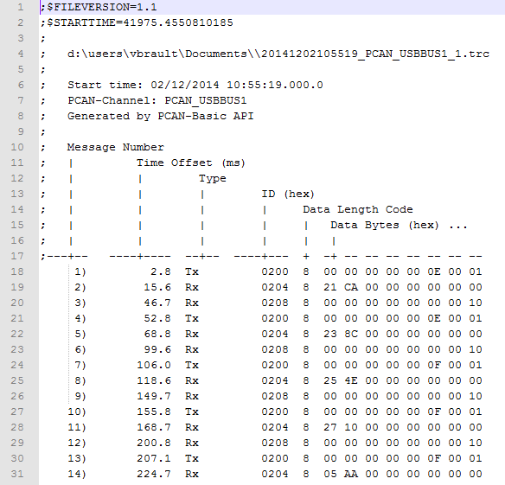

*Created with the Personal Edition of HelpNDoc:* [*Full-featured EBook editor*](http://www.helpndoc.com/create-epub-ebooks)

**Record data file**

Example of a CANStream record data file (*.csv) .

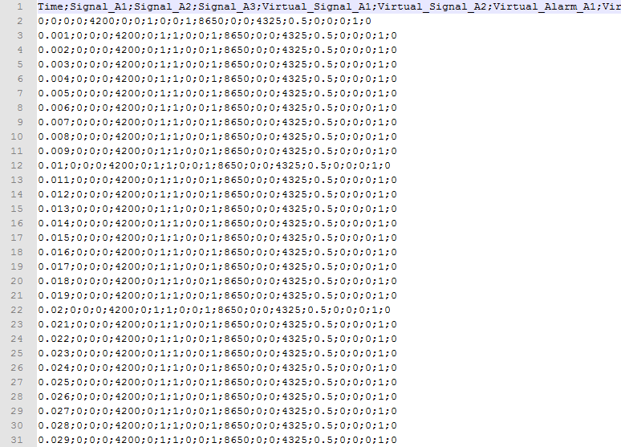

*Created with the Personal Edition of HelpNDoc:* [*Easy to use tool to create HTML Help files and Help web sites*](http://www.helpndoc.com/help-authoring-tool)

**Logging file conversion**

Logging files conversion from the Peak ‘PCAN trace’ format (*.trc)  to the CANStream ‘Record data file’ (*.csv)  is made using a CAN configuration file in order to identify CAN messages and get CAN signals values out of raw byte values of recorded frames.

Very basically, CANStream identifies CAN messages thanks to their identifiers and decodes frame byte values using CAN parameter properties set into the CAN configuration file.

There are two methods to convert data logging file; the manual conversion and the automatic conversion. With manual conversion, user has to manually launch the conversion process while in automatic mode, logging files are automatically converted as soon as the data logger stops and the logging file is closed.

*Created with the Personal Edition of HelpNDoc:* [*Single source CHM, PDF, DOC and HTML Help creation*](http://www.helpndoc.com/help-authoring-tool)

**Manual conversion**

The ‘Record conversion’  sub-menu of the ‘Recording’ menu of the main menu strip contains all data file conversion commands.

As far as the manual conversion, two options are available. It is possible to either convert all logging files at once or to manually select in a list files that have to be converted.

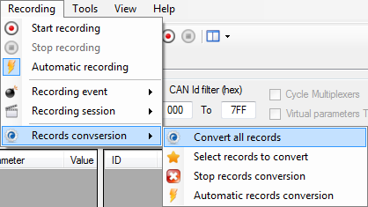

Click the ‘Convert all records’ menu to convert all data files by a single click.

To make your own selection of files to convert, click the ‘Select record to convert’  menu.

The file selection form shows up.

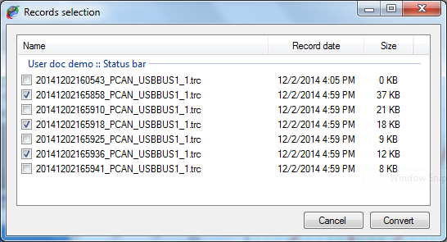

Check the box of all files that you want to convert and then click the ‘Convert’ button once you are ready to launch the conversion process.

*Created with the Personal Edition of HelpNDoc:* [*Free HTML Help documentation generator*](http://www.helpndoc.com)

**Automatic conversion**

As per the automatic recording, automatic conversion only needs to be activated.

Click the ‘Automatic record conversion’ item in the ‘Recording conversion’  menu of the main menu strip.

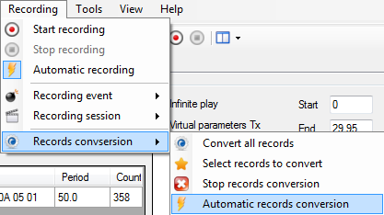

When active, the ‘Automatic conversion’ is automatically launching the file conversion process when the data logger stops and the logging file is closed. Coupled with the automatic recording, the automatic conversion allows you to have your entire work session recorded and converted without the need to care about neither the logger nor conversion.

While automatic conversion is active, the thunderbolt icon of the menu item is highlighted.



*Created with the Personal Edition of HelpNDoc:* [*Easy EBook and documentation generator*](http://www.helpndoc.com)

**Conversion process control**

A progress bar appears in the main form status bar during the conversion process.



This bar shows the progression of the complete conversion process. When the bar is full all logging files have been converted.

You can stop the conversion at any time during the process by click the ‘Stop conversion’ button  of the status bar.

*Created with the Personal Edition of HelpNDoc:* [*iPhone web sites made easy*](http://www.helpndoc.com/feature-tour/iphone-website-generation)

**Data file storage structure**

The data file storage structure is described in great details in the next section. However, basic structure is the following.

All data files (*.trc and *.csv) are stored in the ‘Records’ folder in ‘CANStream’ folder of the user ‘Documents’ directory (…\users\xxx\Documents\CANStream\Records)

The ‘Records’ folder contains three sub-folders: ‘Data’, ‘Raw’ and ‘Stack’.

* + Data folder: contains converted record data files (*.csv) .
  + Raw folder: contains PCAN Trace data files (*.trc)  that have been converted already.
  + Stack folder: contains PCAN Trace data files (*.trc)  that are waiting to be converted.

You may find also a couple of XML files in those three folders. Check the next section for more details about those XML files.

*Created with the Personal Edition of HelpNDoc:* [*Produce electronic books easily*](http://www.helpndoc.com/create-epub-ebooks)

**Recording event & Recording session**

Until you have only three, four or five data files it is fairly easy to remember and identify what those file are. Imagine now that you have fifty of those data files! It becomes a kind of tricky to figure out what file is the file corresponding to the test you are looking for, especially if you are looking for an old record.

To assist you with file archiving and make data files research a way easier, CANStream uses the ‘Event\Session’ structure for data storage.

With such structure, data files are not stored in a unique folder. A folder is created for each event and sub-folders are created for every session. Then data files are placed into their respective session folder.

Term ‘event’ should be considered as a major group. Let’s say ‘CANStream documentation’. Inside this event we have multiple ‘sessions’ each of them corresponding to a specific topic. Let’s say that we have three sessions ‘Manual mode’, ‘Cycle mode’ and ‘Virtual channel’.

Thanks to this structure, we know that all data of the ‘CANStream documentation’ folder are data that have been generated for the documentation. Then, session folders indicate for what exact part of the documentation, data files have been recorded.

On the top of that, for every session of every event, CANStream creates an XML file containing information about the session or event. An event/session XML file contains the name of the event or session, its date and description and optionally a bunch of user information. This list of user information can be anything the final user has found useful to identify and track data files. In our example (CANStream documentation) we can set the CANStream release name and the name of the CAN configuration that have been used. Number and content of user information is actually unlimited so you can have how many you want and write whatever you want.

Name of both current recording event and current session is shown in the main form status bar.



*Created with the Personal Edition of HelpNDoc:* [*Easy EPub and documentation editor*](http://www.helpndoc.com)

**Recording event creation & edition**

Record event control commands are available in the ‘Record event’ item  of the ‘Record’ menu of the main menu strip.

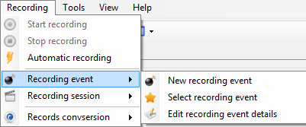

Click the ‘New recording event’ menu  to create a new recording event or click the ‘Edit recording event details’ menu  to edit the current recording event.

The recording event edition form shows up.

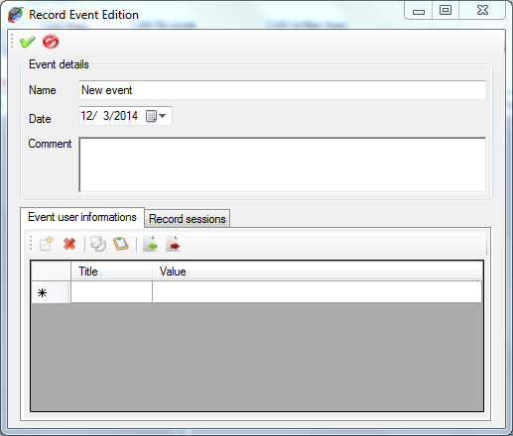

Tool bar on the top contains only two commands

 Apply: Create the record event or apply changes to the current record event

 Cancel: Cancel the record event creation or change made to the current record event

When creating a new record event, this event becomes the current record event. So all records performed afterward will stored under this new event.

Frame ‘Event details’ contains main information about the recording event.

* + Name: Name of the recording event
  + Date: Starting date of the recording event
  + Comment: Recording event description.

Panel at the bottom of the form has two tabs.

* + Event user information: Management of user information attached to the record event. Check the ‘User information’ section for more details
  + Record sessions: Management of the record sessions of the current event

The ‘Record sessions’ panel contains session control commands for the current record event. When creating a new record event, a session ‘New session’ is created by default.

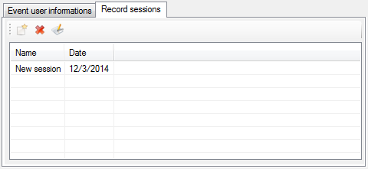

All sessions of the record event are listed in the record session list. Tool bar on the top of the list contains session control commands.

 New: Create a new session inside the current record event.

 Delete: Delete a session of the current record event.

 Edit: Edit details of the selected session. Check ‘Recording session creation & edition’ for more details.

When deleting a record session, session is only removed from the list. Data that may have been recorded under the session to delete are not deleted.

*Created with the Personal Edition of HelpNDoc:* [*iPhone web sites made easy*](http://www.helpndoc.com/feature-tour/iphone-website-generation)

**Recording event selection**

At any time, you can switch to a different recording event. If the recording event that you want switch to has already been created, it is possible to pick it up in a list.

Click the ‘Select recording event’ menu  to switch to another recording event.

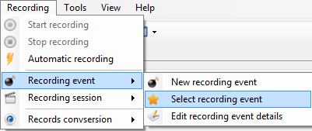

The available record events list pops up.

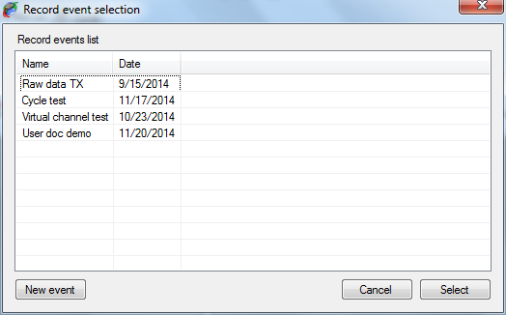

Just double click the record event you want to use or click the ‘Select’ button after having selected it into the list.

Alternatively, you can also create a new record event by clicking the ‘New event’ button.

*Created with the Personal Edition of HelpNDoc:* [*Single source CHM, PDF, DOC and HTML Help creation*](http://www.helpndoc.com/help-authoring-tool)

**Recording session creation & edition**

Record session control commands are available in the ‘Record session’  item of the ‘Record’ menu of the main menu strip.

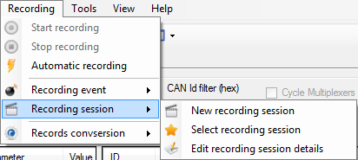

Click the ‘New recording session’ menu  to create a new recording session or click the ‘Edit recording session details’ menu  to edit the current recording event.

The recording session edition form shows up.

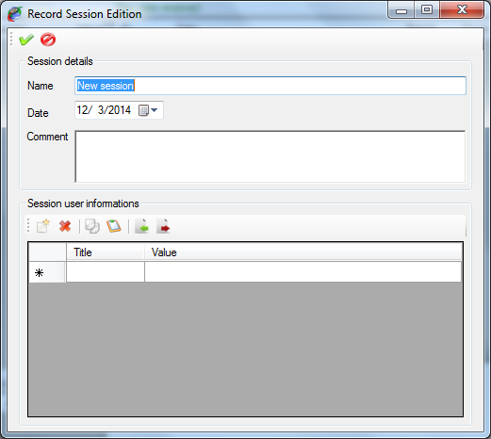

Tool bar on the top contains only two commands.

 Apply: Create the record session or apply changes to the current record session.

 Cancel: Cancel the record session creation or change made to the current record session.

When creating a new record session, this session becomes the current record session. So all records performed afterward will stored under this new session.

Frame ‘Session details’ contains main information about the recording session

* + Name: Name of the recording event.
  + Date: Starting date of the recording event.
  + Comment: Recording event description.

Panel ‘Session user information’ contains control commands for user information attached to the record session. Check the ‘User information’ section for more details.

*Created with the Personal Edition of HelpNDoc:* [*Free CHM Help documentation generator*](http://www.helpndoc.com)

**Recording session selection**

At any time, you can switch to a different recording session. It is possible to pick up in a list the recording session that you want switch to if this session has already been created.

Click the ‘Select recording session’ menu  to switch to another recording event.

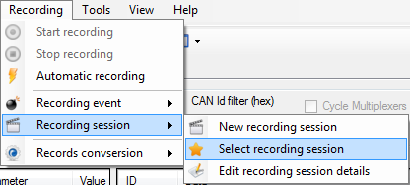

The available record session list pops up.

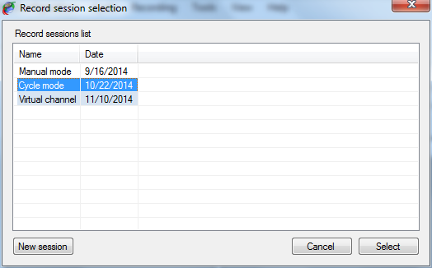

Just double click the record session you want to use or click the ‘Select’ button after having selected it into the list.

Alternatively, you can also create a new record session by clicking the ‘New session button.

*Created with the Personal Edition of HelpNDoc:* [*Easily create HTML Help documents*](http://www.helpndoc.com/feature-tour)

**User information**

User information for record event or record session is an optional collection of information defined by the user and which are attached to an event or to a session.

Number and content of this information is unlimited so you can have as many as you want of user information and they can contain whatever you want attached to an event or to a session. User information is not mandatory; it is possible to have event or session without any user information.

User information control panel is common for both recording event and recording session objects.

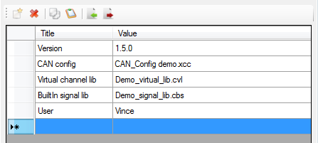

User information control panel is composed of a grid containing all user information, and a tool bar in which user info control commands are accessible.

User information is made of two fields:

* + Title: The title of the user information.
  + Value: Value of the user information.

To be considered as valid (and consequently to be stored) a user information must have a least a title. Value can remain empty but all grid rows having their ‘Title’ cell empty will be ignored.

To create a new ‘user information’, simply write its title in the empty row at the bottom of the list. Then write its value in the ‘Value’ cell.

The tool bar contains the following commands:

 Add: Create a new user information.

 Del: Remove a user information from the list.

 Copy: Copy a user information on the clipboard.

 Past: Past a user information from the clipboard.

 Import: Import a user information collection file.

 Export: Export the current collection of user information into a file.

In order to avoid the need of having to recreate all the time your collection of user information, it is possible to export a collection into a file and re-use this file whenever you need it. The same user information can be used either for a record event or a record session without any restriction.

*Created with the Personal Edition of HelpNDoc:* [*Produce Kindle eBooks easily*](http://www.helpndoc.com/feature-tour/create-ebooks-for-amazon-kindle)

**Data analysis**

In addition of logging and decoding data CANStream offers the possibility to analyze those data into a graphic window. The data viewer of CANStream allows loading multiple data files at once even if they are not part of the same record event or session. Data files are concatenated in order to create a data set that appear as a continuous record in the data viewer.

The menu ‘Tools’ of the main menu strip gives access to this data analysis window.

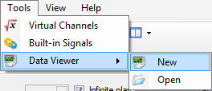

Item ‘Data Viewer’ of the ‘Tools’ menu contains two sub-menu: ‘New’  and ‘Open’ .

Click the ‘New’  menu to open an empty data analysis window and click the ‘Open’  menu to open an existing data analysis window.

*Created with the Personal Edition of HelpNDoc:* [*Free Kindle producer*](http://www.helpndoc.com/feature-tour/create-ebooks-for-amazon-kindle)

**Analysis window**

When creating a new analysis window, the window comes empty.

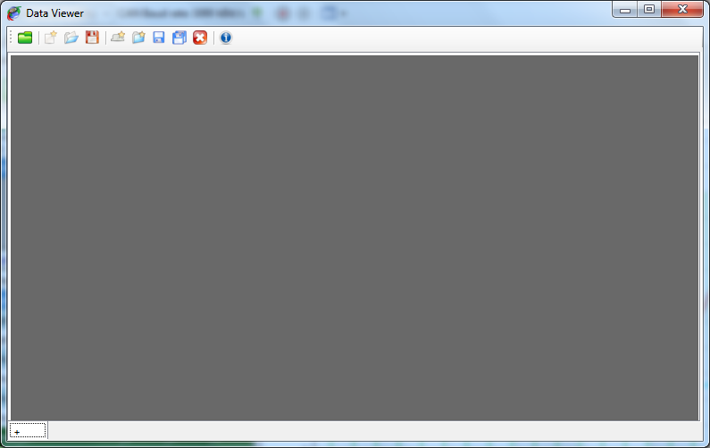

The data viewer window is composed of two elements.

* + The tool bar on the top, containing all data viewer control commands.
  + The multi-tab panel containing all pages of the data viewer.

Since the data viewer window can have multiple pages it can be considered as book. Each page of this book is a graphic window with a different graphic configuration.

Data to be displayed are loaded through the data browser. Check the ‘Data browser’ section for more details. However the set of data loaded is unique over the entire book. It means that all pages are actually showing the same set of data. It is consequently impossible to see the data file ‘A’ in the first page and the data file ‘B’ in the second page.

This behavior might sound as a weakness or a missing functionality, but actually this is not a weakness. Experienced users know that while working with multiple pages it is possible to get lost and not remember what exact data set is loaded on each page. So to make things easy all pages are showing the same data set.

*Created with the Personal Edition of HelpNDoc:* [*Free EBook and documentation generator*](http://www.helpndoc.com)

**Data viewer page creation**

Click the ‘+’ tab  at the bottom or click the ‘New data viewer page’ button  of the tool bar to create a new page in the data viewer.

The new data viewer page is created.

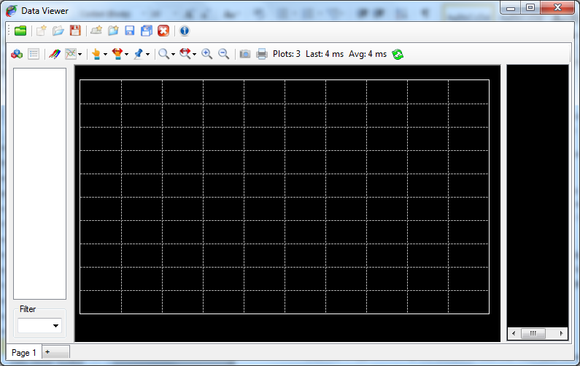

A data viewer book can contain as many pages as you wish. Each single page appears as a tab of the multi-tab panel.



Right click on a page tab to get the viewer page contextual menu.

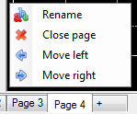

This contextual menu has four commands.

 Rename: Rename the active page of the data viewer.

 Close: Close the active page of the data viewer.

 Move left: Move the active page one step on the left.

 Move right: Move the active page one step on the right.

Click the ‘Rename’ menu  to rename a page. A text box pops up.



Write the new name for the page in this text box.



Then press the ‘Enter’ key.



Data viewer pages can be individually saved and loaded through commands available in the tool bar. The entire data viewer book can be saved as well.

An entire section of the documentation is dedicated to the usage and configuration of the graphic window. Please check this section for more details.

*Created with the Personal Edition of HelpNDoc:* [*Free EPub producer*](http://www.helpndoc.com/create-epub-ebooks)

**Data viewer Toolbar**

Tool bar of the ‘Data viewer’ window contains the following commands

 Data browser: Open the data browser window.

 New: Create new data viewer book.

 Open: Open a data viewer book.

 Save: Save the current data viewer book (all pages).

 New page: Create a new data viewer page.

 Open page: Open an existing data viewer page (only one).

 Save page: Save the current data viewer page.

 Save all pages: Save all pages of the data viewer book.

 Close page: Remove the current page from the data viewer book.

 Info: Shows event and session details of the loaded data set.

*Created with the Personal Edition of HelpNDoc:* [*Free EPub and documentation generator*](http://www.helpndoc.com)

**Data set information**

When data are displayed into the data viewer it is possible to see their record event and record session information. Click the ‘Show event/session information’ button  of the tool bar to get the information window.

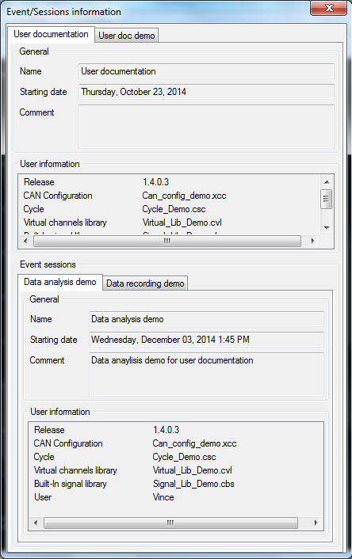

Event and session information cannot be changed from this window. They are only displayed for information purpose.

Information window contains only a multi-tab panel.

Each tab of the panel corresponds to one the record event of a data file of the current data set.



The ‘General’ section of the panel shows general information about the recording event.

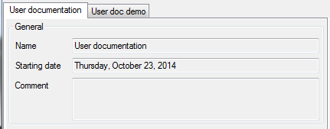

The ‘User information’ section shows all user information attached to the record event.

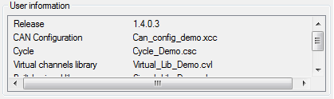

Section ‘Record sessions’ shows details of each record session being part of the current data set.

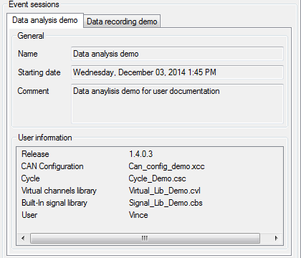

Each record session has its own tab in the ‘Event session’ section multi-tab panel.



As per record event, ‘General’ section of a record session tab shows general information about the record session.

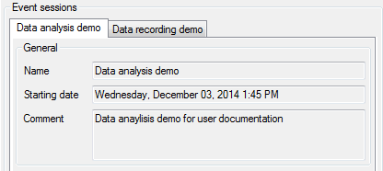

The ‘User information’ section shows all user information attached to the record session.

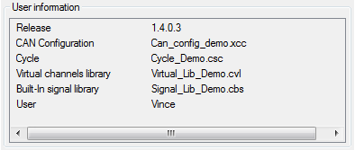

*Created with the Personal Edition of HelpNDoc:* [*Free CHM Help documentation generator*](http://www.helpndoc.com)

**Data browser**

The CANStream data browser in a data file explorer. Data that have to be displayed in the data viewer has to be loaded from this explorer.

Click the ‘Data browser’  button of the data viewer tool bar to open the data browser.

The data browser shows up.

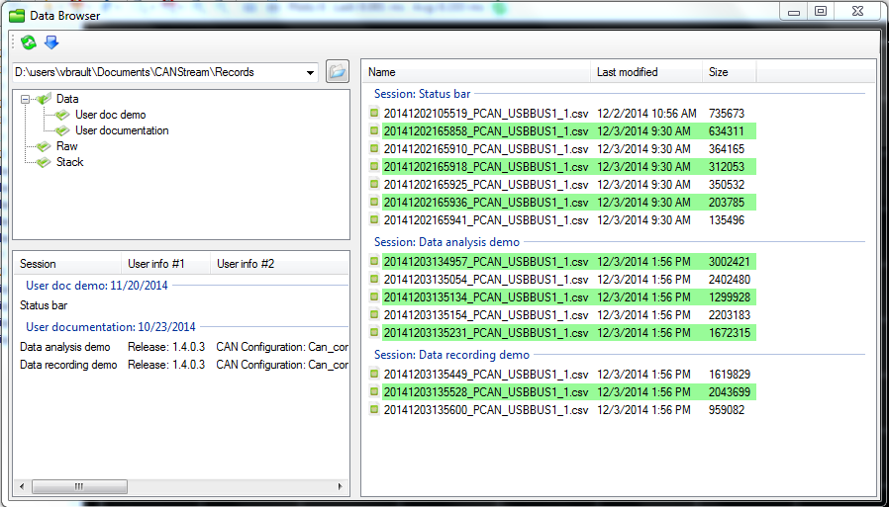

The data browser is made of four parts:

* + The tool bar: Toolbar contains only two commands, ‘Refresh’ and ‘Load’
  + The root folder tree: It shows the folder arborescence from current root folder
  + The event list: It shows all record events contained in the selected folder
  + The data file list: It shows all data files grouped by record session present in the selected folder and all its sub-folders.

*Created with the Personal Edition of HelpNDoc:* [*Full-featured Help generator*](http://www.helpndoc.com/feature-tour)

**Root folder tree**

The root folder tree shows the folder arborescence from the current root folder.

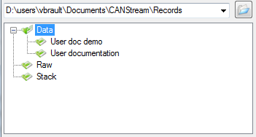

Click the ‘Open’  button to change the root folder. Root folder text box is actually a list that can be dropped in order to get the history of all root folder previously used and quickly switch among those root folders.

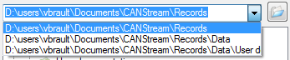

The last ten folders used as root folder are saved in this list.

Click a folder to explore its subfolders and all their child folders.

*Created with the Personal Edition of HelpNDoc:* [*Free EPub producer*](http://www.helpndoc.com/create-epub-ebooks)

**Events & sessions list**

The events and sessions list is located at the bottom of the root folder tree.

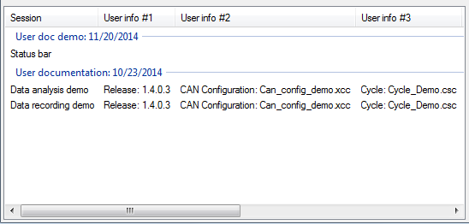

Each group of the list represents a record event.



Items of each group are a record session.

Select a session item in order to apply a filter to the logging data list and show only data file part of the selected record session.

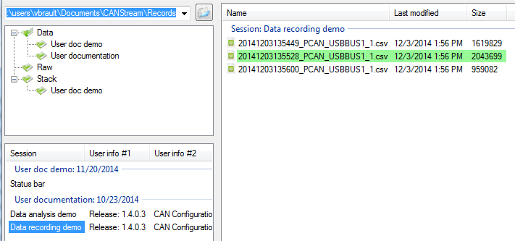

To get information about a particular record event of the list, right click one of its sessions.



Click the ‘Event details’  menu to get the information window.

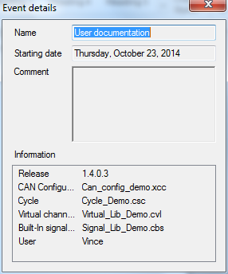

*Created with the Personal Edition of HelpNDoc:* [*Easily create EBooks*](http://www.helpndoc.com/feature-tour)

**Logging data list**

The logging data list contains actual data files that can be loaded into the data viewer window.

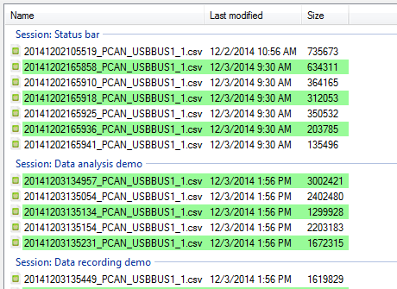

Each group of the list represents a record session.



Select all files that you want to load and press the ‘Enter’ key or click the ‘Load selected files’ button  of the tool bar.

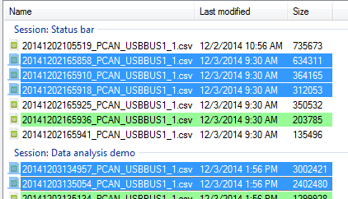

The data browser shows the two logging data formats. ‘*.csv’ files  for converted data file and ‘*.trc’ files  for raw PCAN-Trace data file.

‘*.csv’ files  only can be loaded in the data viewer. Files with such extension appear with a green background.

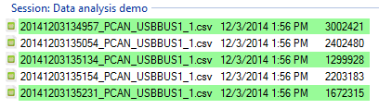

‘*.trc’ files  appear with a red background but they cannot be loaded directly into the data viewer. You need to convert those file (if it has not been done already) prior to see those data.

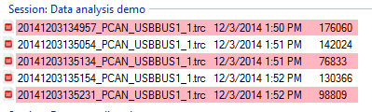

To get information about a particular record session of the list, right click one of its data files.

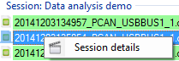

Click the ‘Session details’  menu to get the information window.

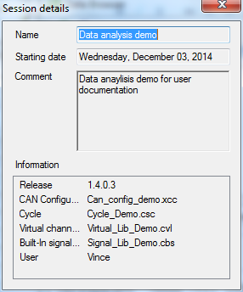

*Created with the Personal Edition of HelpNDoc:* [*Free Web Help generator*](http://www.helpndoc.com)

**Data browser tool bar**

The data browser tool bar contains only two commands.

.

 Refresh: Refresh the folder tree, event and session list as well as the data file list.

 Load: Load data files selected into the data viewer.

*Created with the Personal Edition of HelpNDoc:* [*Free help authoring tool*](http://www.helpndoc.com/help-authoring-tool)

**Graphic window**

The graphical data analysis window shows recorded data in a graphical form.

In addition of simply showing graphical data trace, the analysis window offers extensive tools such as zoom, cursors and statistics computation.

On the top of that, the graphical configuration of the analysis window is fully configurable run time. Through its intuitive configuration forms, it is possible for instance, to change the window back color or change the color of a data trace or even change its tracing mode just by simple clicks and without having to reload the data or reset the form.

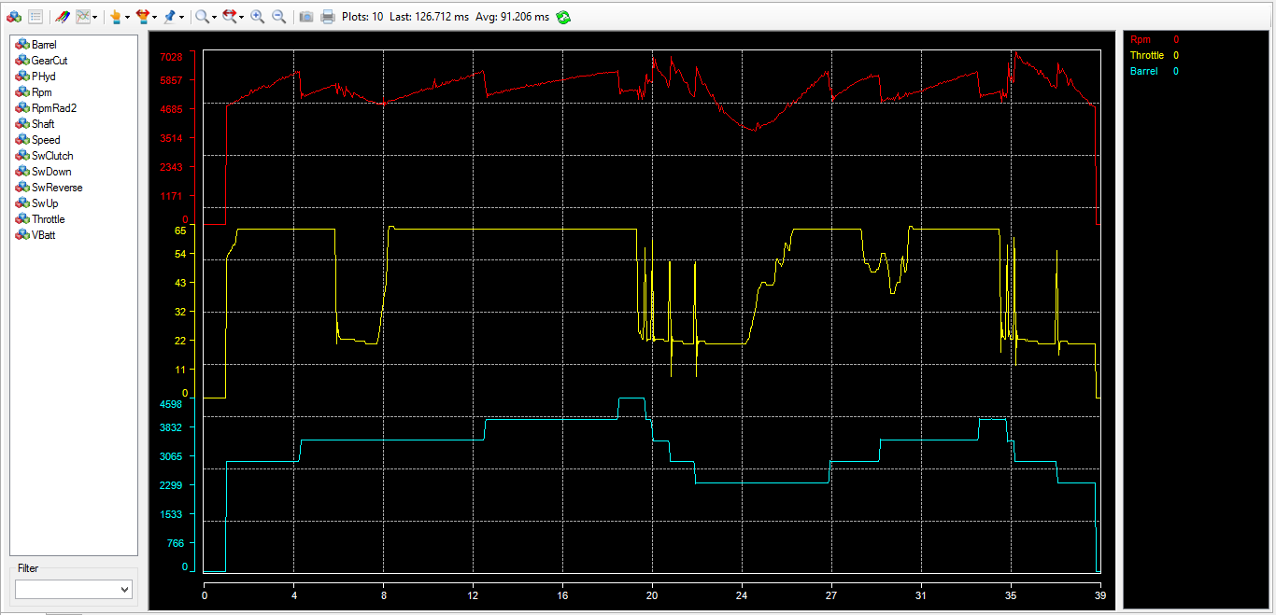

The analysis window has four main areas:

* + The graphic: where traces are drawn.
  + The channel list: On the left, where all channels available in the loaded data file are displayed.
  + The legend: On the right, where all channel plotted as well as their values, units and statistics are shown.
  + The tool bar: On the top, where all principal command of the graphic window are available.

*Created with the Personal Edition of HelpNDoc:* [*iPhone web sites made easy*](http://www.helpndoc.com/feature-tour/iphone-website-generation)

**Graphic window tool bar**

The analysis window tool bar is shown on the top of the graphic window form. It regroups main analysis window commands.

There are actually a lot more commands for the analysis windows spread into configuration forms and contextual menus.



 Channel list: Show or hide the channel list panel.

 Legend: Show or hide the graphic legend panel.

 Graphic configuration: Open the main graphic configuration form.

 Graphic layout: Change the current graphic layout (Parallel, Overlay, Custom).

 Cursor type: Change the current type of the main graph cursor.

 Cursor step: Change the current cursor step for key board arrows keys.

 Reference cursor: Reference cursor command (Set, Clear).

 Zoom mode: Change the current mode of zoom.

 Zoom factor: Change the current zoom factor of 'Zoom plus' and 'Zoom minus' functions.

 Zoom plus: Zoom plus command.

 Zoom minus: Zoom minus command.

 Snapshot: Graphic snapshot command.

 Print: Graphic print command.

*Created with the Personal Edition of HelpNDoc:* [*Write EPub books for the iPad*](http://www.helpndoc.com/create-epub-ebooks)

**Shortcut keys**

Here is a summary of all shortcuts keys of the analysis window.

|  |  |
| --- | --- |
| Key | Function |
| + | Zoom plus |
| - | Zoom minus |
| W | Zoom min (0% zoom) |
| N | Zoom max (100% zoom) |
| X | Zoom mode X |
| Y | Zoom mode Y |
| B | Zoom mode XY |
| V | Cursor vertical |
| H | Cursor horizontal |
| K | Cursor cross |
| Pg Up | Cursor step + |
| Pg Down | Cursor step - |
| R | Set reference cursor |
| ESC | Clear reference cursor |
| O | Graph layout overlay |
| P | Graph layout parallel |
| C | Graph layout custom |
| G | Graph properties edition |
| T | Show/Hide legend selected series |
| DEL | Remove legend selected series from the graph |

*Created with the Personal Edition of HelpNDoc:* [*Free PDF documentation generator*](http://www.helpndoc.com)

**Data file**

The data file format used by the analysis window is CSV (Column Separated Value)

Columns must be separated by a semi-comma character [ ; ].

Values decimal separator must be point [ . ] or comma [ , ].

First line of the file contains names of data channels.

First column must be abscisse value (X axis values).

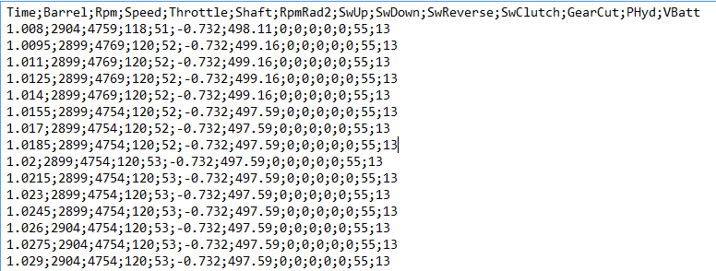

*Created with the Personal Edition of HelpNDoc:* [*Easy to use tool to create HTML Help files and Help web sites*](http://www.helpndoc.com/help-authoring-tool)

**Analysis functions**

This section regroup analysis features documentation of the graphic window.

*Created with the Personal Edition of HelpNDoc:* [*Free EPub and documentation generator*](http://www.helpndoc.com)

Main cursor

The main graphic cursor is a graphical help for analysis. It permits to point any coordinates within the graphic area.

Just click anywhere in the graphic area to make the cursor visible. Press the mouse right button and move the mouse to have the cursor following your movements. Release the mouse right button and the cursor gets fixed.

Default cursor type is 'Cross', which means that graphical cursor is taking a cross form.

There are actually seven cursor modes:

* + None: Graphical cursor is disabled.
  + Vertical line: Cursor is a vertical line following the mouse along the X axis.
  + Horizontal line: Cursor is a horizontal line following the mouse along the Y axis.
  + Cross: Cursor is cross made by a vertical and a horizontal line, lines crossing each other at the mouse location.
  + Graticule: Cursor is a small cross following the mouse inside the graphic area.
  + Square: Cursor is a small square surrounding the actual mouse location.
  + Circle: Cursor is a small circle surrounding the actual mouse location.

To change the cursor type, click on the 'Main graph cursor type' of the tool bar  and select the desired type. You can also use the 'Cursor' menu  of the graphic contextual menu (right click in the graphic area). 'Vertical line', 'Horizontal line' and 'Cross' are also available through keyboard shortcuts 'V', 'H' and 'K'.

While moving the graphic cursor, you can see in the legend that each trace value is updated with the actual value of the trace at the position of the cursor.



In addition of that, for 'Vertical', 'Horizontal' and 'Cross' cursor types, values of graphical coordinate are showed.

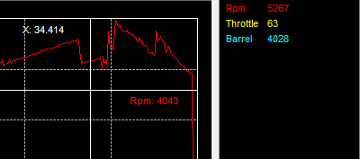

By coordinates, we mean X and Y axis values at the position of the cursor. For instance on the screen shot above, '34.414' is the value along the X axis and '4043' is the value along the Y axis which is named 'Rpm'. You may have more than one Y axis at the position of the cursor, in that case all axis values are showed.

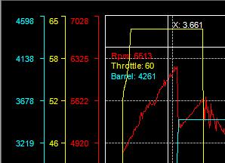

Using 'left', 'right', 'up' and 'down' arrow keys of the keyboard you can move the cursor to the direction you want. Obviously, 'up' and 'down' movements are disabled for the 'Vertical line' cursor type, while 'left' and 'right' are disabled for the 'Horizontal line' type.

By setting the 'Cursor step' you can define how big (or small) cursor movement will be for each arrow key press event.

To change the cursor step, click the 'Main cursor step' button  of the tool bar and select the step you want. This command is also available through the graphic contextual menu, under the 'Cursor \ Cursor step' menu. You may also use 'Page Up' and 'Page Down' keys to change the cursor step.

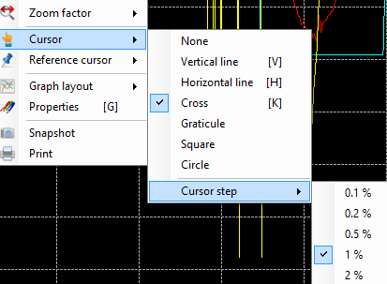

Cursor step values are percentage values... OK but percentage of what ? Good question !

Step values are percentage of the current X axis values span. For example, if 100 seconds of data are plotted and the cursor step is 1%, the cursor will move by step of 1 second.

For Y axis, since it could be several different values here, screen size is used as reference value. In other words, with a cursor step of 1%, cursor will move up and down by steps representing 1% of the screen size.

Graphical properties of the graphic cursor (color, size) can be adjusted through the graphic configuration form. Please check the 'Cursors properties' section for more details.

*Created with the Personal Edition of HelpNDoc:* [*Free Kindle producer*](http://www.helpndoc.com/feature-tour/create-ebooks-for-amazon-kindle)

Reference cursor

The reference cursor is an extension of the 'Main cursor' function. It permits to compare values of all traces between two particular points in the graphic.

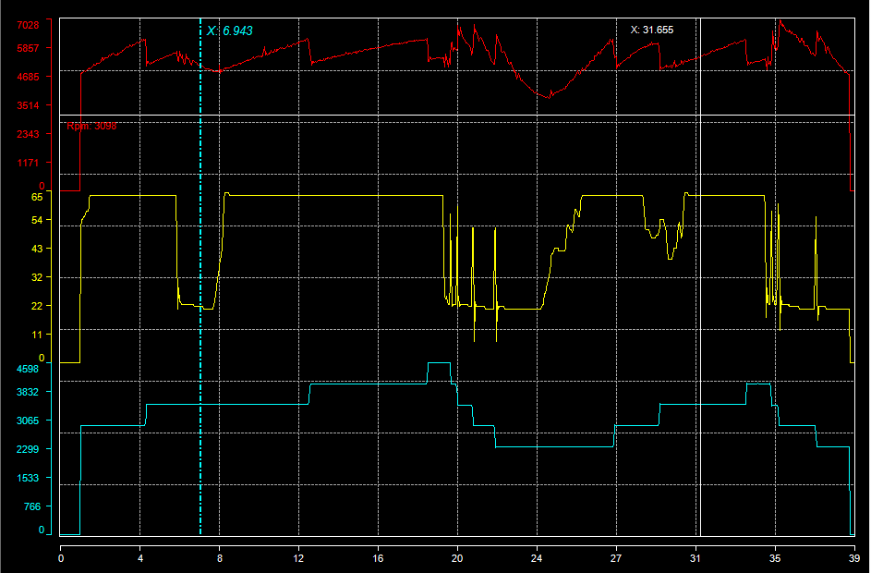

Click on the 'Reference cursor  \ Set' menu of tool bar to set the reference cursor position. This function is also accessible in the 'Reference Cursor\Set' command of the graphic window contextual menu, or by pressing the 'R' key of the keyboard.

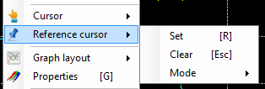

Place the reference at the position of your choice and then click the 'Reference cursor  \ Lock' command of the tool bar or the 'Reference Cursor\Lock' command of the graphic window contextual menu, or by press the 'Enter' to lock the reference cursor position and get the main cursor back on.

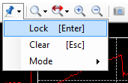

Main cursor being back, it can be place anywhere in the graph in order to compare the main cursor value and the reference cursor value.

Finally, once done with the comparison, click the 'Reference cursor  \ Clear' command of the tool bar or the 'Reference Cursor\Clear' command of the graphic window contextual menu, or by press the 'Escape' to clear the reference cursor.

The biggest benefit of the reference cursor is that it shows both reference and main cursor values in the legend, leading to have a direct cursors value comparison.

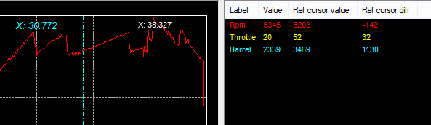

When the reference cursor is active, four statistics are added to the legend:

* + Reference cursor value: The actual value of the trace at the reference cursor position.
  + Reference cursor value difference: The difference in value between the main and the reference cursor.
  + Reference cursor value difference percentage: The difference in percentage of the reference value between the main and the reference cursors values.
  + Reference cursor gradient: Value the gradient between the main and the reference cursor values. Gradient being defined as the difference in value over cursors X axis values difference.

There are three kinds of reference cursor:

* + None: Reference cursor is disabled.
  + Vertical: Reference cursor is a vertical line. This mode is intended to be used with any main cursor type except the 'Horizontal line' main cursor type.
  + Horizontal: Reference cursor is a horizontal line. This mode is intended to be used with any main cursor type except the 'Vertical line' main cursor type.

Use the 'Reference cursor  \ Mode' command of the tool bar or the 'Reference Cursor\Mode' command of the graphic window contextual menu to change the current reference cursor type.

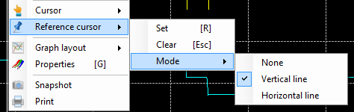

As per the main cursor, the reference cursor aspect can be customized in the graphic configuration form. Please check the 'Cursors properties' section for more details.

*Created with the Personal Edition of HelpNDoc:* [*Free help authoring tool*](http://www.helpndoc.com/help-authoring-tool)

Zoom

As per its name definition, zoom is a function permitting to zoom a particular graphic area and see traces of this area with greater details.

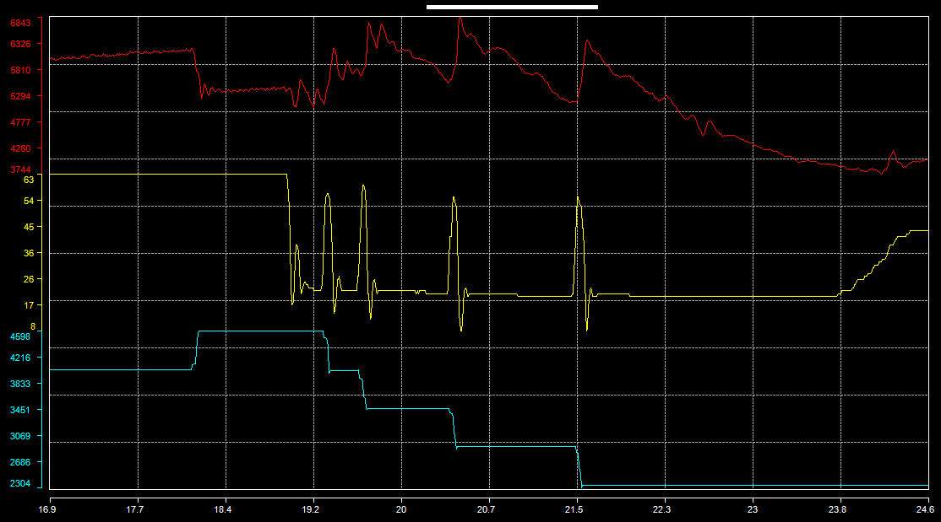

To zoom a particular area of the graphic, place the mouse cursor at the beginning, or at the end, of the area you want zoom in. Press the right mouse button and then drag the zoom box up the end of the zoom area. When the zoom area is defined click the 'Zoom' command of the contextual menu that pops up on the right mouse button release.

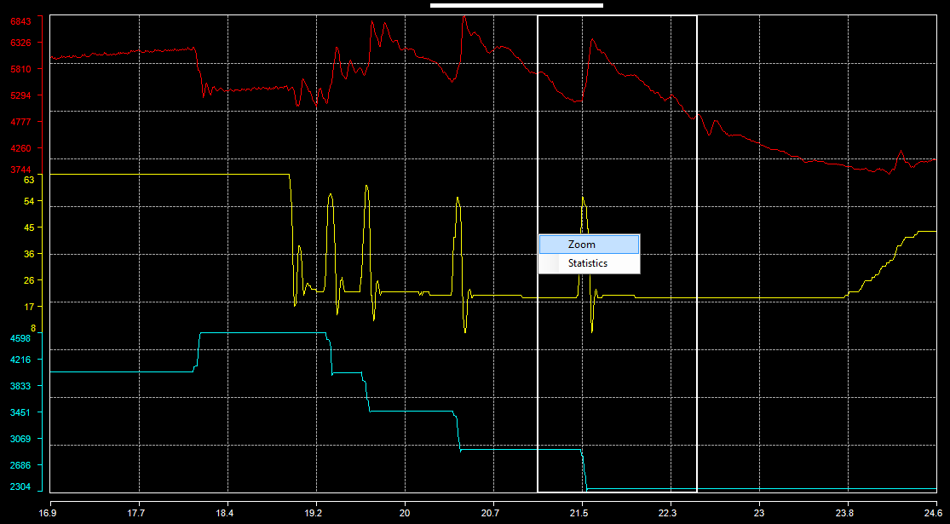

Four different zoom modes are available:

* + Disabled: Zoom function is disabled.
  + Zoom X: Zoom is performed along the X axis only, Y axis being unchanged.
  + Zoom Y: Zoom is performed along the Y axis only, X axis being unchanged.
  + Zoom XY: Zoom is performed along both X and Y axis.

To switch to a different zoom mode, click the 'Zoom Mode'  command of the tool bar or the 'Zoom mode'  command of the graphic window contextual menu.

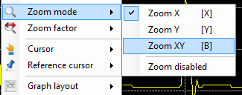

An alternative solution is to use zoom mode shortcut keys 'X', 'Y', 'B' for 'Zoom X', 'Zoom Y' and 'Zoom XY'.

Another way to zoom a graphic in and out is to use 'Zoom +'  and 'Zoom -'  functions. Both of those functions are available either in the tool bar or in the graphic window contextual menu. They are also accessible by pressing '+' and '-' keys of the keyboard for 'Zoom +' and 'Zoom -'.

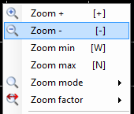

With this kind of zoom, the zoom area is defined by a factor applied around the main graphic cursor position. If the main graphic cursor is not set, the center of the screen is used as reference position.

The zoom factor can defined either through the 'Zoom factor'  button of the tool bar or through the 'Zoom factor'  item of the graphic window contextual menu.

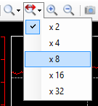

The zoom factor value represents the magnitude of zoom as a function of X axis values span (for zoom X and zoom XY) and the screen height (for zoom Y and zoom XY).

For example, if 80 seconds of data are plotted and the zoom factor is set to 'x 8', in the case of the 'Zoom X' mode, the X axis values span resulting of the zoom will be eight time smaller than the original span. So 80 / 8 = 10 sec.

In the case of a zoom out, the X axis values span will be eight time bigger than the original one. So 10 x 8 = 80 sec.

The third and last method to zoom in and out is to use 'Zoom min' and 'Zoom max' functions. Those functions are not available in the tool bar (for clarity) but they are in the graphic window contextual menu and through the shortcut keys 'W' and 'N' for 'Zoom min' and 'Zoom max'.

The 'Zoom min' will revert to a zoom magnitude of 1, so the whole data will be shown as if there wasn't any zoom. While 'Zoom max' will do the exact opposite and apply the biggest zoom factor (x 32).

While the zoom function is operating, X and Y zoom bars are shown.

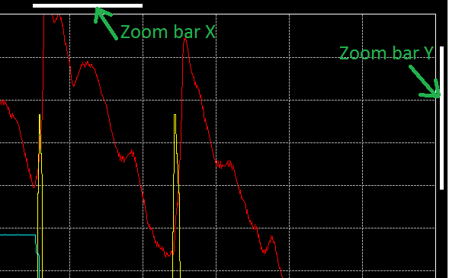

Obviously, the 'Zoom bar X' is shown only if the X axis is zoomed, so it won't be shown in 'Zoom Y' mode and the 'Zoom bar Y' is shown only if the Y axis is zoomed, so it won't be shown in 'Zoom X' mode.

Those zoom bars indicate two things:

* + The magnitude of the zoom: bar width (for the zoom bar X) and bar height (for the zoom bar Y) are function of the zoom magnitude.

If the zoom factor is set to 'x 8', zoom bar X width will be eight time smaller than the whole graphic area width. The same logic is used for the zoom bar Y, with a zoom factor of 8, zoom bar Y height will be eight time smaller than the whole graphic area height.

* + The position of zoomed area: bar left position (for zoom bar X) and bar top position (for the zoom bar Y) are function of the zoomed area position

if the whole data length is 60 seconds and the zoom area starts at the second 30, zoom bar X left position will right on the middle of the graphic area. The same logic applies as well for the zoom bar Y.

Zoom bar X and Y have also second purpose, they can be moved by user in order to move the zooming area.

Place the mouse cursor over one zoom bar and the cursor will transform either in 'east-west arrows' cursor for the zoom bar X or in 'north-south arrows' cursors for the zoom bar Y. Press the mouse right button and drag the zoom bar at the position you want to change the zooming area.

*Created with the Personal Edition of HelpNDoc:* [*Easily create Help documents*](http://www.helpndoc.com/feature-tour)

Statistics

Another useful feature of the analysis window is statistics computation.

As per the zoom function, right click is graphic area and drag the zoom box up to end of area in which you want compute statistics. Release the mouse right button and click the 'Statistics' command of the contextual menu that has popped up. Prior to do that, make sure the zoom mode is not 'Zoom disabled', otherwise the zoom box will not appear.

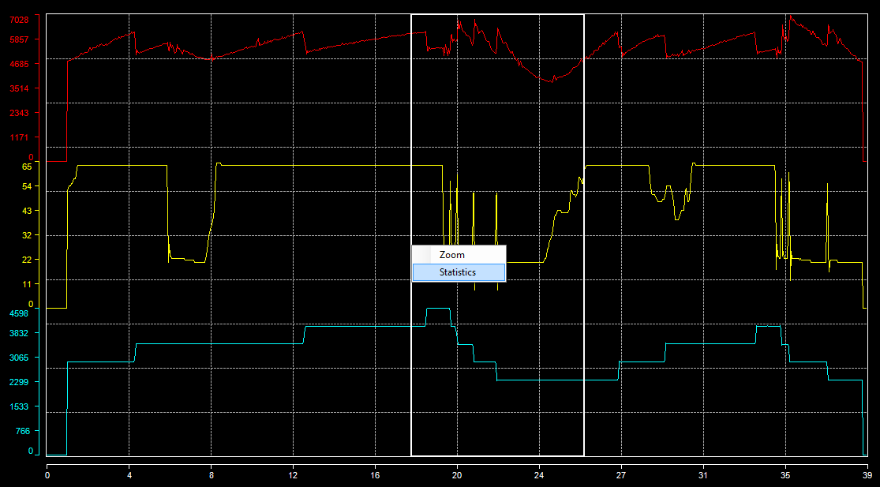

The statistics window appears.

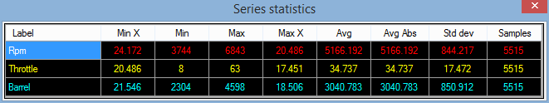

In this statistics windows we can find different statistics about plotted data

* + Min X: X axis value at the minimum trace value.
  + Min: Minimum value of the trace inside the zoom box.
  + Max: Maximum value of the trace inside the zoom box.
  + Max X: X axis value at the maximum trace value.
  + Avg: Average of all trace values inside the zoom box.
  + Avg abs: Average of all trace absolute values inside the zoom box.
  + Std dev: Standard deviation of all trace values inside the zoom box.
  + Samples: Trace samples count used for statistics computation.

Those statistics can even be copied into the Windows clipboard in order to be pasted into an external application such as Microsoft Excel.

Select all cells of the statistics grid that are of your interest and press Ctrl+C on your keyboard. All selected cells values are now in the Windows clipboard and are ready to be used in any application accessing the clipboard.

*Created with the Personal Edition of HelpNDoc:* [*Full-featured Documentation generator*](http://www.helpndoc.com)

Legend

As briefly explained in the 'Main cursor' and 'Reference cursor' sections, legend shows plotted trace values at the position of the main cursor.



If you make a right-click on the legend, the legend contextual menu will pop up and shows all available legend options.

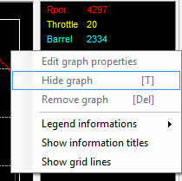

The 'Legend information' menu propose you to define what information you want to see in the legend.

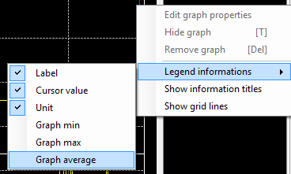

There are six information that you can make visible or invisible. Just check infos that you want to see, unchecked info will be invisible.

* + Label: Titles of the graphic traces set into the graphic configuration form.
  + Cursor value: Traces values at the position of the main cursor.
  + Unit: Trace units set set into the graphic configuration form.
  + Graph min: Traces minimum value visible in the graphic area.
  + Graph max: Traces maximum value visible in the graphic area.
  + Graph average: Traces average value of all sample visible in the graphic area.

In case of the reference cursor function usage, there are an extra bunch of infos that you can make visible.

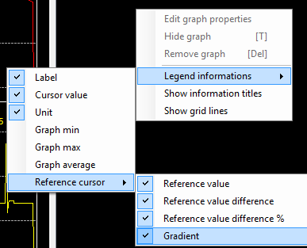

* + Reference cursor value: The actual value of the trace at the reference cursor position.
  + Reference cursor value difference: The difference in value between the main and the reference cursor.
  + Reference cursor value difference percentage: The difference in percentage of the reference value between the main and the reference cursors values.
  + Reference cursor gradient: Value the gradient between the main and the reference cursor values. Gradient being defined as the difference in value over cursors X axis values difference.

Menus 'Show legend information titles' and 'Show grid lines' permit to show and hide the legend header and legend grid lines.

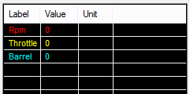

A right-click on a legend item will enabled trace related function of the legend.

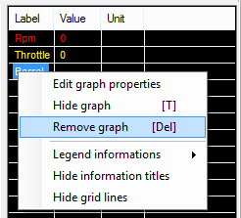

Menu 'Edit graph properties' will open the selected trace 'Detailed serie properties' windows in order to fine tune graphical properties of a particular trace.

'Hide graph' command will hide the selected trace in the graphic area. Alternatively, once a trace hidden, this menu becomes 'Show graph' in order to re-enable a hidden trace. This command is also available by pressing the 'T' key of the keyboard.

'Remove graph' will definitively remove a trace from the graphic area. Be careful, this operation is not revertible ! Once a trace removed it is gone for ever and you will have to add it into the graph again.

The legend panel can be hidden at any time by clicking the 'Show/Hide legend' button  of the tool bar. Once hidden click again the 'Show/Hide legend' button  to re-open the legend panel.

Some more legend properties can be adjusted through the graphic configuration form. Please check the 'General properties' section for more details.

*Created with the Personal Edition of HelpNDoc:* [*Create iPhone web-based documentation*](http://www.helpndoc.com/feature-tour/iphone-website-generation)

Snapshot

Snapshot function makes a picture of your graphic that can be reused in a presentation, or an email or anything else.

Snapshot outputs a bitmap picture file (*.bmp), this picture including legend but excluding the channel list.

To make a snapshot of your graphic, simply click the 'Make a snapshot image of the graphic' , set the name and path of the output picture in the file saving dialog and click 'Save'.

Example of a graphic snapshot.

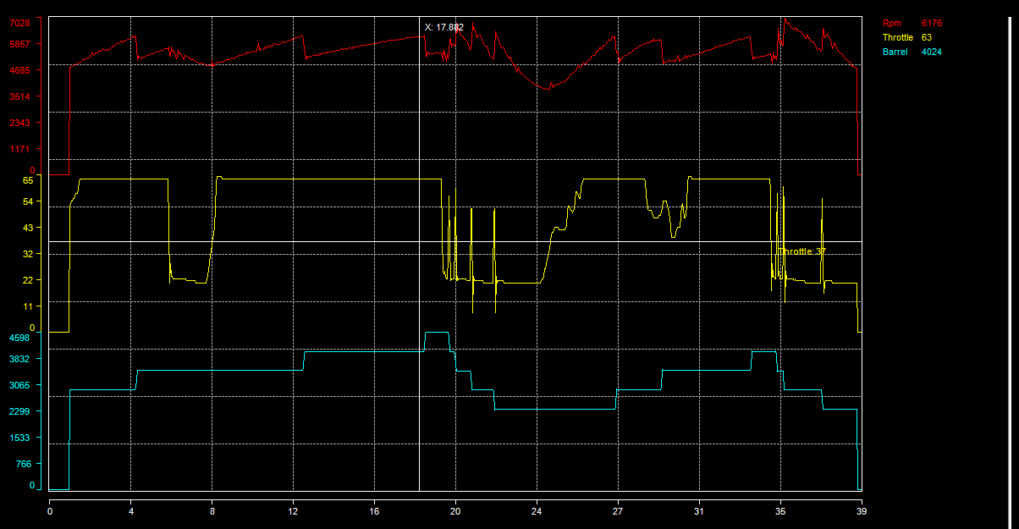

*Created with the Personal Edition of HelpNDoc:* [*Easy EPub and documentation editor*](http://www.helpndoc.com)

Print

The 'Print' function permits to print your graphic out.

Click the 'Print graphic'  button to open the print preview window.

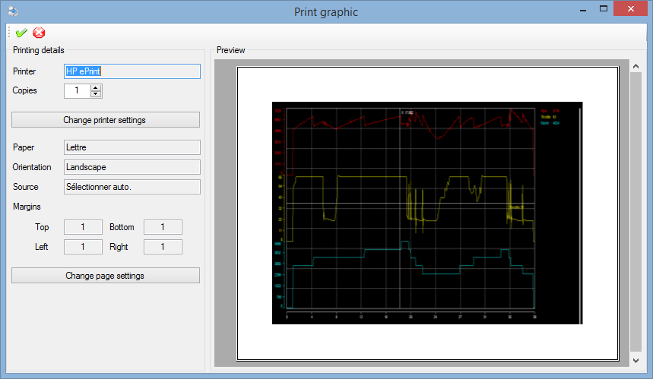

The right side panel of print preview form contains printing details such as printer name, number of copies, paper format and orientation.

The left side panel shows an actual preview of the document as it will be once printed out.

Set the number of copies to print in the field 'Copies'. To change the printer and its properties, click the 'Change printer settings' button.

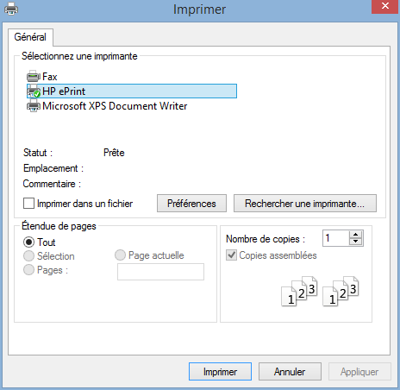

Click the 'Change page settings' button to change paper orientation or adjust margins.

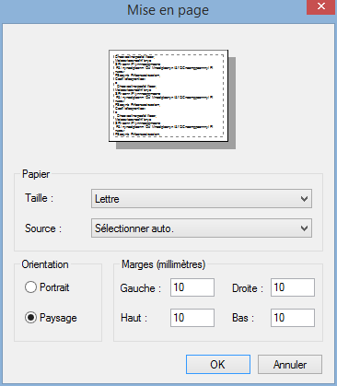

Once done with all settings, click the 'Print'  button to print the page.

The 'Cancel'  button, simply close the form. It doesn't cancel the printing request if such request has been sent to a printer.

*Created with the Personal Edition of HelpNDoc:* [*Create iPhone web-based documentation*](http://www.helpndoc.com/feature-tour/iphone-website-generation)

**Graphic window settings**

This section regroup graphical properties configuration documentation of the graphic window.

*Created with the Personal Edition of HelpNDoc:* [*Easily create PDF Help documents*](http://www.helpndoc.com/feature-tour)

Channel list

The channel list shows the list of data channels contained in the data file loaded.

Channel list is located in the left side panel of the analysis window. It is visible by default but it can be hidden by clicking on the 'Show/Hide channel list'  button of the tool bar. Once hidden, click again on this button to get the channel list back.

Double click on a channel to add it in the graphic. This can also be done by a 'drag & drop' of a channel (or a bunch of channels) from the channel list to the graphic area.

Alternatively, select channels that you want to add in the graphic and press 'Enter'.

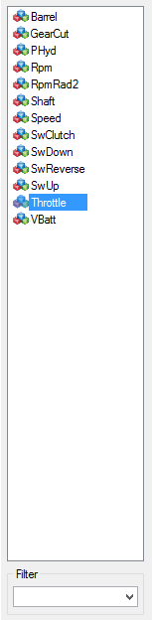

At the bottom of the channel list there is the 'Filter' area. This area permits to filter channel names shown in the list. Just type a name or a part of a name that you are looking for and press enter. If the character sting that you typed in is contained into one or more channels, only those channels will be shown in the list.

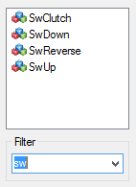

Filter is text box is actually a list that stores the last ten filters used. Just select that filter to reuse it.

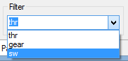

Clear the filter text box to reset the filter and get back the whole channel list.

*Created with the Personal Edition of HelpNDoc:* [*Easy to use tool to create HTML Help files and Help web sites*](http://www.helpndoc.com/help-authoring-tool)

Graphic layout

Term 'graphic layout' means the way graphic series (or traces) are set into the graphic.

There are three possible layouts:

* + Overlay: All series are overlaying each other on the full graphic area height.
  + Parallel: Series are evenly arranged onto the graphic area.

If there are four series to plot, each serie will be plotted over 25% of the whole graphic area height. If there are five series, each serie will use 20% of the graphic height, 10% for ten series, so forth and so on...

* + Custom: Series top and bottom position are defined by the user.

Series are not necessarily evenly set, a serie can fully or partially overlap one or more series.

Click the 'Graphic layout mode'  button of the tool bar to change the current layout. This command is also available through the 'Graph layout'  item of the graphic contextual menu.

Layout mode can also be changed using 'O', 'P' and 'C' shortcut keys for 'Overlay', 'Parallel' and 'Custom' modes.

Graphic in 'Overlay' layout mode:

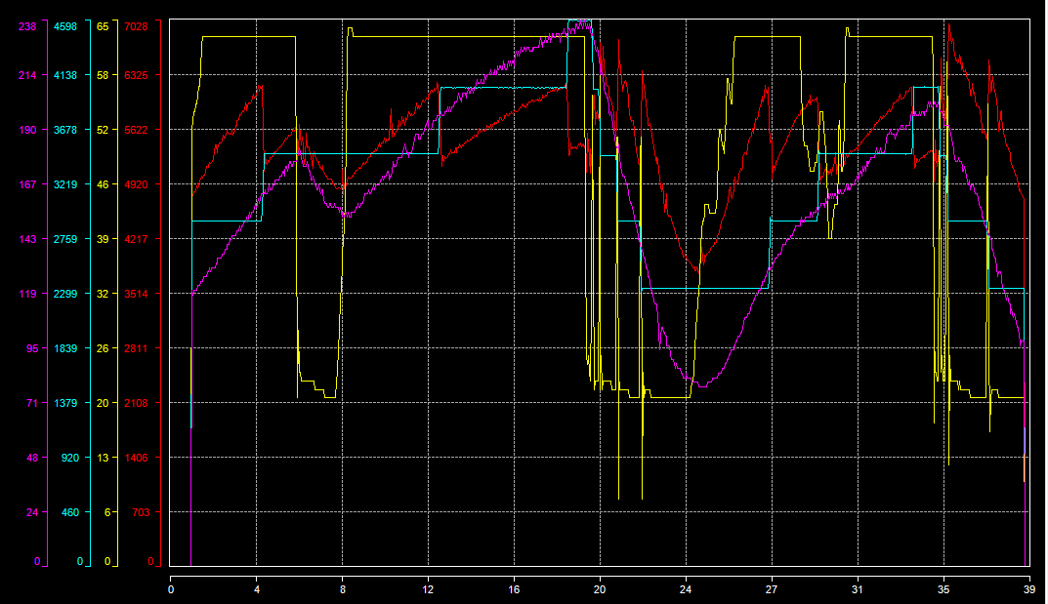

Graphic in 'Parallel' layout mode:

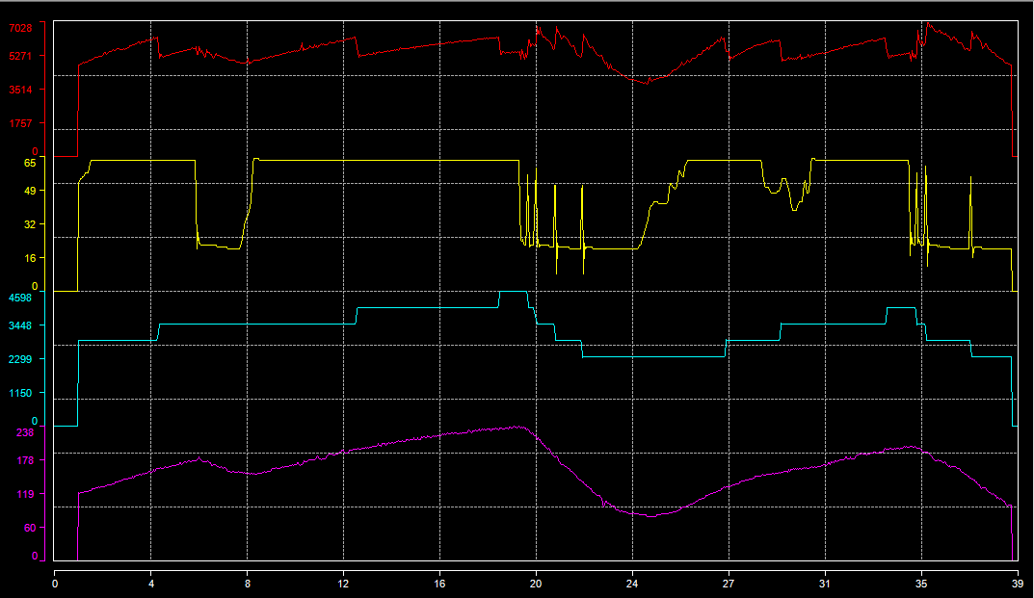

Graphic in 'Custom' layout mode:

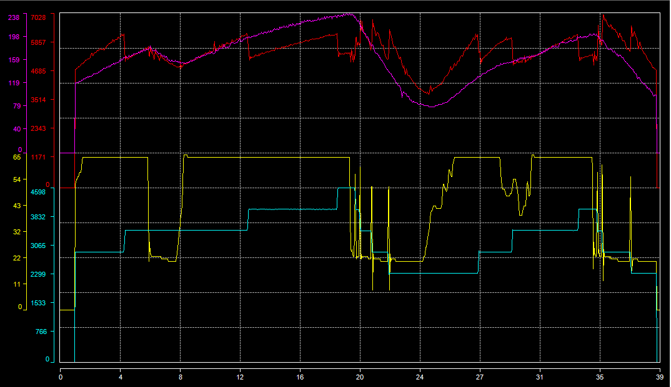

*Created with the Personal Edition of HelpNDoc:* [*Easy CHM and documentation editor*](http://www.helpndoc.com)

Graphic configuration

The graphic configuration window permits to edit all properties related to the the graphic window.

Click the 'Edit graph properties'  button of the tool bar to open the graphic configuration window. This command is also available through the 'Properties'  item of the graphic contextual menu. Alternatively, press the 'G' key of the keyboard to open the configuration window.

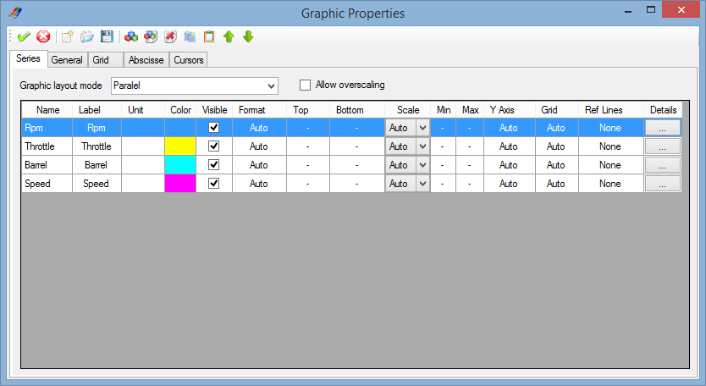

The graphic configuration window is composed by a tool bar and a multi-tabs window.

Each tab of the multi-tab is dedicated to a particular configuration section. There five different sections:

* + Series: Generic properties of the graph series (or trace).
  + General: General properties of the graphic window.
  + Grid: Graphic window grids properties.
  + Abscisse: Properties related to the graphic abscisse (X axis).
  + Cursors: Graphic properties of main and reference cursors.

Tool bar contains most common configuration commands.

 Apply: Apply graphic configuration changes.

 Cancel: Cancel graphic configuration changes.

 New: Create a new graphic configuration file.

 Open: Open a graphic configuration file (*xgw).

 Save: Save the graphic configuration file (*.xgw).

Check the 'Generic series properties' section for details of the rest of tool bar commands

*Created with the Personal Edition of HelpNDoc:* [*Single source CHM, PDF, DOC and HTML Help creation*](http://www.helpndoc.com/help-authoring-tool)

Generic series properties

The 'Series' tab of the graphic configuration window contains generic properties of graphic series (or trace)

List graphic layout mode permits to change the current layout mode of the graphic.

All graphic series (or traces) are shown is the series grid.



First cell apart, all cells value can be modified in order to set a particular property of a graphic serie.

* + Name: Name of data channel as shown in the channel list used as data source of the serie.
  + Label: Title of the serie in the graphic legend.
  + Unit: Serie value unit shown is the graphic legend.
  + Color: Trace color of the serie in the graphic and in the legend.
  + Visible: Serie visible flag. Check the box to make the serie visible, uncheck it to hide the serie.
  + Format: Double click on this cell to open the serie value format dialog.
  + Top: Serie top position in the graphic area. This setting is only available with the 'Custom' layout mode.
  + Bottom: Serie bottom position in the graphic area. This setting is only available with the 'Custom' layout mode.
  + Scale: Serie scaling mode, either 'Auto' or 'Manual'. See 'General serie properties' section for more details.
  + Y Axis: Double click on this cell to open the serie Y axis properties setting dialog.
  + Grid: Double click on this cell to open the serie custom grid properties setting dialog.
  + Ref lines: Double click on this cell to open the serie reference lines properties setting dialog.
  + Details: Click on this cell to open the whole detailed serie properties dialog.

Some commands of tool bar are specific to the 'Series' tab.

 Channel list: Open the channel list to add graphic series.

 Create serie: Create new graphic serie.

 Delete serie: Delete a graphic serie.

 Copy: Copy a graph serie.

 Past: Past a graph serie.

 Move up: Move a serie up in the grid.

 Move down: Move a serie down in the grid.

Check box 'Allow overscaling' enable over scaling for all graphic series.

Over scaling is applied on series only for the 'Manual' serie scaling mode. If the scale span set by the user is smaller than the actual serie values span, the 'Overscaling' flag will defined whether or not, out of scale sample should be drawn on the graphic.

Non over scaled graphic:

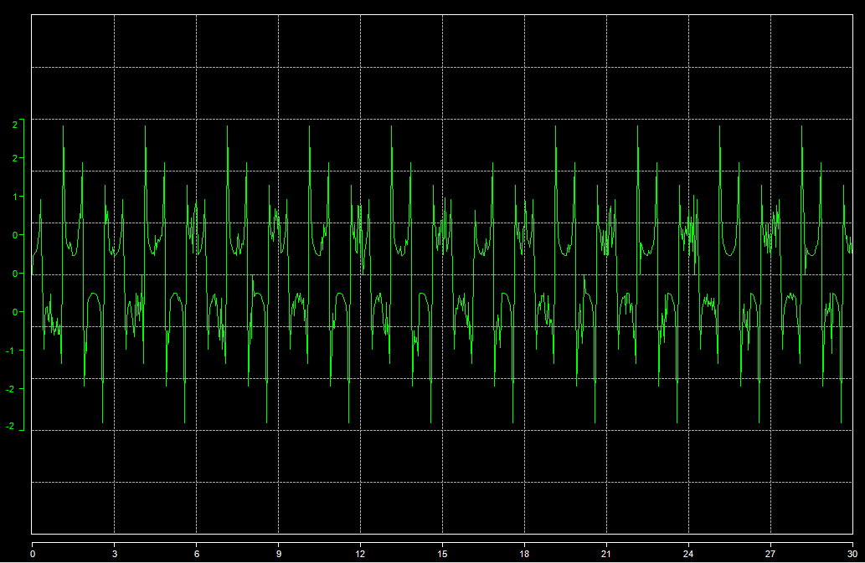

Over scaled graphic:

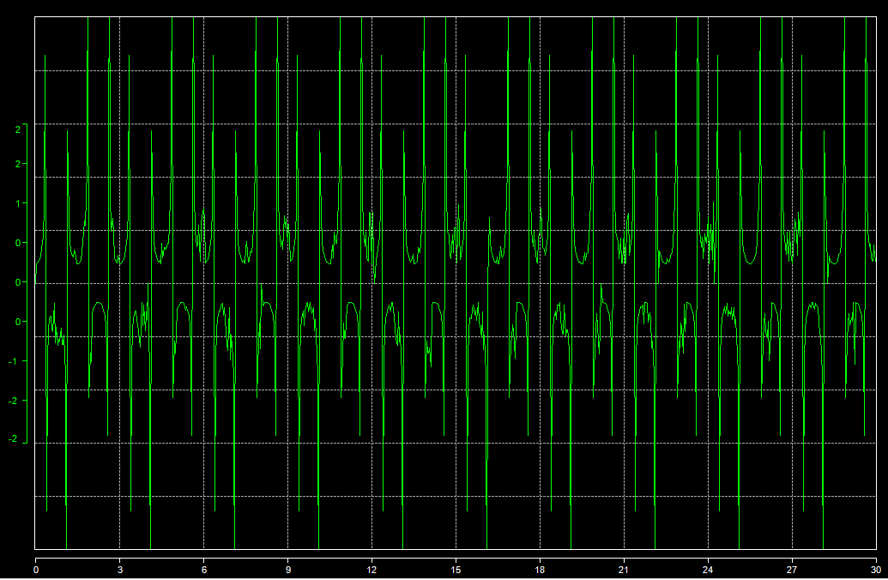

*Created with the Personal Edition of HelpNDoc:* [*Full-featured EPub generator*](http://www.helpndoc.com/create-epub-ebooks)

General properties

The 'General' tab contains general graph window properties.

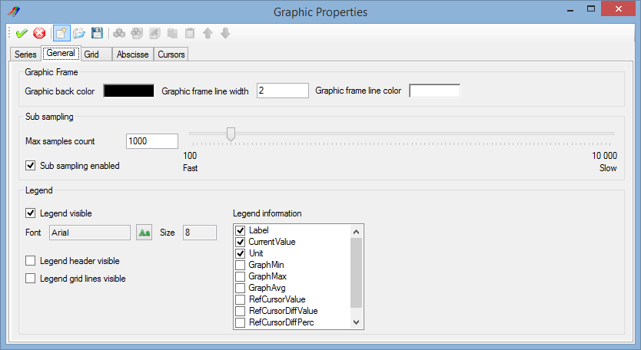

### Graphic frame

This panel contains properties of the graphic frame

* + Window back color: Double click on the colored square to open the color selection dialog and define the graph window back color.
  + Graphic frame line width: Set the desired width of the graphic frame lines.
  + Graphic frame line color: Double click on the colored square to open the color selection dialog and define the graphic frame lines color.

### Sub sampling

Sub sampling property defines the maximum number of samples that will drawn in the graphic for each serie.

In order to accelerate graphic drawing, number of samples drawn can be limited to a certain value that keeps drawing time within a reasonable limit without altering the graphic accuracy. Bigger is the drawn samples count longer will be the graphic drawing.

Tick the 'Sub sampling enabled' box to enable the sub sampling and move the sub sampling cursor or type a value into the 'Max samples count' text box to define the sub sampling level.

Sub sampling set to 100 (100 samples drawn).

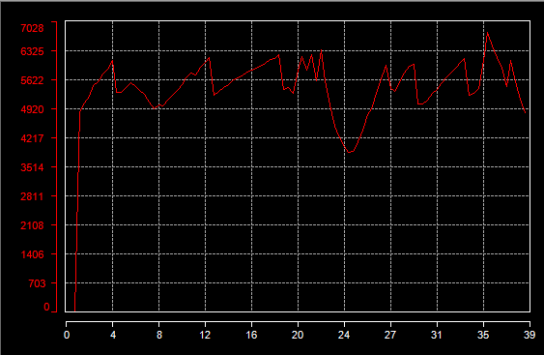

Sub sampling disabled (26 000 samples drawn).

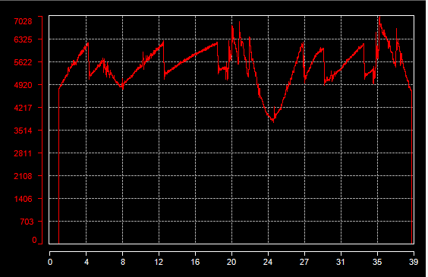

### Legend

In addition of legend properties that can be directly set in the graphic window (infos and header/grid lines visible), it is here possible to change the font used for legend items.

Click the 'Font'  button to open the font selection dialog, select a font and set its size and attributes and click 'OK'.

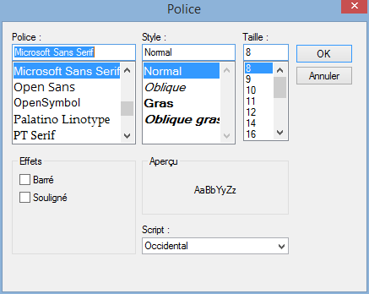

*Created with the Personal Edition of HelpNDoc:* [*Easily create CHM Help documents*](http://www.helpndoc.com/feature-tour)

Graphic grids properties

In order to enhance the analysis experience, vertical and horizontal grids are drawn in background of the graphic area.

There are two kinds of grid:

* + Main grid: Main grid (horizontal and vertical) chops the graphic area in ten parts.
  + Secondary grid: Secondary grid (horizontal and vertical) chops the graphic area in twenty parts.

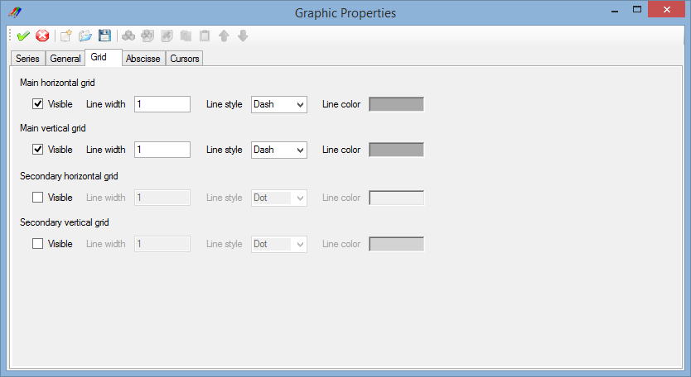

Each single grid (main/secondary, horizontal/vertical) can be individually set.

* + Visible: Check the 'Visible' box to make the grid visible.
  + Line width: Set the width of the grid line.
  + Line style: Set the line style of the grid line. Check 'Line styles' section for details.
  + Line color: Double click the colored area to open the color selection dialog and select the grid line color.

*Created with the Personal Edition of HelpNDoc:* [*Free EPub producer*](http://www.helpndoc.com/create-epub-ebooks)

Abscisse properties

The 'Abscisse' tab contains graph window abscisse (X axis) properties

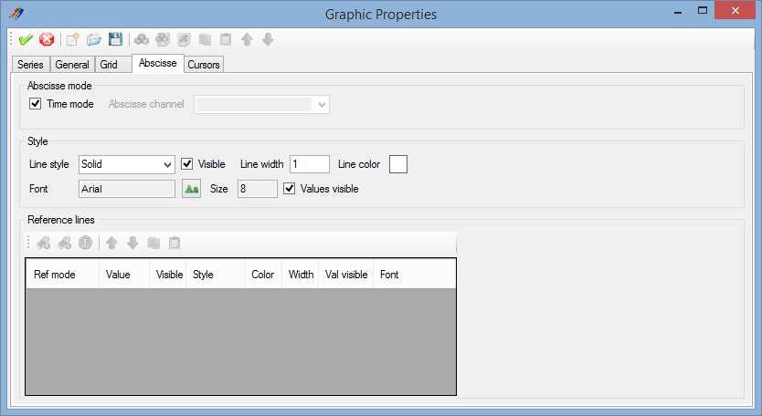

### Abscisse mode

By default graphic uses the first channel of the data file (the time basically) as values for the X axis. It is however possible to choose another data channel as data source for the X axis.

Uncheck the 'Time mode' box and pick a channel up in the 'Abscisse channel' list to use it as X axis data source.

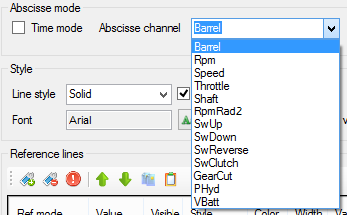

### Style

This panels regroup X axis aspect properties

* + Line style: Select the X axis line style. Check 'Line styles' section for details.
  + Visible: Check/uncheck this box the make the X axis visible or invisible.
  + Line width: Set the width of the X axis line.
  + Line color: Double click the colored square to open the color selection dialog and select the X axis line color.
  + Font: Click the 'Font' button to open the font selection dialog, select a font and set its size and attributes and click 'OK'.
  + Values visible: Check/uncheck this box the make the X axis values visible or invisible.

Example of a customized X axis.

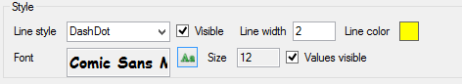



### Reference lines

Abscisse reference lines are available only if the abscisse time mode is disabled.

Manage X axis reference lines from this panel. Check 'Serie reference lines' section for more details.

Example of graphic using abscisse reference line.

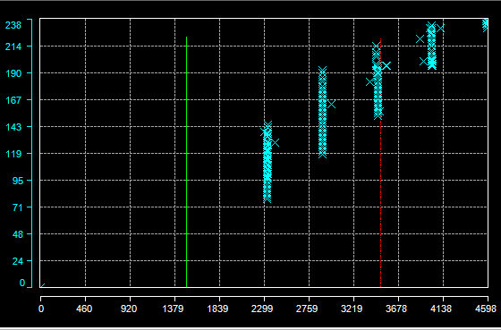

*Created with the Personal Edition of HelpNDoc:* [*Full-featured EBook editor*](http://www.helpndoc.com/create-epub-ebooks)

Cursors properties

The 'Cursors' tab contains graph cursors properties.

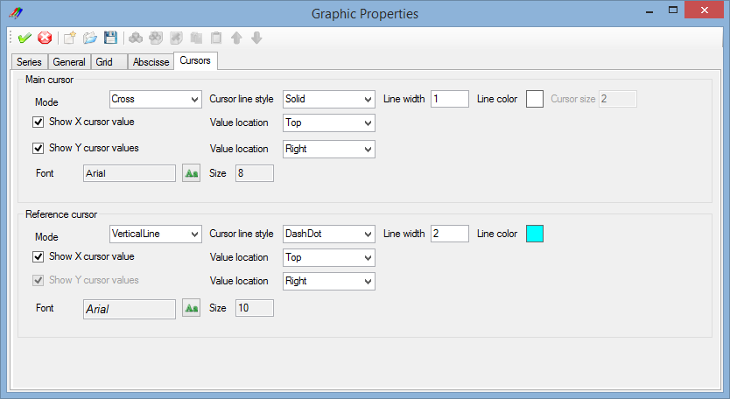

### Main cursor

In addition of main cursor properties that can be directly set in the graphic window, it is here possible to change the graphical aspect of the main cursor.

* + Mode: Select in this list the main cursor mode.
  + Line style: Select the cursor line style. Check 'Line styles' section for details.
  + Line width: Set the width of the cursor line.
  + Line color: Double click the colored square to open the color selection dialog and select the cursor line color.
  + Show X value: Check/uncheck this box the make the cursor X value visible or invisible.
  + Show Y values: Check/uncheck this box the make the cursor Y values visible or invisible.
  + X cursor value location: Set the location (left, right or center) of the cursor X value.
  + Y cursor values location: Set the location (top, bottom or center) of the cursor X values.
  + Font: Click the 'Font' button to open the font selection dialog, select a font and set its size and attributes and click 'OK'.

### Reference cursor

In addition of reference cursor properties that can be directly set in the graphic window, it is here possible to change the graphical aspect of the reference cursor.

* + Mode: Select in this list the main cursor mode.
  + Line style: Select the cursor line style. Check 'Line styles' section for details.
  + Line width: Set the width of the cursor line.
  + Line color: Double click the colored square to open the color selection dialog and select the cursor line color.
  + Cursor size: Only available for 'Graticule', 'Square' and 'Circle' modes, set the size of the cursor.
  + Show X value: Check/uncheck this box the make the cursor X value visible or invisible.
  + Show Y values: Check/uncheck this box the make the cursor Y values visible or invisible.
  + X cursor value location: Set the location (left, right or center) of the cursor X value.
  + Y cursor values location: Set the location (top, bottom or center) of the cursor X values.
  + Font: Click the 'Font' button to open the font selection dialog, select a font and set its size and attributes and click 'OK'.

*Created with the Personal Edition of HelpNDoc:* [*Full-featured Documentation generator*](http://www.helpndoc.com)

Graphic serie detailed configuration window

The graphic serie detailed configuration window permits to edit all properties related to a graphic serie.

To open this form, double click on a serie in the legend, or open the 'Graphic window configuration' form and click the 'Details' button of a serie in the 'Series' configuration tab.

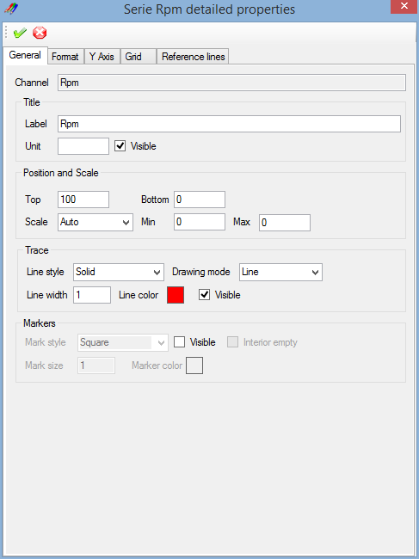

The graphic configuration window is composed by a tool bar and a multi-tabs window.

Each tab of the multi-tab is dedicated to a particular configuration section. There five different sections:

* + General: General properties of the graphic serie.
  + Format: Serie value format properties.
  + Y Axis: Serie Y axis properties.
  + Grid : Serie custom grid properties.
  + Reference lines: Serie reference lines properties.

Tool bar contains most common configuration commands.

 Apply: Apply graphic configuration changes.

 Cancel: Cancel graphic configuration changes.

*Created with the Personal Edition of HelpNDoc:* [*Free iPhone documentation generator*](http://www.helpndoc.com/feature-tour/iphone-website-generation)

Serie general properties

As per the 'Generic series properties' panel of the 'Graphic window configuration' form, this regroups main serie properties, but not only.

Graphical trace aspect can be fully customized from this panel.



### Channel

Content of this text box cannot be modified, it only shows the data channel source of the serie.

### Title

This panel contains legend properties of the serie.

* + Label: Title of the serie shown in the legend. Label can be different than the name of the data channel.
  + Unit: Serie value unit.
  + Visible: Master visibility switch, whatever 'Trace' and 'Marker' visibility states are if that box is not checked, serie will not be drawn in the graphic.

### Position and scale

Set the serie position and scale properties.

* + Top: Serie's top position in the graphic area.
  + Bottom: Serie's bottom position in the graphic area.
  + Scale mode: Scaling mode of the serie, either 'Auto' or 'Custom'.
  + Min: Custom scale minimum value.
  + Max: Custom scale maximum value.

It is important to note that 'Top' and 'Bottom' properties are applied only if the graphic layout is set to 'Custom'.

Regarding scaling mode, in 'Auto' mode, actual serie's minimum and maximum values are used to set the scale.

### Trace

Set the serie trace aspect.

* + Line style: Select the trace line style. Check 'Line styles' section for details.
  + Drawing mode: Serie's trace drawing mode, either 'Line' or 'Step'.
  + Line width: Set the width of the trace line.
  + Line color: Double click the colored square to open the color selection dialog and select the trace line color.
  + Visible: Trace visibility flag. Check that box to make the trace visible.

As far as the drawing mode, 'Line' means that two graphic samples will be joined by a simple line and 'Step' means that two sample will be joined with two lines in a shape of a step.

It is important to note, that assuming the the master visible switch of the title panel is set. If both 'Visible' checks of 'Trace' and 'Markers' are set, serie will be shown with trace and markers. If none of those are set, serie will not be drawn whatever value has the master visible switch.

### Markers

Set the serie trace aspect.

Markers are special shapes placed on each graphical sample marking the real position of a sample in the graph.

There are 5 possible shapes for makers:

 Square

 Round

 Diamond

 Cross

 Triangle

Markers have the following properties

* + Mark style: Select the marker style. ('Square', 'Round', 'Diamond', 'Cross' or 'Triangle').
  + Visible: Markers visibility flag. Check that box to make markers visible.
  + Interior empty: Set markers emptiness. If this box is not checked, markers will be filled with the maker color.
  + Mark size: Set the size of the marker.
  + Marker color: Double click the colored square to open the color selection dialog and select the mark color.

It is important to note, that assuming the the master visible switch of the title panel is set. If both 'Visible' checks of 'Trace' and 'Markers' are set, serie will be shown with trace and markers. If none of those are set, serie will not be drawn whatever value has the master visible switch.

Example of graphic set with trace and markers

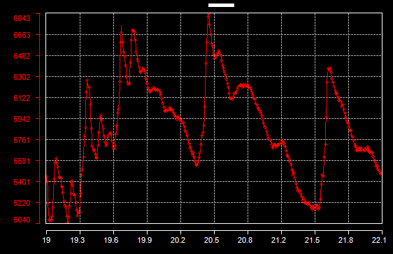

*Created with the Personal Edition of HelpNDoc:* [*Free iPhone documentation generator*](http://www.helpndoc.com/feature-tour/iphone-website-generation)

Serie format

The 'Format' tab contains serie value format properties

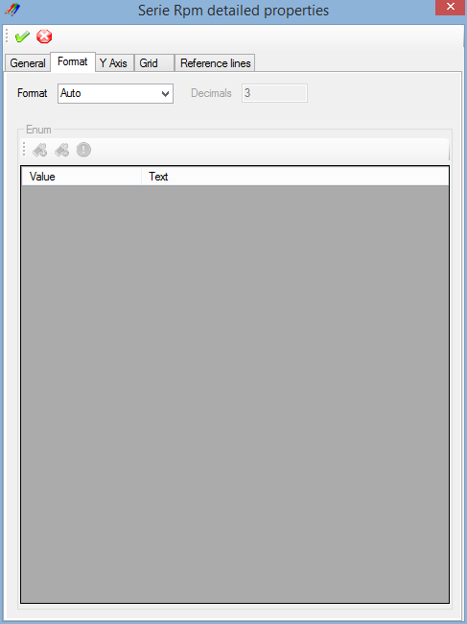

The serie's format describes how physical values of the serie are formated.

For example, if a the value of a serie is 21.47895526 in the data file, using the format property this value can be shown in the graphic as 21.5 or 21.48.

Five formats are available:

* + Auto: Value is shown as a decimal value and number of decimal digits is a function of the span of plotted samples.
  + Decimal: Value is shown as a decimal value and number of decimal digits is set by the user.
  + Hexadecimal: Value is shown as an hexadecimal value, decimal part of the value being skipped.
  + Binary: Value is shown as a binary value, decimal part of the value being skipped.
  + Enum: A text is set for every possible value and this text is shown in the legend.

### Enum format

To configure an enumeration for a serie, first select 'Enum' in the 'Format' list. Once 'Enum' selected, the enumeration configuration grid becomes active.

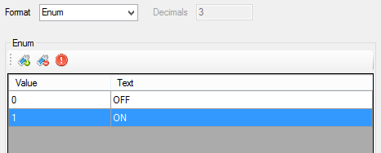

The 'Enum' panel is composed by a tool bar, containing enumeration control commands, and a grid containing every possible values of the serie and their corresponding text.

 Add enum: Add a value into the enumeration. Set a value into the 'Value' cell and the corresponding text into the 'Text' cell.

 Delete enum: Delete a value from the enumeration.

 Clear enums: Remove all values of the enumeration.

Example of graphic using enum format.

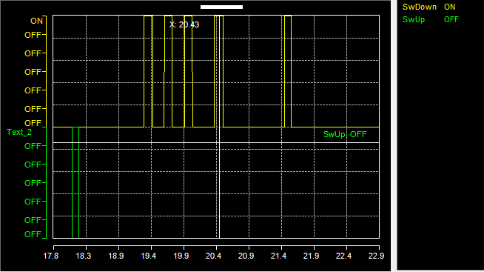

*Created with the Personal Edition of HelpNDoc:* [*Easily create Web Help sites*](http://www.helpndoc.com/feature-tour)

Serie Y Axis

The 'Y Axis' tab contains serie Y axis properties.

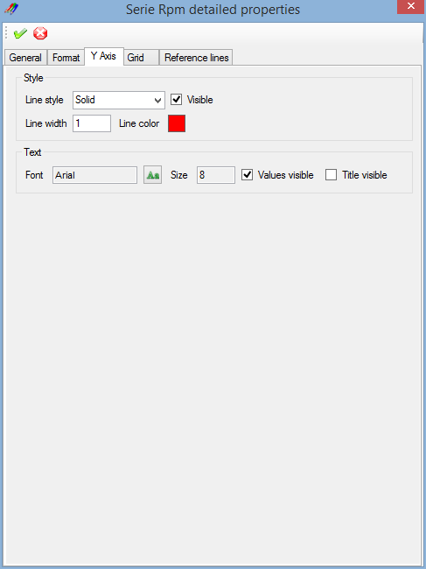

### Style

* + Line style: Select the Y axis line style. Check 'Line styles' section for details.
  + Visible: Y axis visibility flag. Check that box to make the Y axis visible.
  + Line width: Set the width of the Y axis line.
  + Line color: Double click the colored square to open the color selection dialog and select the Y axis line color.

### Text

* + Font: Click the 'Font'  button to open the font selection dialog, select a font and set its size and attributes and click 'OK'.
  + Value visible: Y axis values visibility flag. Check that box to make the Y axis values visible.
  + Title visible: Y axis title visibility flag. Check that box to make the Y axis title visible.

Example of a graphic with a customized Y axis.

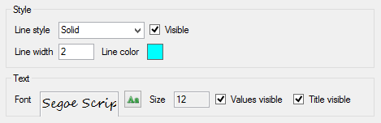

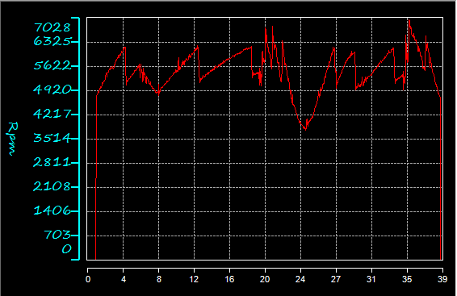

*Created with the Personal Edition of HelpNDoc:* [*Produce Kindle eBooks easily*](http://www.helpndoc.com/feature-tour/create-ebooks-for-amazon-kindle)

Serie custom grid

In addition of standard graphic grids, a graphic serie may have its own custom grid. Custom grid can be used as a complement of serie reference lines.

The 'Grid' tab of the 'Graphic serie detailed properties' window permits to set up this custom grid.

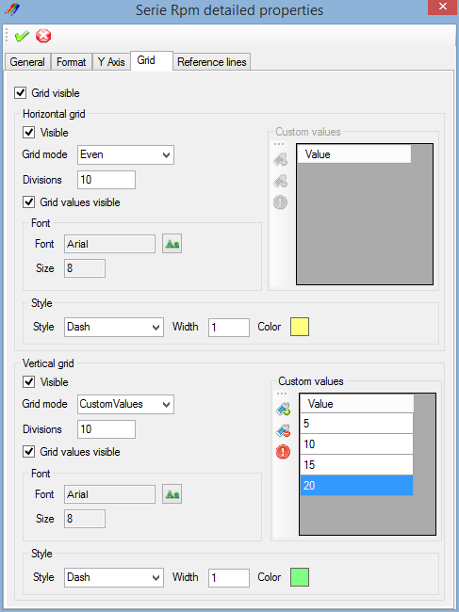

The 'Grid' tab is split in two sections: 'Horizontal grid' and 'Vertical grid'. Both sections containing properties for horizontal grid lines and vertical grid lines.

### Visible

The 'Grid visible' check box at the top of the tab  is the master grid visibility switch.

The serie's custom grid will be drawn only if this box is checked. This allows the user to decide whether or not the custom grid should be drawn by a simple command whatever the grid lines settings are.

### Grid lines properties

Both 'Horizontal grid' and 'Vertical grid' panels contain the same properties for grid lines.

* + Visible: Grid lines visibility flag. Check that box to make horizontal or vertical grid lines visible
  + Grid values visible: Grid lines values visibility flag. Check that box to make horizontal or vertical grid lines values visible

#### Grid mode

A serie custom grid may be drawn in different fashions:

* + None: No grid lines (equivalent to uncheck the 'Grid visible' box).
  + Even: Grid lines will be evenly set along graphic area of the serie.
  + MinMaxAvg: Three grid lines will be drawn at minimum, maximum and average values of the serie.
  + MinMaxZero: Three grid lines will be drawn at minimum, maximum and zero values of the serie.
  + CustomValues: Grid lines will be set at values defined by the user.

For the 'Even' mode, number of grid divisions is defined by the 'Divisions' field. It is the actual number of divisions made by the grid, number of grid lines being the number of division +1.

#### Custom values

The 'Custom values' panel is used when grid mode is set to 'CustomValues'. This panel is composed by a grid containing the user values list and a tool bar regrouping list control commands.

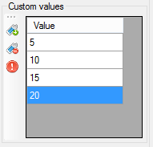

 Add value: Add a value into the list. Set a value into the 'Value' cell.

 Delete value: Delete a value of the list

 Clear values: Remove all values of the list

#### Font

The 'Font' panel defines font properties for grid lines values if the box 'Grid values visible' has been checked.

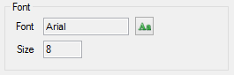

Click the 'Font'  button to open the font selection dialog, select a font and set its size and attributes and click 'OK'.

#### Style

The 'Style' panel defines graphical properties of grid lines.



* + Style: Select grid lines style. Check 'Line styles' section for details.
  + Width: Set the width of grid lines.
  + Color: Double click the colored square to open the color selection dialog and select grid lines color.

Example of a graphic using a serie custom grid:

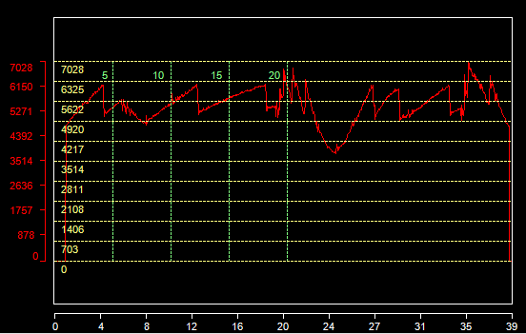

*Created with the Personal Edition of HelpNDoc:* [*Easily create HTML Help documents*](http://www.helpndoc.com/feature-tour)

Serie reference lines

A reference line is a line drawn at a particular value of a graphic serie. A single serie can have multiple reference lines and reference lines can be used as a complement of the serie custom grid.

Reference lines are usually horizontal except in the case of abscisse reference line where they are vertical.

The 'Reference lines' tab of the 'Graphic serie detailed properties' window permits to set up those reference lines.

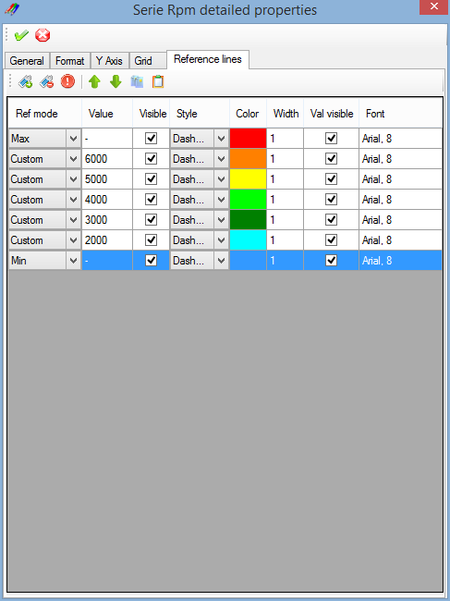

The 'Reference lines' tab is composed by a tool bar, containing reference lines control commands, and by grid showing properties of reference lines created by the user.

### Tool bar

Add: Create a new reference line.

 Delete: Delete reference lines selected.

 Clear: Delete all reference lines.

 Move up: Move a reference line up in the list.

 Move down: Move a reference line down in the list.

 Copy: Copy a reference line.

 Past: Past a reference line in the list.

### Reference lines grid

The reference lines grid has different columns for the different properties of a reference line.



* + Ref mode: Reference mode of the reference line.
  + Value: Value of the reference line in 'Custom' mode.
  + Visible: Reference line visibility flag. Check that box to make the reference line visible.
  + Style: Select reference line style. Check 'Line styles' section for details.
  + Color: Double click the colored cell to open the color selection dialog and select reference line color.
  + Width: Set the width of the reference line.
  + Val visible: Reference line value visibility flag. Check that box to make the reference line value visible.
  + Font: Double click the 'Font' cell to open the font selection dialog, select a font and set its size and attributes and click 'OK'.

#### Reference mode

Value of a reference line may be defined by different methods.

* + None: No reference line (equivalent to uncheck the 'Visible' box).
  + Zero: Reference line is drawn at the zero value of the graphic serie.
  + Min: Reference line is drawn at the minimum value of the graphic serie.
  + Max: Reference line is drawn at the maximum value of the graphic serie.
  + Average: Reference line is drawn at the zero average of the graphic serie.
  + Custom: Reference line is drawn at the value defined by the user in the 'Value' cell.

Example of a graphic using reference lines:

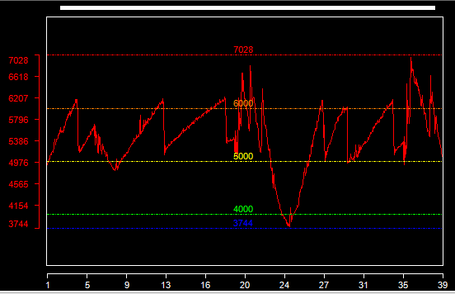

*Created with the Personal Edition of HelpNDoc:* [*Free EPub producer*](http://www.helpndoc.com/create-epub-ebooks)

Line styles

Five line styles are available

 Solid

 Dash dot

 Dash dot dot

 Dash

 Dot

*Created with the Personal Edition of HelpNDoc:* [*Create iPhone web-based documentation*](http://www.helpndoc.com/feature-tour/iphone-website-generation)

**Virtual Channels**

Unlike a real CAN signal, a virtual channel is not contained within any CAN message, it is virtual! Value of such channel is therefore not static but dynamically calculated using a mathematical expression

and values of one, two or more real CAN signals.

For example, let's consider CAN signals 'Signal_1', 'Signal_2' and a virtual channel 'Virtual' using 'Signal_1 + Signal_2' as expression.

On reception of signals 'Signal_1' and 'Signal_2', CANStream will evaluate expression of our virtual channel, then parameter 'Virtual' will take the sum of 'Signal_1' and 'Signal_2' as value.

Virtual channel expressions being evaluated each time a new value is received for 'Signal_1' or 'Signal_2', value of our virtual channel 'Virtual' is, at any time, equal to the sum of 'Signal_1' and 'Signal_2'.

Virtual channels calculation can be made using any CANStream object: CAN signal, built-in signal, logging data channel or another virtual channel as well.

Virtual channels can also become real since they can be sent in CAN message as a 'Virtual CAN parameter'.

*Created with the Personal Edition of HelpNDoc:* [*Free CHM Help documentation generator*](http://www.helpndoc.com)

**Virtual channel edition**

Virtual channels are stored in library. Several virtual channels libraries can be loaded at the same time. If a virtual channels library is loaded once, CAN stream will reload it at each start up so you don't have to reload all your libraries all the time.

Simply remove a library from the active libraries list to not load it at start up.

Click the 'Tools\Virtual channels'  command of the menu strip to open the virtual channel editor.

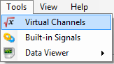

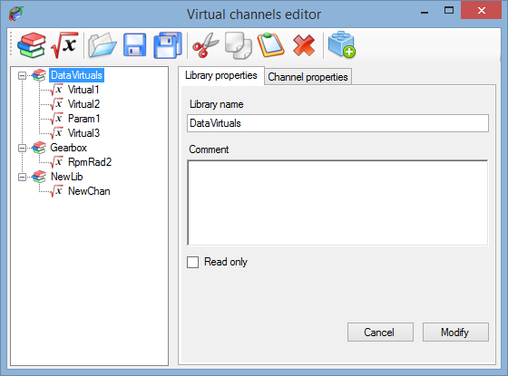

The virtual channels editor is composed by:

* + A tool bar, on the top, containing libraries and virtual channels control commands
  + A tree view, on the left, showing all active libraries and virtual channels part of those libraries
  + A multi-tab window, on the right, showing properties of either a library or a virtual channel

### Tool bar

 New library: Create a new virtual channels library.

 New virtual channel: Create a new virtual channel.

 Open library: Load an exiting virtual channels library.

 Save library: Save the active virtual channels library.

 Save all libraries: Save all active virtual channels libraries.

 Cut: Cut the selected item (library or channel).

 Copy: Copy the selected item (library or channel).

 Past: Past a cut/copied item (library or channel).

 Delete: Delete selected item (library or channel).

 Load object file: Load a virtual channel objects file.

### Tree view

The tree view shows all active libraries, each library is represented by a node  in the tree. Virtual channels of a library are child nodes  (or branches) of a library node.

Simply click on a library or a virtual channel to edit its properties.

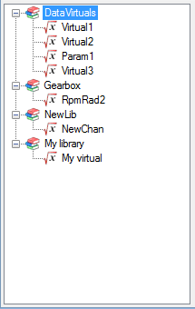

*Created with the Personal Edition of HelpNDoc:* [*Write eBooks for the Kindle*](http://www.helpndoc.com/feature-tour/create-ebooks-for-amazon-kindle)

**Virtual channel library properties**

Click on the 'New library'  button of the tool bar to create a new virtual channels library or click on a library node  of the tree view to edit its properties.

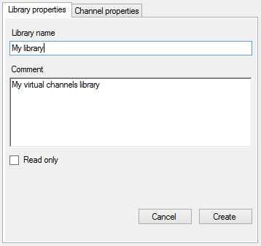

A library has actually very few properties:

* + Library name: Name of the library.
  + Comment: Description of the library.
  + Read only: Check this box if you want protect your library against unwanted change.

Once all properties set, just click the 'Create' button to add the library into the active libraries list.

In case of library edition, 'Create' button will become 'Modify', just click the 'Modify' button to apply changes.

Button 'Cancel' cancel the library creation or edition.

*Created with the Personal Edition of HelpNDoc:* [*Free iPhone documentation generator*](http://www.helpndoc.com/feature-tour/iphone-website-generation)

**Virtual channel properties**

Click on the 'New virtual channel'  button of the tool bar to create a new virtual channels or click on a virtual channel node  of the tree view to edit its properties.

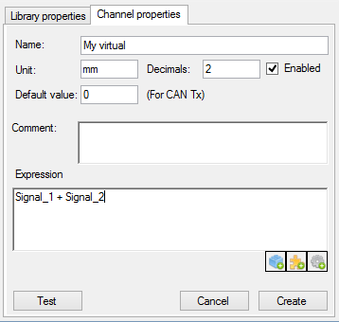

A virtual channel has the following properties:

* + Name: Name of the virtual channel.
  + Unit: Unit of the virtual channel value.
  + Decimal: Number of decimal.
  + Default value: Virtual channel default value (used only if the virtual channel is used as source of a virtual CAN parameter).
  + Comment: Description of the virtual channel.
  + Expression: Mathematical expression of the virtual channel.

There are three buttons at the bottom of the mathematical expression text box .

Those buttons permit to ease and accelerate edition of the virtual channel expression. Click on one of those buttons to open a list containing different items that can be used in the virtual channel expression. Double click an item of list to insert it into the expression.

It is possible to insert three kinds of item

 Virtual channel objects: List of variable (CAN signal, built-in signal, logging channel or another virtual channel).

 Virtual channel functions: List of built-in virtual channel function (abs, cos, sin, ...).

 Virtual channel operators: List of operators (+, -. *, /).

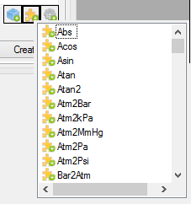

Regarding virtual channel objects, click the 'Load an object file'  button of the tool bar to load an object file and retrieve all names that can be used in a virtual channel expression.

: ***For virtual channels functions using multiple arguments, such as*** IFGT, ***the argument separator character is ' ; '.***

Thus, expression "IFGT(4 **;** 2)" will be correctly evaluated while the expression "IFGT(4 **,** 2)" will lead to a raise of an expression evaluation error.

While writing the virtual channel expression, it is possible to test it by simulating a computation. To do so, click on 'Test'  button.

Check the 'Virtual channel testing' section for more details.

*Created with the Personal Edition of HelpNDoc:* [*Free CHM Help documentation generator*](http://www.helpndoc.com)

**Virtual channel testing**

While writing the virtual channel expression, it is possible to test it by simulating a computation. To do so,  button of the virtual channel properties panel.

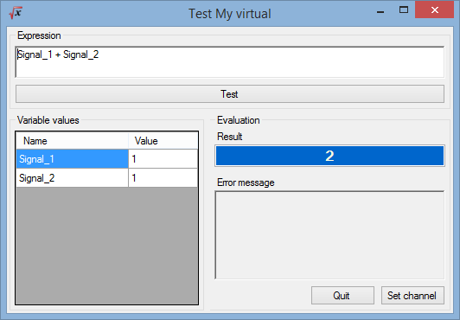

On the form opening, the virtual channel expression is evaluated using default values for expression variables.

The evaluation result is shown the 'Result' text box of the 'Evaluation' panel. The 'Variable values' grid, on the left, contains all variables of the virtual channel to test.

Change values in the grid to make a new calculation and verify the expression with different values.

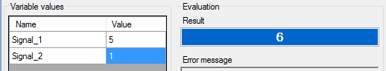

The mathematical expression itself can be modified. Simply change the expression written in the 'Expression' text box and click the 'Test' button to evaluate the modified expression.

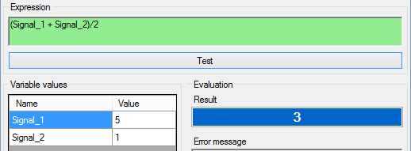

If the modified expression is mathematically correct, 'Expression' text box goes green. If an error occurs

during the evaluation, text box goes red.

In order to easily identify the error, the 'Error message' text box indicated what is the error and where it is.

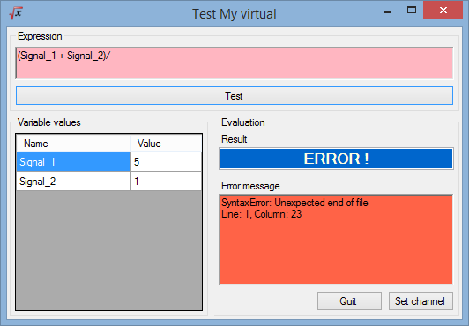

Once the expression is working, click on the 'Set channel' button to set the test expression in the 'Expression' text box of the virtual channel properties panel.

*Created with the Personal Edition of HelpNDoc:* [*Easily create Help documents*](http://www.helpndoc.com/feature-tour)

**Virtual channel built-in functions**

Here is the list of CANStream built-in function for virtual channel.

|  |  |
| --- | --- |
| ***Function*** | ***Description*** |
| Abs (A) | Returns the absolute value of a A number. |
| Acos (A) | Returns the angle whose cosine is the A number. |
| Asin (A) | Returns the angle whose sine is the A number. |
| Atan (A) | Returns the angle whose tangent is the A number. |
| Atan2 (A; B) | Returns the angle whose tangent is the quotient of specified A and B numbers. |
| Atm2Bar (A) | Return pressure A converted from atmosphere to bar |
| Atm2kMmHg (A) | Return pressure A converted from atmosphere to mercure millimeter |
| Atm2kPa (A) | Return pressure A converted from atmosphere to kilo Pascal |
| Atm2Pa (A) | Return pressure A converted from atmosphere to Pascal |
| Atm2Psi (A) | Return pressure A converted from atmosphere to psi |
| Bar2Atm (A) | Return pressure A converted from bar to atmosphere |
| Bar2kPa (A) | Return pressure A converted from bar to kilo Pascal |
| Bar2MmHg (A) | Return pressure A converted from bar to mercure millimeter |
| Bar2Pa (A) | Return pressure A converted from bar to Pascal |
| Bar2Psi (A) | Return pressure A converted from bar to psi |
| BigMul (A; B) | Produces the full product of two 32-bit A and B numbers. |
| Cal2Joule (A) | Return energy A convered from calorie to Joule |
| Cal2kCal (A) | Return energy A convered from calorie to kilo calorie |
| Cal2kJ (A) | Return energy A convered from calorie to kilo Joule |
| Ceiling (A) | Returns the smallest integral value that is greater than or equal to the specified A number. |
| Celcius2Fahrenheit (A) | Return temperature A converted from Celcius degree to Fahrenheit degree |
| Celcius2Kelvin (A) | Return temperature A converted from Celcius degree to Kelvin degree |
| Cos (A) | Returns the cosine of the specified angle. |
| Cosh (A) | Returns the hyperbolic cosine of the specified angle. |
| Deg2Grad (A) | Return value of angle 'A" converted from degree to gradian |
| Deg2Rad (A) | Return value of angle 'A" converted from degree to radian |
| DivRem (A; B; out C) | Calculates the quotient of A and B numbers and also returns the remainder in an output parameter C. |
| Exp (A) | Returns e raised to the A power. |
| Fahrenheit2Celcius (A) | Return temperature A converted from Fahrenheit degree to Celcius degree |
| Fahrenheit2Kelvin (A) | Return temperature A converted from Fahrenheit degree to Kelvin degree |
| Feet2Km (A) | Return length A converted from feet to kilometer |
| Feet2Meter (A) | Return length A converted from feet to meter |
| Feet2Mile (A) | Return length A converted from feet to mile |
| Feet2Yard (A) | Return length A converted from feet to yard |
| Floor(A) | Returns the largest integer less than or equal to the specified A number. |
| Floor(A) | Returns the largest integer less than or equal to the specified A number. |
| Grad2Deg (A) | Return value of angle 'A" converted from gradian to degree |
| Grad2Rad (A) | Return value of angle 'A" converted from gradian to radian |
| Gram2Kg (A) | Return weigth A converted from gram to kilogram |
| Gram2Ounce (A) | Return weigth A converted from gram to ounce |
| Gram2Pound (A) | Return weigth A converted from gram to pound |
| Gram2Tonne (A) | Return weigth A converted from gram to tonne |
| IEEERemainder (A; B) | Returns the remainder resulting from the division of a the A number by the B number. |
| IFEQ (A; B) | Return 1 if value of argument 'A' is equal to value of argument 'B' |
| IFGE (A; B) | Return 1 if value of argument 'A' is greater or equal to value of argument 'B' |
| IFGT (A; B) | Return 1 if value of argument 'A' is greater than value of argument 'B' |
| IFLE (A; B) | Return 1 if value of argument 'A' is smaller or equal to value of argument 'B' |
| IFLT (A; B) | Return 1 if value of argument 'A' is smaller than value of argument 'B' |
| IFNE (A; B) | Return 1 if value of argument 'A' is not equal to value of argument 'B' |
| INRG (A; Min; Max) | Return 1 if value of argument 'A' is contained within the 'Min/Max' range |
| Joule2Cal (A) | Return energy A convered from Joule to calorie |
| Joule2kCal (A) | Return energy A convered from Joule to kilo calorie |
| Joule2kJ (A) | Return energy A convered from Joule to kilo Joule |
| KCal2Cal (A) | Return energy A convered from kilo calorie to calorie |
| KCal2Joule (A) | Return energy A convered from kilo calorie to Joule |
| KCal2kJ (A) | Return energy A convered from kilo calorie to kilo Joule |
| Kelvin2Celcius (A) | Return temperature A converted from Kelvin degree to Celcius degree |
| Kelvin2Fahrenheit (A) | Return temperature A converted from Kelvin degree to Fahrenheit degree |
| Kg2Gram (A) | Return weigth A converted from kilogram to gram |
| Kg2Ounce (A) | Return weigth A converted from kilogram to ounce |
| Kg2Pound (A) | Return weigth A converted from kilogram to pound |
| Kg2Tonne (A) | Return weigth A converted from kilogram to tonne |
| Kj2Cal (A) | Return energy A convered from kilo Joule to calorie |
| Kj2Joule (A) | Return energy A convered from kilo Joule to Joule |
| Kj2kCal (A) | Return energy A convered from kilo Joule to kilo calorie |
| Km2Feet (A) | Return length A converted from kilometer to feet |
| Km2Meter (A) | Return length A converted from kilometer to meter |
| Km2Mile (A) | Return length A converted from kilometer to mile |
| Km2Yard (A) | Return length A converted from kilometer to yard |
| kPa2Atm (A) | Return pressure A converted from kilo Pascal to atmosphere |
| kPa2Bar (A) | Return pressure A converted from kilo Pascal to bar |
| kPa2MmHg (A) | Return pressure A converted from kilo Pascal to mercure millimeter |
| kPa2Pa (A) | Return pressure A converted from kilo Pascal to pascal |
| kPa2Psi (A) | Return pressure A converted from kilo Pascal to psi |
| kph2mph (A) | Return speed A converted from kilometer per hour to mile per hour |
| kph2ms (A) | Return speed A converted from kilometer per hour to meter/second |
| Log (A) | Returns the natural (base e) logarithm of a A number. |
| Log (A; B) | Returns the logarithm of a A number in the specified B base. |
| Log10 (A) | Returns the base 10 logarithm of a A number. |
| Max (A; B) | Returns the larger of A and B numbers |
| Meter2Feet (A) | Return length A converted from meter to feet |
| Meter2Km (A) | Return length A converted from meter to kilometer |
| Meter2Mile (A) | Return length A converted from meter to mile |
| Meter2Yard (A) | Return length A converted from meter to yard |
| Mile2Feet (A) | Return length A converted from mile to feet |
| Mile2Km (A) | Return length A converted from mile to kilometer |
| Mile2Meter (A) | Return length A converted from mile to meter |
| Mile2Yard (A) | Return length A converted from mile to yard |
| Min (A; B) | Returns the smaller of A and B numbers |
| MmHg2Atm (A) | Return pressure A converted from mercure millimeter 2 kilo atmosphere |
| MmHg2Bar (A) | Return pressure A converted from mercure millimeter 2 bar |
| MmHg2kPa (A) | Return pressure A converted from mercure millimeter 2 kilo Pascal |
| MmHg2Pa (A) | Return pressure A converted from mercure millimeter 2 Pascal |
| MmHg2Psi (A) | Return pressure A converted from mercure millimeter 2 psi |
| mph2kph (A) | Return speed A converted from mile per hour to kilometer per hour |
| mph2ms (A) | Return speed A converted from mile per hour to meter/second |
| ms2kph (A) | Return speed A converted from meter/second to kilometer per hour |
| ms2mph (A) | Return speed A converted from meter/second to mile per hour |
| OOR (A; Min; Max) | Return 1 if value of argument 'A' is not contained within the 'Min/Max' range |
| Ounce2Gram (A) | Return weigth A converted from ounce gram |
| Ounce2Kg (A) | Return weigth A converted from ounce kilogram |
| Ounce2Pound (A) | Return weigth A converted from ounce pound |
| Ounce2Tonne (A) | Return weigth A converted from ounce tonne |
| Pa2Atm (A) | Return pressure A converted from Pascal to atmosphere |
| Pa2Bar (A) | Return pressure A converted from Pascal to bar |
| Pa2kPa (A) | Return pressure A converted from Pascal to kilo Pascal |
| Pa2MmHg (A) | Return pressure A converted from Pascal to mercure millimeter |
| Pa2Psi (A) | Return pressure A converted from Pascal to psi |
| Pound2Gram (A) | Return weigth A converted from pound to gram |
| Pound2Kg (A) | Return weigth A converted from pound to kilogram |
| Pound2Ounce (A) | Return weigth A converted from pound to ounce |
| Pound2Tonne (A) | Return weigth A converted from pound to tonne |
| Pow (A; B) | Returns the A number raised to the B power. |
| Psi2Atm (A) | Return pressure A converted from psi to atmosphere |
| Psi2Bar (A) | Return pressure A converted from psi to bar |
| Psi2kPa (A) | Return pressure A converted from psi to kilo Pascal |
| Psi2MmHg (A) | Return pressure A converted from psi to mercure millimeter |
| Psi2Pa (A) | Return pressure A converted from psi to Pascal |
| Rad2Deg (A) | Return value of angle 'A" converted from radian to degree |
| Rad2Grad (A) | Return value of angle 'A" converted from radian to gradian |
| Round (A) | Rounds the value A to the nearest integral value. |
| Sign (A) | Returns the value indicating the sign of a A number. |
| Sin (A) | Returns the sine of the A angle. |
| Sinh (A) | Returns the hyperbolic sine of the A angle. |
| Sqrt (A) | Returns the square root of a A number. |
| Tan (A) | Returns the tangent of the A angle. |
| Tanh (A) | Returns the hyperbolic tangent of the A angle. |
| Tonne2Gram (A) | Return weigth A converted from tonne to gram |
| Tonne2Kg (A) | Return weigth A converted from tonne to kilogram |
| Tonne2Ounce (A) | Return weigth A converted from tonne to ounce |
| Tonne2Pound (A) | Return weigth A converted from tonne to pound |
| Truncate(Decimal) | Calculates the integral part of a specified A number. |
| Yard2Feet (A) | Return length A converted from yard to feet |
| Yard2Km (A) | Return length A converted from yard to kilometer |
| Yard2Meter (A) | Return length A converted from yard to meter |
| Yard2Mile (A) | Return length A converted from yard to mile |

*Created with the Personal Edition of HelpNDoc:* [*Free iPhone documentation generator*](http://www.helpndoc.com/feature-tour/iphone-website-generation)

**Built-in signals**

Built-in signals are a tool used for cycle creation. Instead of making a cycle based on real data contained into a text file or an Excel file, CANStream can generate data of a periodic signal that will be used as a source of data in the cycle.

*Created with the Personal Edition of HelpNDoc:* [*Free EPub producer*](http://www.helpndoc.com/create-epub-ebooks)

**Built-in signals edition**

As per virtual channels, built-in signals are organized by libraries. A library can contain several signals and multiple libraries can loaded together at the same time.

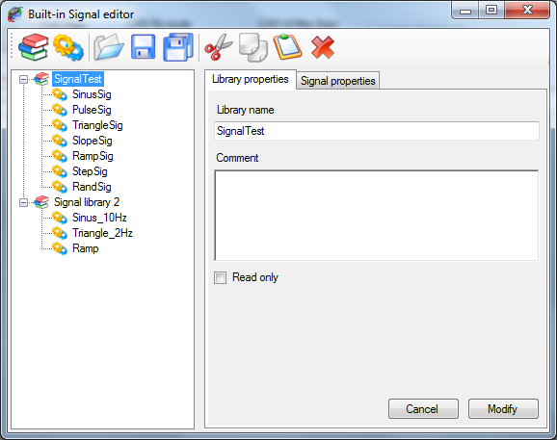

The built-in signal editor is composed of:

* + A tool bar, on the top, containing signals and libraries control commands.
  + A tree view, on the left, in which appears all signal libraries loaded.
  + A multi-tab panel, on the right, for signal and library properties edition.

In the tree view, each built-in signal library is represented by the  node. All built-in signals contained in a library are child node (or branch) of the library and are represented by the  node.

The tool bar contains the following commands:

 New signals library: Create a new built-in signals library.

 New signal: Create a new built-in signal into the current library.

 Open library: Load an existing built-in signals library.

 Save library: Save the current built-in signals library.

 Save all libraries: Save all loaded built-in signals libraries.

 Cut: Cut an item an place it onto the clipboard.

 Copy: Copy an item an place it onto the clipboard.

 Past: Paste an item from the clipboard.

 Delete: Delete the selected item.

*Created with the Personal Edition of HelpNDoc:* [*Produce electronic books easily*](http://www.helpndoc.com/create-epub-ebooks)

**Built-in signals library**

Click on a library item  of the tree view to edit its properties or click the ‘Create new signals library’  button to create a new signal.

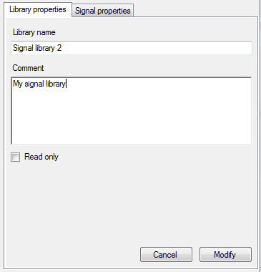

A built-in signals library has very few properties:

* + Library name: Name of library.
  + Comment: Description of the library.
  + Read only: Check that box if you want prevent unwanted changes in the library.

Make all changes you want and then click the ‘Modify’ button to apply your changes. In the case of the creation of a new library, ‘Modify’ button will become ‘Create’, just click it to create the library.

*Created with the Personal Edition of HelpNDoc:* [*Easily create HTML Help documents*](http://www.helpndoc.com/feature-tour)

**Built-in signals properties**

Click a signal node  to edit its properties or click the ‘Create new signal’  button to create a new signal.

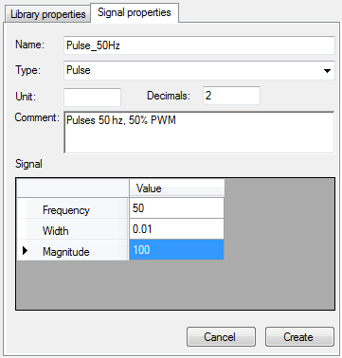

A built-in signal has several properties:

* + Name: Name of the signal.
  + Type: Kind of periodic signal to be generated. Check 'Built-in signals types' section for more details.
  + Unit: Unit of the signal.
  + Decimal: Number of signal decimal digits.
  + Comment: Signal description.
  + Signal math properties grid: Content of this grid depends of the type of signal selected. Check built-in signals type section for more details.

Set, at least, the signal name and type as well as its math properties and then click the ‘Create’ button to create the signal. In case of signal edition, this button will become ‘Modify’, just click it to apply all changes you may have done.

*Created with the Personal Edition of HelpNDoc:* [*Free EPub and documentation generator*](http://www.helpndoc.com)

**Built-in signals types**

There are seven signal types available; each of them has its own math properties.

*Created with the Personal Edition of HelpNDoc:* [*Full-featured EPub generator*](http://www.helpndoc.com/create-epub-ebooks)

**Sinus**

Generate a sinusoidal waveform.

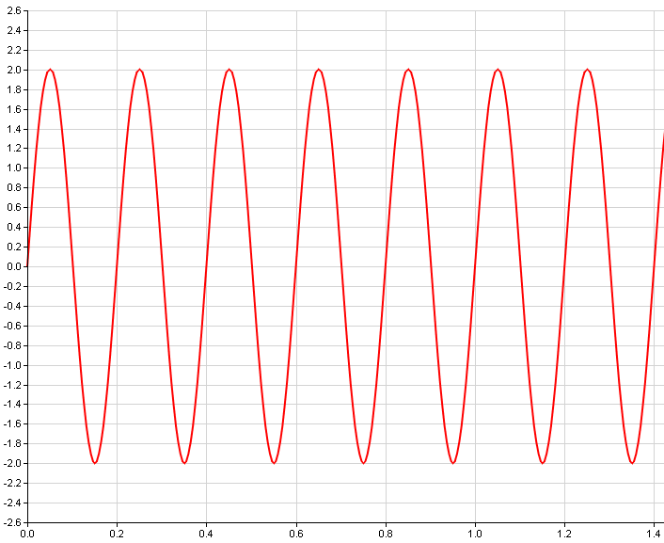

Uses the following math properties

* + Frequency: Sinusoid frequency in Hertz.
  + Magnitude: Peak to peak signal magnitude.
  + Offset: Signal offset with respect to zero.
  + Phase: Sinusoid phase offset.

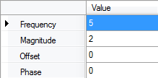

*Created with the Personal Edition of HelpNDoc:* [*Easily create Help documents*](http://www.helpndoc.com/feature-tour)

**Pulses**

Generate multiple pulses waveform.

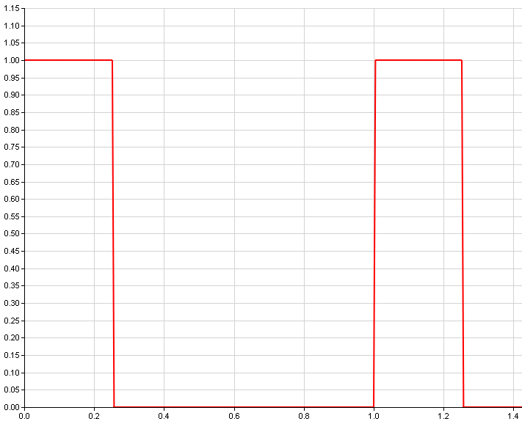

Uses the following math properties:

* + Frequency: Pulses frequency in Hertz.
  + Width: Pulse width with respect to the signal period in second.
  + Magnitude: Peak to peak signal magnitude.

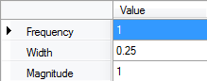

*Created with the Personal Edition of HelpNDoc:* [*Easily create HTML Help documents*](http://www.helpndoc.com/feature-tour)

**Triangle**

Generate a triangle waveform.

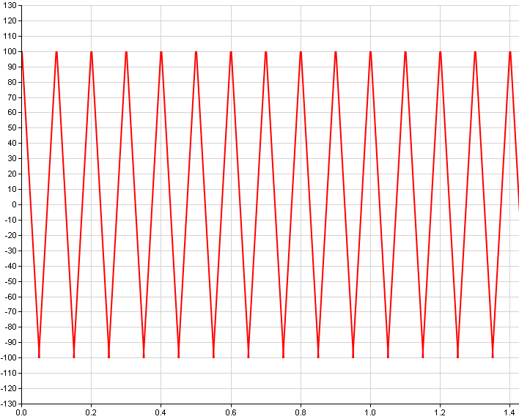

Uses the following math properties:

* + Frequency: Triangle frequency in Hertz.
  + Magnitude: Peak to peak signal magnitude.
  + Offset: Signal offset with respect to zero.
  + Phase: Triangle phase offset.

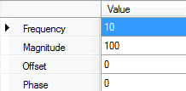

*Created with the Personal Edition of HelpNDoc:* [*iPhone web sites made easy*](http://www.helpndoc.com/feature-tour/iphone-website-generation)

**Slopes**

Generate multiple slopes waveform.

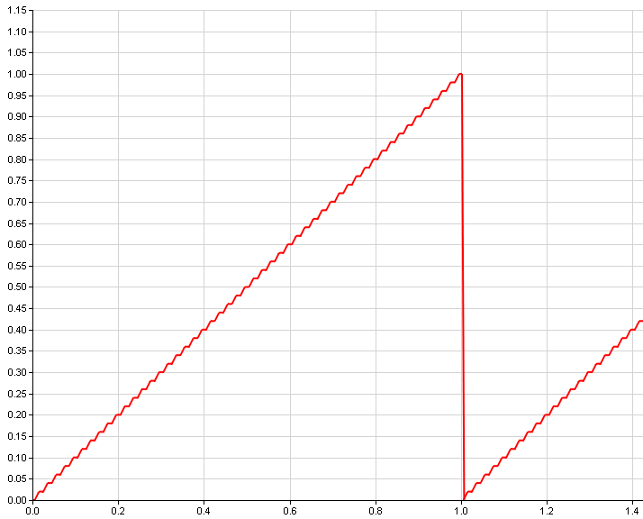

Uses the following math properties:

* + Frequency: Slopes frequency in Hertz.
  + Start value: Slope starting value.
  + End value: Slope ending value.

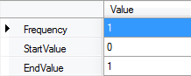

*Created with the Personal Edition of HelpNDoc:* [*Free Kindle producer*](http://www.helpndoc.com/feature-tour/create-ebooks-for-amazon-kindle)

**Ramp**

Generate a ramp waveform.

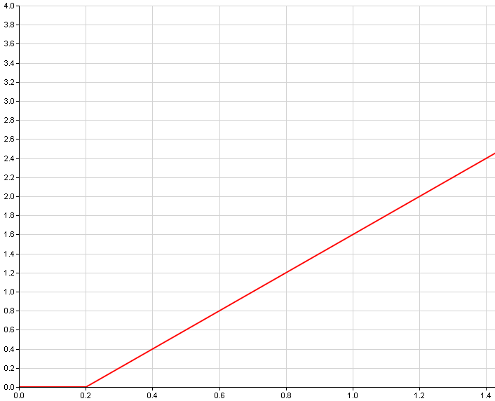

Uses the following math properties:

* + Slope: Ramp gradient.
  + Start value: Ramp starting value.
  + End value: Ramp starting time in second.

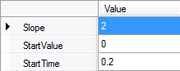

*Created with the Personal Edition of HelpNDoc:* [*Write EPub books for the iPad*](http://www.helpndoc.com/create-epub-ebooks)

**Step**

Generate a single step waveform.

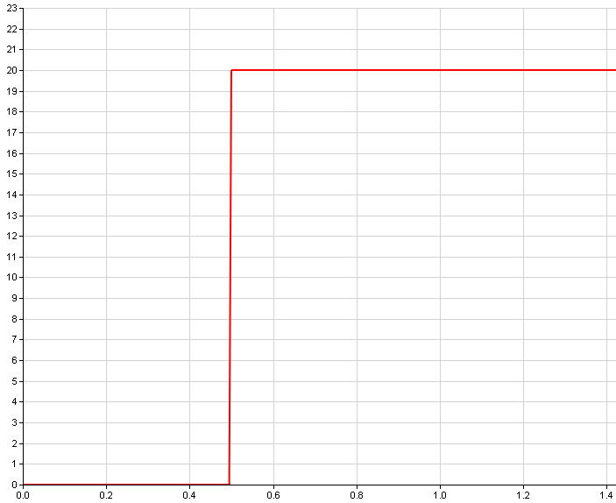

Uses the following math properties:

* + Start value: Step starting value.
  + End value: Step ending value.
  + Start time: Stepping time in second.

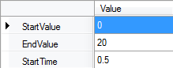

*Created with the Personal Edition of HelpNDoc:* [*Easy EBook and documentation generator*](http://www.helpndoc.com)

**Random**

Generate a random values waveform.

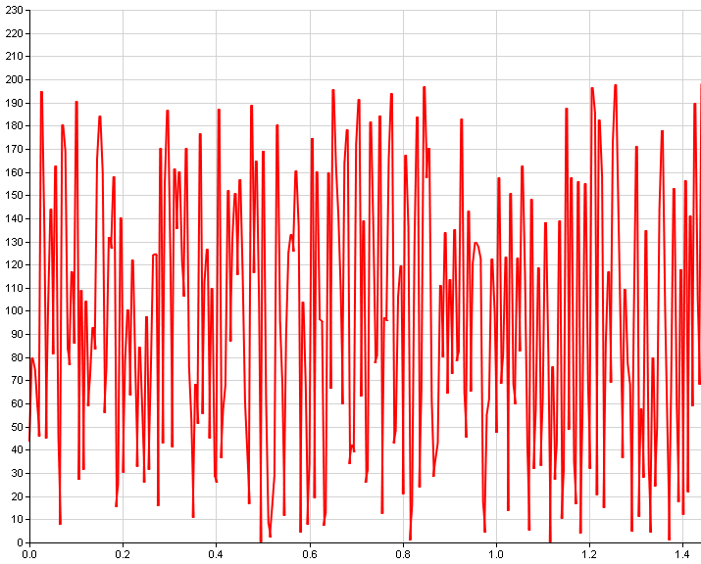

Uses the following math properties:

* + Min value: Signal minimum value.
  + Max value: Signal maximum value.

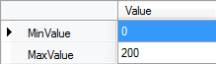

*Created with the Personal Edition of HelpNDoc:* [*Free HTML Help documentation generator*](http://www.helpndoc.com)